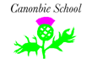
Canonbie Primary Termly Overview
Primary 5/6/7
This is an overview of the areas of learning which will be covered during term 2.
Writing & Listening and Talking  In writing we will be covering a variety of areas through Children’s Rights Topic and the different celebrations/events: Halloween spooky story, black out Remembrance poetry, poster for the different articles that form the UNCRC, a leaflet and writing linked to our class book.    In listening and talking, we will be taking part in group discussions, debates, asking and answering questions, taking notes during our topic and class novel work. | Maths  In numeracy, we will be focusing on multiplication, division, fractions, decimals and percentages.  In maths this term, we will be exploring measurement starting with length, weight, volume and area.  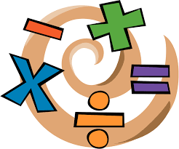 | HWB & PE  Primary 6 and 7 will be having some sessions with a Youth Worker from D&G Council on managing emotions, building resilience, online safety and social media and friendship.  This term we are doing a gymnastics block with some Scottish Country Dancing nearer the end of the term.  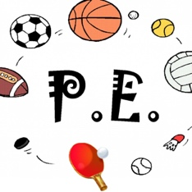 | Art/RME  Our artwork will be linked to topic and celebrations and events happening this term. We will be creating haunted house portraits to accompany our writing using different shades of the same colour to create atmosphere. Remembrance poppies using charcoal and Christmas art activities.  In RME we will be exploring World Religion’s special celebrations and finding out what other countries and cultures do to celebrate Christmas.  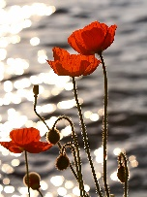
Expressive Arts  This term will have a big focus on music, singing, dancing and drama due to rehearsing for our Christmas show. We are putting on the performance of ‘The Boy, The Mole, The Fox and The Horse.’ We will be joining with the primary 4 and 5 pupils from the P345 class.  Music: Primary 7 pupils will continue their fortnightly music sessions with Mrs Baxter.  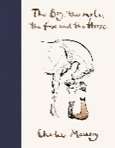 | Social Studies  Through our Children’s Rights topic, we will be learning about the rights children have, categorising children’s rights into basic needs, safe from harm or express themselves, recognising the difference between needs and wants, matching children’s rights to responsibilities, deciding which answer is responsible and not responsible in different scenarios as well as learning about the Scottish Government and democracy.  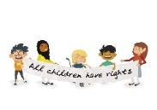 | Reading  This term we will be reading a book linked to our topic: Children Who Changed the World by Marcia Williams. We will be engaging in a range of tasks to show our understanding of the text.  Pupils will also have the opportunity to read for enjoyment and challenge through Accelerated Reading, Get Epic and reading groups.  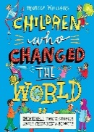 | Spelling & Grammar  In spelling with Mrs Tilley, we will be continuing our fluid spelling programme, concentrating on various phonemes, common words and stage appropriate words.  In grammar with Mrs Wilson, we are working on  