PART 1
- The symbol for the element iron is
A FE
B Ir
C I
D Fe

- What is the name of the compound with formula NH₃

A nitrogen
B nitrogen hydride
C nitrogen trihydride
D nitrogen hydroxide

- Methanol has the formula CH₃OH
Which of the following diagrams represents methanol

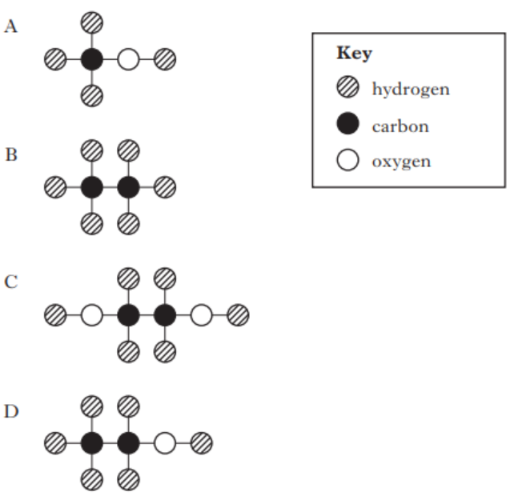

4.
The formula for dinitrogen trioxide is
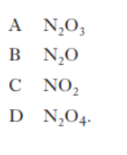
5.
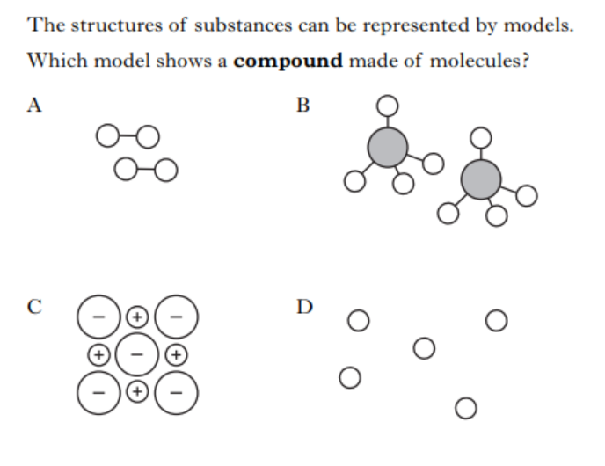
ELEMENT
6.
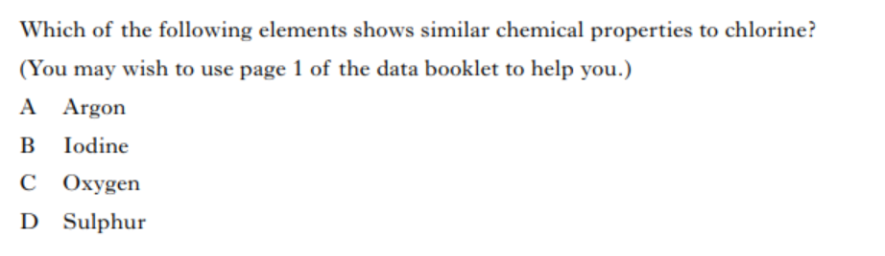
Helium

7. The atomic number of Meitnerium
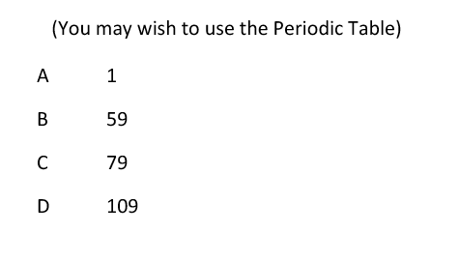

8.
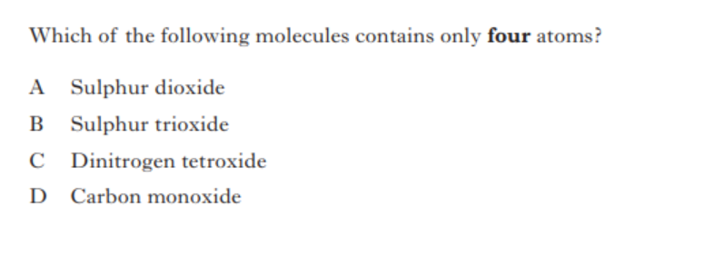
3

PART 2

1 (a) What is the symbol for nickel

(b) Is nickel a metal or a non-metal

- The diagram below represents methyl ethanoate – a flavour molecule
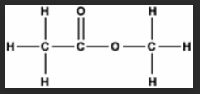

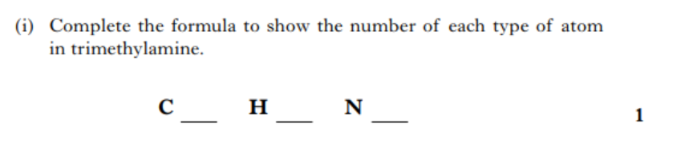
O __ ____
Methyl ethanoate
4.

In a chemical reaction when calcium is heated with oxygen and calcium oxide is produced .Write a word equation for this chemical reaction

5. Name the elements present in the following compounds

- Magnesium bromide

- Lithium nitrite

- Nickel carbonate

(d) Calcium hydroxide

6.

