Blackfish Name………………………………………………………………..
- How many reports have there been of wild orcas killing people? ………………………………….
…………………………………………………………………………………………………………………………………………………………….
- How long do orcas live in the wild? ………………………………………………………………………………................
……………………………………………………………………………………………………………………………………………………………..
- How long do orcas live in captivity? …………………………………………………………………………………….........
……………………………………………………………………………………………………………………………………………………………..
- Where did Seaworld go to capture the orcas? ……………………………….…………………………………......
………………………………………………………………………………………………………………………………………………………………
- What kind of accommodation did the Sealand orcas have when they were not performing? …………………………………………………………………………………………………………………………………...…
………………………………………………………………………………………………………………………………………………………………
- How long were they kept in these conditions? …………………………………………………………………………
……………………………………………………………………………………………………………………………………………………………..
- When was Tilikum captured? ……………………………………………………………………………………………………….
- How old was he when he was captured? ……………………………………………………………………………………
……………………………………………………………………………………………………………………………………………………………
- Keltie was killed in 1991, how long had Tilikum been kept in captivity when Keltie died? ………………………………………………………………………………………………………………………………………………………..…..
- What percentage of wild male orcas have a flopped over dorsal fin? ………………………………..
- What percentage of captive male orcas have a flopped over dorsal fin?…………….…………….
- What do scientists think the flopped over dorsal fin shows? .................................................
……………………………………………………………………………………………………………………………………………………………..
- What do orcas eat in the wild? ……………………………………………………………………………………………………
- How far would a wild orca swim in an average day? …………………………………………………………………

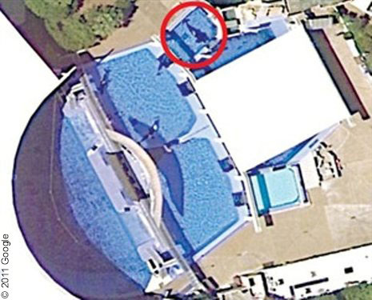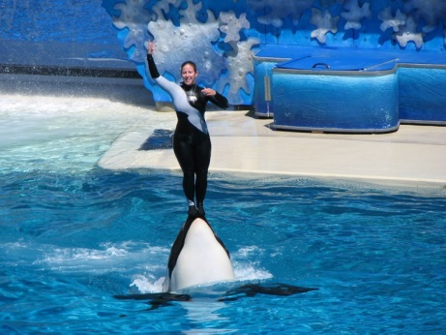

Homework Questions – answer in full sentences in your jotter. For each homework put the week’s title and date and underline both with a ruler.
Week 1 - Capture
- Why do you think they chose to capture young orcas?
- What did the adult orcas do after the babies were captured?
Week 2 - Fighting
- Why do you think that Tilikum was attacked by the other orcas when he arrived at Seaworld?
- What explanation was given in the documentary for why the captive orcas fight with each other?
Week 3 - Training
- Describe the techniques used to train new orcas
- Do you think the orcas ‘want’ to do the tricks the trainers try to make them do?
Week 4 – For and against
- If animals experience emotions like grief what does this tell us about the way we should treat them?
- Copy the grid into your jotter and putting one in each box, give as many reasons for and as many reasons against keeping animals in captivity for entertainment purposes.
For keeping animals in captivity | Against keeping animals in captivity

