Research


This part of the course is required to support candidates with both the Higher Psychology question paper and the assignment. In addition to the skills required for the question paper, candidates also develop the following skills in this area of study and in their assignments:
♦interpret and evaluate descriptive statistics in psychological research
♦ use research skills to generate, select, organise, interpret, analyse and evaluate information in psychology
♦ use communication skills to present information, including a report on psychological research
Research Success Criteria | Date covered in class | Revised
Understand the main stages of the research process.
Describe the key features of experimental research methods, including:
- Independent, dependent and extraneous variables
- Validity and reliability
- Cause and effect
- Lab experiments
- Field experiments
- Naturalistic experiments
Describe the key features of non-experimental research methods, including:
- Questionnaires/surveys
- Interviews
- Observation
- Case studies
- Correlational studies
Describe the key features of different types of sampling, including:
- Opportunity sampling
- Random sampling
- Self-selection
- Systematic
- Quota sampling
- Stratified sampling
Become familiar with the ethical codes of conduct in research:
- Consent
- Deception
- Withdrawal
- Protection
- Confidentiality
- Debriefing
Develop knowledge and understanding of the use of descriptive statistics and demonstrate an ability to calculate mean, median and mode and range.
Discuss merits and disadvantages of mean, median and mode.
Introduction to Research

Aim: to become familiar with the scientific method and the research process.
Success Criteria:
- Differentiate between theory and fact.
- Describe the scientific method.
- Understand variables and how these affect research.
- Describe the main stages of the research process.

How do researchers investigate psychological phenomena? They utilize a process known as the scientific method to study different aspects of how people think and behave. Using this method, theories must be backed up with valid and reliable evidence that has been gathered from practical research.

A theory is an idea that is supported by the current evidence. Theories are not facts. In science, a fact is a piece of evidence that has been repeatedly confirmed. Theories should be stated in a way that can be tested – it must be possible to prove the theory wrong.

The Scientific Method

The scientific method is essentially a step-by-step process that researchers can follow to determine if there is some type of relationship between two or more variables.
A variable is something that can change in observable and measurable ways. One variable is changed, and its effect on another variable is measured, while all other variables are kept constant.

The independent variable (IV) is the variable that is controlled and manipulated by the experimenter. For example, in an experiment on the impact of sleep deprivation on test performance, sleep deprivation would be the independent variable.
The dependent variable (DV) is the variable that is measured by the experimenter. In this example, the scores on the test performance measure would be the dependent variable.

It is important to note that the independent and dependent variables are not the only variables present in many experiments. In some cases, extraneous variables may also play a role. This type of variable is one that may have an impact on the relationship between the independent and dependent variables.

In the previous description of an experiment on the effects of sleep deprivation on test performance, other factors such as age, gender, and academic background may have an impact on the results. In such cases, the experimenter will note the values of these extraneous variables so this impact on the results can be controlled for.

If an extraneous variable influences one condition more than the other, it becomes a confounding variable. It is impossible to tell what is causing a change in the results – the IV or the confounding variable.

Cause
(independent variable)
Effect/outcome
(dependent variable)
Other factors
(confounding variables)

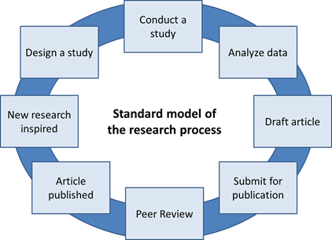
While the everyday judgments we make about human behaviour are subjective and anecdotal, researchers use the scientific method to study psychology in an objective and systematic way. It must be possible to replicate studies – to allow other researchers to repeat them using the same methodology in order to test the findings (e.g. Asch, Mori and Arai).

The scientific method involves a cyclical research process of generating ideas, conducting practical research, analysing the findings of the research and then generating new ideas.
The Research Process

Before a researcher can begin, they must choose a topic to study. Once an area of interest has been chosen, the researchers must then conduct a thorough review of the existing literature on the subject. This review will provide valuable information about what has already been learned about the topic and what questions remain to be answered.

Steps in the Research Process

- Generating a Theory
A statement is made about how a process in Psychology works.
- Forming a Hypothesis
From the theory, researchers make a prediction about the relationship between two or more variables.
- Gathering Data
Once you have a solid hypothesis, the next step of the scientific method is to put this hunch to the test by collecting data. The exact methods used to investigate a hypothesis depend on exactly what is being studied.
- Analysing Data
Once a researcher has designed the study and collected the data, it is time to examine this information and draw conclusions about what has been found. Using statistics, researchers can summarize the data, analyse the results, and draw conclusions based on this evidence.
- Publish Findings
The data and analysis are published so that other scientists can comment on them.
- Debating and Amending Theories
If the evidence does not support the theory, it may need to be changed. However, usually the findings must be replicated before anyone will accept the need to change a theory.

 Answer the following questions

- Can research studies prove a theory right or wrong?

- Define a theory

- Is it ok to criticise theories?

- What process comes after generating a hypothesis?

- What is meant by knowledge being cumulative?

The Experimental Method

Aim: to learn about the main features of the experimental method of research.

Success Criteria:
- State what is meant by an experimental condition.
- Describe the main features of the 3 types of experimental design:
  - Repeated measures design
  - Independent groups design
  - Matched participants design

Experiments are the main tool of the scientific method. The experimental method involves the manipulation of variables to establish cause and effect relationships. The key features are controlled methods and the random allocation of participants into controlled and experimental groups.

An experiment is an investigation in which a hypothesis is scientifically tested. In an experiment, an independent variable (the cause) is manipulated and the dependent variable (the effect) is measured; any extraneous variables are controlled.

An advantage is that experiments should be objective. The views and opinions of the researcher should not affect the results of a study. This is good as it makes the data more valid, and less biased.

Experimental Conditions
Every experiment involves a comparison. In order to make a comparison, there must be two or more experimental conditions – parts of the experiment that are different. For example, if you were to study the effect of background noise on revision, you would have a low noise condition and a high noise condition. The IV would be noise and the DV would be exam performance.
What extraneous variables would need to be considered?
Sometimes there is only one experimental condition, so the researchers set up a control experiment to compare the results. It establishes a baseline by measuring how things are under normal conditions.

Experimental Design
Design refers to the way in which participants are allocated to the different experimental conditions.

In a repeated measures design, participants take part in every condition. It is important to counterbalance the order in which the participants complete the conditions. If there are two conditions, half will do condition one first and half will do condition two first. Failure to counterbalance can lead to order effects where people do better/worse in later conditions due to practice/fatigue.

The main advantage of a repeated measure design is that participants scores in one condition are being compared with the same participants’ scores in another condition. This reduces the effect of participant variables, which are things that vary from one participant to the next such as ability level.

In an independent groups design, participants are divided into groups and each group completes one condition. This is used when a repeated measures design is not possible, for example, if there is an element of deception that would make the aims of the study obvious if participants did both conditions. For example, in Milgram’s shock experiment, the same participants could not have been used in more than one condition, as they would have realised the second time around that the electric shocks were fake.

For an independent groups design, there needs to be one group for every condition so the total number of participants in each group will be smaller. For example, if there are 28 participants and four conditions, only seven would take part in each condition. In a repeated measures experiment, all 28 complete every condition, producing more data.
Matched participants design is similar to the independent groups design, except that each participant is matched up with one or more other participants. The matched (similar) participants are then allocated to the separate conditions. There are many variables on which participants could be matched, for example age, sex, IQ and personality type.
Complete the following table using the statements.

Types of Experimental Design
Type | Description | Advantage | Disadvantage
Repeated measures design
Independent groups design
Matched Participants

A separate group of participants in each condition
The same participants do all conditions of an experiment
Matching pairs/groups of participants, then dividing them between conditions
Avoids order effects and controls some participant variables
No order effects – participant only does one condition
Participant variables kept to a minimum
Order effects and demand characteristics
Time consuming and not always practical to conduct
Participant variables.

For each of the following examples, state what experimental design was used.
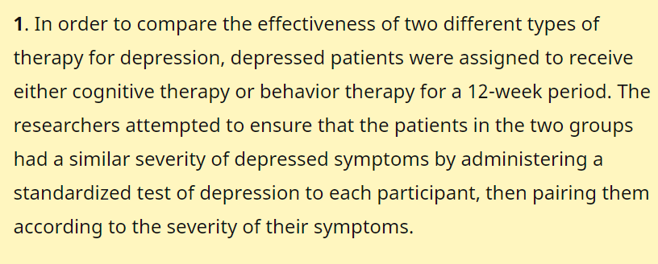
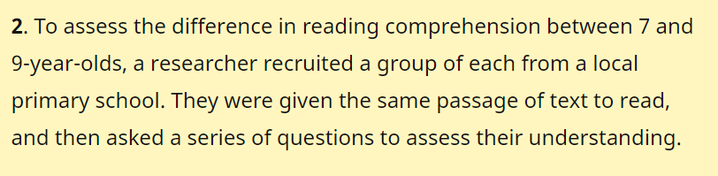
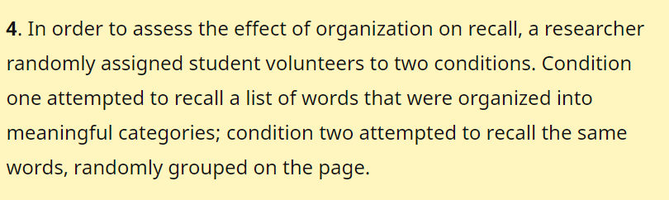
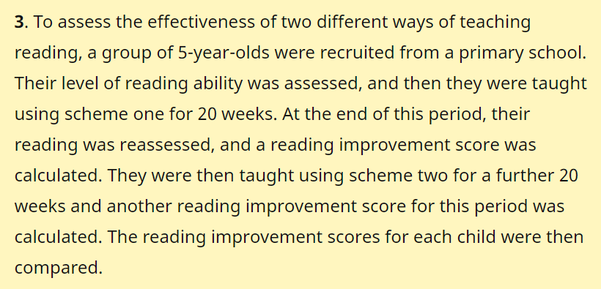

1 2

3 4
Types of Experiment

Aim: To learn about the three main types of experiment used in Psychology.

Success Criteria:
- Understand what is meant by random allocation.
- Describe the main features of a lab experiment, including advantages and disadvantages.
- Describe the main features of a field experiment, including advantages and disadvantages.
- Describe the main features of a natureal experiment, including advantages and disadvantages.
- Describe what is meant by a Quasi-experiment.

Random Allocation

Any true experiment must randomly allocate participants to conditions. In an independent groups study, the researcher allocates every participant to one of the experimental conditions randomly by tossing a coin, for example. Randomly allocating participants to independent variable conditions means that all participants should have an equal chance of taking part in each condition. The principle of random allocation is to avoid bias in the way the experiment is carried out and to limit the effects of participant variables.

Types of Experiment

There are three types of experiment you should know about:
- Lab Experiment
- Field Experiment
- Natural (naturalistic) Experiment
A laboratory experiment is an experiment conducted under highly controlled conditions (not necessarily a laboratory), where accurate measurements are possible. The researcher decides where the experiment will take place, at what time, with which participants, in what circumstances and using a standardized procedure. Participants are randomly allocated to each independent variable group. An example is Milgram’s experiment on obedience.

- Strength: It is easier to replicate (i.e. copy) a laboratory experiment. This is because a standardized procedure is used.
- Strength: They allow for precise control of extraneous and independent variables. This allows a cause and effect relationship to be established.
- Limitation: The artificiality of the setting may produce unnatural behaviour that does not reflect real life, i.e. low ecological validity. This means it would not be possible to generalize the findings to a real-life setting.
- Limitation: Demand characteristics or experimenter effects may bias the results and become confounding variables.

Field experiments are done in the everyday (i.e. real life) environment of the participants. The experimenter still manipulates the independent variable, but in a real-life setting (so cannot really control extraneous variables).

- Strength: behaviour in a field experiment is more likely to reflect real life because of its natural setting, i.e. higher ecological validity than a lab experiment.
- Strength: There is less likelihood of demand characteristics affecting the results, as participants may not know they are being studied. This occurs when the study is covert.
- Limitation: There is less control over extraneous variables that might bias the results. This makes it difficult for another researcher to replicate the study in exactly the same way.

Naturalistic experiments are conducted in the everyday (i.e. real life) environment of the participants, but here the experimenter has no control over the independent variable as it occurs naturally in real life. For example, Hodges and Tizard's attachment research (1989) compared the long-term development of children who have been adopted, fostered or returned to their mothers with a control group of children who had spent all their lives in their biological families.

- Strength: behaviour in a natural experiment is more likely to reflect real life because of its natural setting, i.e. very high ecological validity.
- Strength: Can be used in situations in which it would be ethically unacceptable to manipulate the independent variable, e.g. researching stress.
- Limitation: They may be more expensive and time consuming than lab experiments.
- Limitation: There is no control over extraneous variables that might bias the results. This makes it difficult for another researcher to replicate the study in exactly the same way.

Quasi-experiments
Quasi-experiment means partial experiment. It lacks the control of a true experiment because the IV is something that is fixed in a participant and therefore it is impossible to randomly allocate participants to experimental or control experiments. Examples include comparisons of males and females or comparisons of personality types.
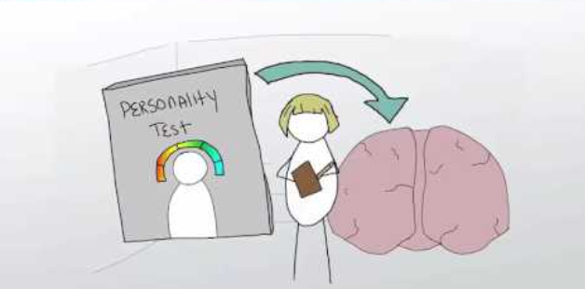

Summarize the main types of experiment, including one advantage and one disadvantage, in a mind-map.

Experimental Terminology

Aim: To become familiar with common experimental terminology used in Psychological research.

Success Criteria:

- Understand the terms, reliable, valid and hypothesis in relation to psychological research.
- Successfully complete a matching exercise summarising other experimental terminology.

Reliability and Validity

The term reliability in psychological research refers to the consistency of a research study or measuring test. If findings from research are replicated consistently, they are reliable. A correlation coefficient can be used to assess the degree of reliability. If a test is reliable it should show a high positive correlation.

Whether or not a study is valid relates to whether it is possible to draw a logical conclusion from its findings. If an experiment has high internal validity, it means it is well designed and research can draw a sound conclusion about whether the IV has had an effect on the DV or not.

The ability to generalise from a study is known as its external validity. If a study has high internal validity it could be highly artificial. If it is hard to generalise the results in the study to a real-life situation, it is said to lack ecological validity. Even in a field experiment, participants might be asked to do something quite unnatural. Experimental tasks that are not typical of everyday life are said to lack mundane realism. If the results can be generalised from the sample to the wider population, this is known as population validity.
Hypotheses

A hypothesis (plural hypotheses) is a precise, testable statement of what the researcher predicts will be the outcome of the study. This usually involves proposing a possible relationship between two variables: the independent variable (what the researcher changes) and the dependent variable (what the research measures). In research, there is a convention that the hypothesis is written in two forms, the null hypothesis, and the alternative hypothesis.

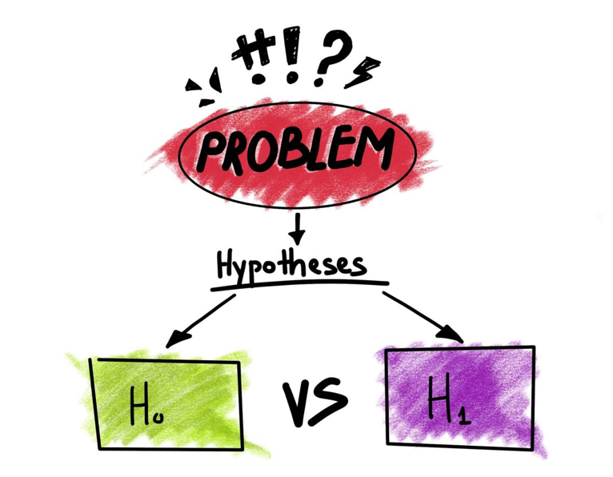
The alternative hypothesis states that there is a relationship between the two variables being studied (one variable has an effect on the other). It states that the results are not due to chance and that they are significant in terms of supporting the theory being investigated.

The null hypothesis states that there is no relationship between the two variables being studied (one variable does not affect the other). It states results are due to chance and are not significant in terms of supporting the idea being investigated.

A two-tailed non-directional hypothesis predicts that the independent variable will have an effect on the dependent variable, but the direction of the effect is not specified, e.g., there will be a difference in how many numbers are correctly recalled by children and adults.

A one-tailed directional hypothesis predicts the nature of the effect of the independent variable on the dependent variable, e.g., adults will correctly recall more words than children.

Research the following terms and match them to their definition:

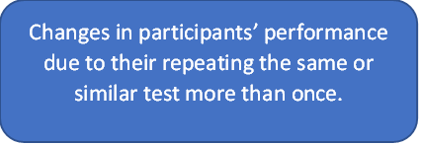
These are the ways that the experimenter can accidentally influence the participant through their appearance or behaviour.
Things that vary from one participant to the next, such as personality and ability levels.
The clues in an experiment that lead the participants to think they know what the researcher is looking for (e.g. experimenter’s body language).
Experimenter Effects
Demand Characteristics
Order Effects
Participant Variables

Answer the following questions

- Name the two variables that an experimenter manipulates and measures.

- What is the difference between a field experiment and a natural experiment?

- Name three common examples of extraneous variables.

- Give a weakness of the experimental method.

Non-experimental Methods of Research

Aim: To become familiar with the main types of non-experimental research methods.

Success Criteria:
- Describe the circumstances in which it is better to use non-experimental research methods.
- Name the main non-experimental methods.
- State the meaning of a survey.
- Describe the two main types of question used in questionnaires, giving advantages and disadvantages of both.
- Explain potential pitfall traps when creating a questionnaire.
- Describe two ways in which data can be biased

Experiments allow the researcher to have control over variables, but they can be artificial. Therefore, behaviour in an experiment may differ from real everyday behaviour.​
In other cases, it is impractical or unethical to run an experiment (e.g., investigating the effect of pollution on a person's behaviour and exposing them to pollution).
Therefore, it is beneficial to use non-experimental methods of research occasionally.​
Non-experimental methods include:
- Surveys/questionnaires
- Interviews
- Observation
- Case studies
- Correlational studies
Surveys
A survey involves handing out a list of questions (a questionnaire) to participants, usually a very large sample.​ In psychological research, the design of questionnaires needs to be especially careful to avoid misleading participants or introducing bias.​ The questions used in a survey should be carefully considered and written out in advance.​

Open-ended questions allow the participant to use their own words in their response.​
Closed questions provide a selection of answers – yes/no or a set of options. A common type of closed question is the Likert scale, where a question is followed by a numerical scale.​

Type of Question | Strengths | Weaknesses
Open ​ | Rich qualitative data is obtained as open questions allow the respondent to elaborate on their answer. This means the research can find out why a person holds a certain attitude.​ | Time-consuming to collect the data. ​  ​  Not suitable for less educated respondents as open questions require superior writing skills and a better ability to express one's feelings verbally.​
Closed​ | They provide large amounts of research data for relatively low costs. Therefore, a large sample size can be obtained which should be representative of the population, which a researcher can then generalize from.​ | They lack detail. Because the responses are fixed, there is less scope for respondents to supply answers which reflect their true feelings on a topic.​

Potential Pitfalls

Issue​ | Explanation​ | Bad Example Question​ | Improved Example​
Leading Question​ | This leads participants to pick a particular response, often by using strongly emotional language.​ | Do you think that buying a new car from a dealer is a complete waste of money?​ | Do you think that buying a new car from a dealer represents value for money?​
Loaded Question​ | This includes an unwarranted assumption, perhaps reflecting bias on the part of the researcher.​ | Do you think that all immigrants should be prevented from claiming housing benefit? (This assumes that some should be prevented so is not neutral).​ | Do you think that any immigrants should be prevented from claiming housing benefit?​
Jargon​ | A question should avoid technical terms that a participant might not understand.​ | Do you struggle to focus your attention on brief cognitive tasks?​ | Do you sometimes lose concentration after revising for 10-15 minutes?​
Vague/ambiguous Language​ | The question should be as clear and specific as possible.​ | Are some age laws of this country problematic?​ | Should the legal age for driving be raised from 17 to 18?​

Bias
Even if questions are carefully worded, it is possible that data will still be biased in some way due to:​
- Acquiescence Bias – Some participants tend to agree more than disagree, regardless of the question. It is therefore important to have a balance of postive and negative questions.​
- Social Desirability Bias – Participants may distort the truth in order to look good (remember our personality questionnaires!).​

Distribution
With a survey, the questionnaire is designed in advance and then sent to all participants.​ It helps if the questionnaire is fairly short to prevent participants giving up.​ In the past, questionnaires were distributed by post, but now it is common to use internet-based questionnaires.​




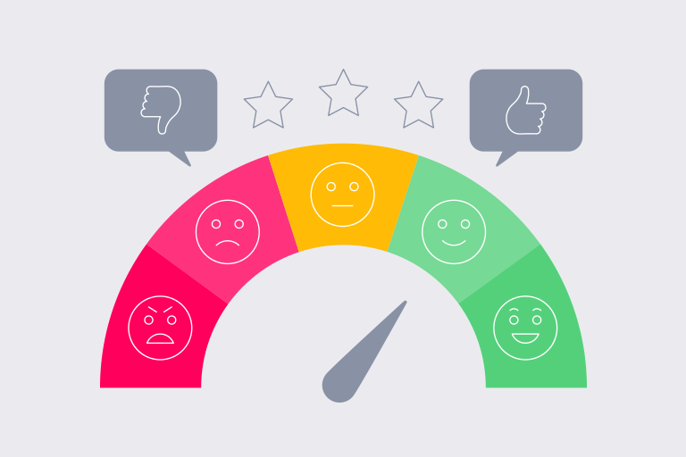
Interviews

Aim: To learn about the interview method.

Success Criteria:
- State what is meant by an interview.
- Name and describe the 3 main types of interview.
- Describe a strength and weakness of structured and unstructured interviews.

The key characteristic of the interview is that questions are asked face-to-face, making research more time consuming but, allowing misunderstandings to be clarified. Interviews are different from questionnaires as they involve social interaction. Unlike questionnaires methods, researchers need training in how to interview (which costs money).
There are 3 main types of interview:
- Structured interview
- Semi-structured interview
- Unstructured interview
A structured interview is a quantitative research method where the interviewer a set of prepared closed-ended questions in the form of an interview schedule, which he/she reads out exactly as worded. Interviews schedules have a standardized format which means the same questions are asked to each interviewee in the same order. The interviewer will not deviate from the interview schedule (except to clarify the meaning of the question) or probe beyond the answers received. Structured interviews are easy to replicate as a fixed set of closed questions are used, which are easy to quantify – this means it is easy to test for reliability. Structure interviews are not flexible. This means new questions cannot be asked impromptu (i.e. during the interview) as an interview schedule must be followed.
Unstructured interviews do not use any set questions, instead, the interviewer asks open-ended questions based on a specific research topic and will try to let the interview flow like a natural conversation. The interviewer modifies his or her questions to suit the candidate's specific experiences. Unstructured interviews are more flexible as questions can be adapted and changed depending on the respondents’ answers. The interviewer can deviate from the interview schedule. It can be time-consuming to conduct an unstructured interview and analyze the qualitative data.

The semi-structured method also uses a set list of questions but allows the interviewer some freedom to expand on these. The interviewer may ask the respondent to elaborate on some answers, prompting them with simple follow up questions, such as "Can you tell me more about...?"

The Interviewer Effect
Because an interview is a social interaction the appearance or behavior of the interviewer may influence the answers of the respondent. This is a problem as it can bias the results of the study and make them invalid. The gender, ethnicity, body language, age, and social status of the interview can all create an interviewer effect. For example, if a researcher was investigating sexism amongst males, would a female interview be more preferable than a male? It is possible that if a female interviewer was used male participants may lie (i.e. pretend they are not sexist) to impress the interviewer, thus creating an interviewer effect.
Interviews may not be the best method to use for researching sensitive topics (e.g., truancy in schools, discrimination etc.) as people may feel more comfortable completing a questionnaire in private.


Answer the following questions.

- What is a closed question?

- Give an example of an issue that needs to be avoided when writing
survey questions.

- Which type of interview mainly sticks to a list of questions but can include follow up questions.

- Why might you choose to use a structured interview instead of a
survey?

- What is social desirability bias?

Observations

Aim: To learn about the observation method

Success Criteria:
- State the meaning of observation.
- Describe the difference between naturalistic and structured observation.
- Give a strength and weakness of each observational method.
- Describe the difference between disclosed and undisclosed observation.
- State what is meant by participant observation.

Observation (watching what people do) can be used on it's own or in combination with other methods. Most experiments involve an element of observation, but a typical observation study is les controlled than an experiment and it gathers data from watching behaviour as it happens.

Naturalistic observation is a research method commonly used by psychologists and other social scientists. This technique involves observing involves studying the spontaneous behaviour of participants in natural surroundings. The researcher simply records what they see in whatever way they can.

- Strength: By being able to observe the flow of behaviour in its own setting studies have greater ecological validity.

- Weakness: Natural observations are less reliable as other variables cannot be controlled. This makes it difficult for another researcher to repeat the study in exactly the same way.

Structured observations are likely to be carried out in a laboratory. The researcher decides where the observation will take place, at what time, with which participants, in what circumstances and uses a standardized procedure. Participants are randomly allocated to each independent variable group. Rather than writing a detailed description of all behaviour observed, it is often easier to code behaviour according to a previously agreed scale using a behaviour schedule.

- Strength: Structured observations can be easily replicated by other researchers by using the same observation schedule. This means it is easy to test for reliability.

- Weakness: Structured observations can lack validity due to demand characteristics. When participants know they are being watched they may act differently.

Mary Ainsworth used a behaviour schedule to study how infants responded to brief periods of separation from their mothers. During the "Strange Situation" procedure, infant's interaction behaviours directed toward the mother were measured, e.g.

- Proximity and contacting seeking
- Contact maintaining
- Avoidance of proximity and contact
- Resistance to contact and comforting

Any observation can be disclosed (participants know they are being observed) or undisclosed (kept secret). Disclosed observation can lead to participants behaving unnaturally – this is known as the observer effect. Undisclosed observation provides more natural results but can be unethical as participants haven't consented to take part in the research.

Participant observation is a variant of the naturalistic observation but here the researcher joins in and becomes part of the group they are studying to get a deeper insight into their lives. If it were research on animals, we would now not only be studying them in their natural habitat but be living alongside them as well! This approach was used by Leon Festinger in a famous study into a religious cult who believed that the end of the world was about to occur. He joined the cult and studied how they reacted when the prophecy did not come true.

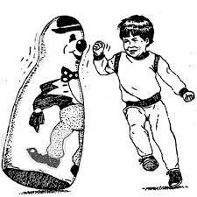
Sometimes the behaviour of participants is observed through a two-way mirror or they are secretly filmed.
This method was used by Albert Bandura to study aggression in children (the Bobo doll studies).

Naturalistic Observation Assignment
For this assignment you are to perform and write up a brief naturalistic observation. Follow the guidelines below.
- Decide what you will observe and develop a hypothesis – What do you THINK you will see during your observation. For example, ‘It is hypothesized 60% of women will look in the mirror while only 25% of men will look in the mirror while passing by.”
- Choose a setting and time for the observation. You should make a detailed record of the subject(s), gathering data which will "begin" to test your hypothesis. Plan your observational "method" to be sure you are not "discovered" (so that the "naturalistic" quality of the observation is not lost).
- Write a one page typed (12 pt. font, double spaced) report of your observations. Try to be as objective as possible, but feel free to make well-reasoned inferences about what you have seen.

Your report should include the following:
- An introduction which tells what the observation is about, including your hypothesis.
- A detailed account of the subject(s) and of the behaviours you observed is needed (Data either in the form of percentages or raw numbers is needed).
- A discussion of any conclusions you can draw from the observation should be included.
Possible ideas (but please BE CREATIVE!)
- Observe people while out on a walk, how many are on their phone?
- How many people driving are on a cell phone?
- How many people go through a yellow light?
- Observe the body language of others in your house when they are working compared to when they are relaxing.
- Observe a particular ‘social group’. What similarities do they show? What differences do they show?
- How many people in a shop/walking in the street are wearing a mask?
- How many people return their shopping carts to the cart area?
- How long do people in your house work for, on average, before taking a break?

REMEMBER – YOU ARE NOT TO SPY ON ANYONE! THERE IS A DIFFERENCE. YOU MAY ONLY WATCH PEOPLE IN PUBLIC PLACES. DO NOT LET THEM KNOW YOU ARE WATCHING THEM… ALL YOU DO IS OBSERVE & TAKE NOTE.
Case Studies

Aim: To learn about the case study method.

Success Criteria:
- State what is meant by a case study.
- Give an example of a well-known case study.
- Describe the circumstances under which a case study might be used.
- Give a strength and a weakness of the case study method.

Case studies are in-depth investigations of a single person, group, event or community. Typically, data are gathered from a variety of sources and by using several different methods e.g., interviews and observations. A case study is generally longitudinal, that is, it follows the individual or group over an extended period of time.

Case studies are done for various reasons. Some of the most well-known case studies in psychology are of individuals with unique psychological problems. They are widely used in psychology and amongst the best known were the ones carried out by Sigmund Freud, including Anna O and Little Hans. Freud conducted very detailed investigations into the private lives of his patients in an attempt to understand and help them overcome their illnesses. Even today case studies are one of the main methods of investigation in abnormal psychology and psychiatry. This method should only be used by a psychologist, therapist or psychiatrist, i.e., someone with a professional qualification.

Case studies are an extremely useful, sometimes essential tool for studying unique cases (such as rare brain damage) that would be unethical to cause deliberately. They provide detailed (rich qualitative) information and provide insight for further research.

Weaknesses on this method include:

- Lacking in scientific rigour and providing little basis for generalization of results to the wider population.
- Researchers' own subjective feeling may influence the case study (researcher bias).
- Difficult to replicate.
- Time-consuming and expensive.

Answer the following questions.

- Which type of observation involves watching participants in their everyday environment?

- Being observed causes behaviour to change. What is this effect called?

- Give three characteristics of the case-study method.

- What techniques are used to gather data in a case study?

- Give a strength that is always true of observation.

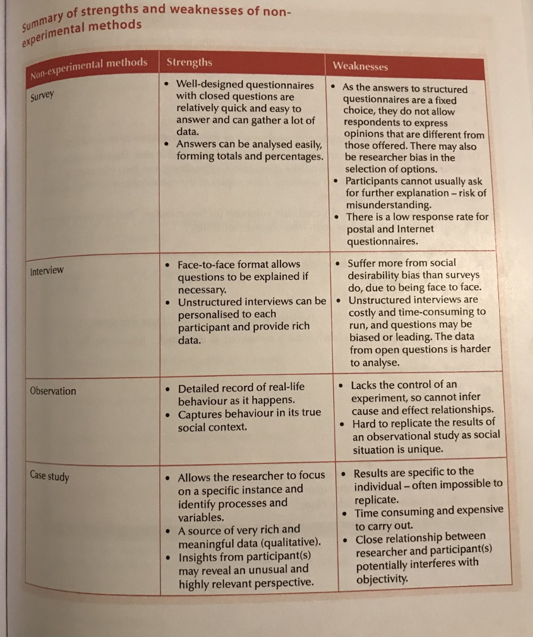
Read the following table and use it to create some Quizlet flashcards.

Correlational Studies – Literacy Task
Read the following article and answer the questions:
https://www.verywellmind.com/correlational-research-2795774

A correlation refers to a relationship between two variables. Correlations can be strong or weak and positive or negative. Sometimes, there is no correlation.
There are three possible outcomes of a correlation study: a positive correlation, a negative correlation, or no correlation. Researchers can present the results using a numerical value called the correlation coefficient.
Positive correlations: Both variables increase or decrease at the same time. A correlation coefficient close to +1.00 indicates a strong positive correlation.
Negative correlations: As the amount of one variable increases, the other decreases (and vice versa). A correlation coefficient close to -1.00 indicates a strong negative correlation.
No correlation: There is no relationship between the two variables. A correlation coefficient of 0 indicates no correlation.

What Is a Correlation Coefficient?
The correlation coefficient is a measure of the correlation strength. It can range from –1.00 (negative) to +1.00 (positive). A correlation coefficient of 0 indicates no correlation.

How Correlational Studies Work
Correlational studies are a type of research often used in psychology, as well as other fields like medicine. Correlational research is a preliminary way to gather information about a topic. The method is also useful if researchers are unable to perform an experiment.

Researchers use correlations to see if a relationship between two or more variables exists, but the variables themselves are not under the control of the researchers. While correlational research can demonstrate a relationship between variables, it cannot prove that changing one variable will change another. In other words, correlational studies cannot prove cause-and-effect relationships.
Types of Correlational Research
There are three types of correlational research: naturalistic observation, the survey method, and archival research. Each type has its own purpose, as well as its pros and cons.
Naturalistic Observation
The naturalistic observation method involves observing and recording variables of interest in a natural setting without interference or manipulation.1
Advantages
- Can inspire ideas for further research
- Option if lab experiment not available
- View variables in natural setting

Disadvantages
- Can be time-consuming and expensive
- Extraneous variables can't be controlled
- No scientific control of variables
- Subjects might behave differently if aware of being observed

This method is well-suited to studies where researchers want to see how variables behave in their natural setting or state. Inspiration can then be drawn from the observations to inform future avenues of research. In some cases, it might be the only method available to researchers; for example, if lab experimentation would be precluded by access, resources, or ethics. It might be preferable to not being able to conduct research at all, but the method can be costly and usually takes a lot of time. Naturalistic observation presents several challenges for researchers. For one, it does not allow them to control or influence the variables in any way nor can they change any possible external variables. However, this does not mean that researchers will get reliable data from watching the variables, or that the information they gather will be free from bias. For example, study subjects might act differently if they know that they are being watched. The researchers might not be aware that the behaviour that they are observing is not necessarily the subject's natural state (i.e., how they would act if they did not know they were being watched). Researchers also need to be aware of their biases, which can affect the observation and interpretation of a subject's behaviour.﻿

The Survey Method
Surveys and questionnaires are some of the most common methods used for psychological research. The survey method involves having a random sample of participants complete a survey, test, or questionnaire related to the variables of interest.1﻿ Random sampling is vital to the generalizability of a survey's results.

Advantages
- Cheap, easy, and fast
- Can collect large amounts of data in a short amount of time
- Flexible

Disadvantages
- Results can be affected by poor survey questions
- Results can be affected by unrepresentative sample
- Outcomes can be affected by participants

If researchers need to gather a large amount of data in a short period of time, a survey is likely to be the fastest, easiest, and cheapest option. It's also a flexible method because it lets researchers create data-gathering tools that will help ensure they get the information they need (survey responses) from all the sources they want to use (a random sample of participants taking the survey). Survey data might be cost-efficient and easy to get, but it has its downsides. For one, the data is not always reliable—particularly if the survey questions are poorly written or the overall design or delivery is weak. Data is also affected by specific faults, such as unrepresented or underrepresented samples. The use of surveys relies on participants to provide useful data. Researchers need to be aware of the specific factors related to the people taking the survey that will affect its outcome. For example, some people might struggle to understand the questions. A person might answer a particular way to try to please the researchers or to try to control how the researchers perceive them (such as trying to make themselves "look better"). Sometimes, respondents might not even realize that their answers are incorrect or misleading because of mistaken memories.

Archival Research
Many areas of psychological research benefit from analyzing studies that were conducted long ago by other researchers, as well as reviewing historical records and case studies. For example, in an experiment known as "The Irritable Heart," researchers used digitalized records containing information on American Civil War veterans to learn more about post-traumatic stress disorder (PTSD).

Advantages
- Large amount of data
- Can be less expensive
- Researchers cannot change participant behaviour

Disadvantages
- Can be unreliable
- Information might be missing
- No control over data collection methods

Using records, databases, and libraries that are publicly accessible or accessible through their institution can help researchers who might not have a lot of money to support their research efforts. Free and low-cost resources are available to researchers at all levels through academic institutions, museums, and data repositories around the world. Another potential benefit is that these sources often provide an enormous amount of data that was collected over a very long period of time, which can give researchers a way to view trends, relationships, and outcomes related to their research. While the inability to change variables can be a disadvantage of some methods, it can be a benefit of archival research. That said, using historical records or information that was collected a long time ago also presents challenges. For one, important information might be missing or incomplete and some aspects of older studies might not be useful to researchers in a modern context. A primary issue with archival research is reliability. When reviewing old research, little information might be available about who conducted the research, how a study was designed, who participated in the research, as well as how data was collected and interpreted. Researchers can also be presented with ethical quandaries—for example, should modern researchers use data from studies that were conducted unethically or with questionable ethics?
Limitations of Correlational Studies
You've probably heard the phrase, "correlation does not equal causation." This means that while correlational research can suggest that there is a relationship between two variables, it cannot prove that one variable will change another. For example, researchers might perform a correlational study that suggests there is a relationship between academic success and a person's self-esteem. However, the study cannot show that academic success changes a person's self-esteem. To determine why the relationship exists, researchers would need to consider and experiment with other variables, such as the subject's social relationships, cognitive abilities, personality, and socioeconomic status.
Answer the following questions.

- What is a correlation?

- Complete a table summarising the 3 possible outcomes of a correlational study and what they mean.

- What term is used to describe a measure of the correlation strength. It can range from –1.00 (negative) to +1.00 (positive). A correlation coefficient of 0 indicates no correlation.

- Under what circumstances might a naturalistic observation be the best method?

- Name one advantage of a naturalistic observation.

- Name one disadvantage of a naturalistic observation.

- Name an advantage of the survey method.

- Name a disadvantage of the survey method.

- Describe an example of archival research.

- Describe a limitation of correlational studies.

Sampling

Aim: To become familiar with methods of sampling in psychological research.
Success Criteria:
- State the meaning of the terms sample, population and target population.
- Describe what makes a good sample.
- Describe and evaluate various types of sampling methods used in psychological research.

The people that a psychology researcher studies are collectively known as a sample. They are drawn from a larger group known as a population. The population that a particular study is interested in is called the target population.
Sampling means selecting people to take part in your research. A good sample should be:
- Unbiased
- Representative of the population as a whole
- Large
Generalisability refers to the extent to which we can apply the findings of our research to the target population we are interested in. If you wanted to conduct research on elderly people in the UK and selected a sample of your grandmother's friends. Your grandmother's friends might be very well-educated and all from Fife so it would be hard to generalise the findings.
Sampling methods include:
- Opportunity Sampling
- Random Sampling
- Self-selection
- Systematic
- Stratified Sampling
- Quota Sampling

Opportunity Sampling uses people from target population available at the time and willing to take part. It is based on convenience. An opportunity sample is obtained by asking members of the population of interest if they would take part in your research. An example would be selecting a sample of students from those coming out of the library. This is a quick way and easy of choosing participants but it may not provide a representative sample, and could be biased (researchers may be unconsciously biased when choosing who to ask).

In Random Sampling, everyone in the entire target population has an equal chance of being selected. This is similar to the national lottery. If the “population” is everyone who has bought a lottery ticket, then each person has an equal chance of winning the lottery (assuming they all have one ticket each). Random samples require a way of naming or numbering the target population and then using some type of raffle method to choose those to make up the sample. This is the best method of selecting your sample from the population of interest. The sample should represent the target population and eliminate sampling bias, however, it is very difficult to achieve (i.e. time, effort and money).
A self-selecting (volunteer sample) means that participants come forward of their own choice, responding to an advert or email request for participants (e.g. Milgram's Obedience study).
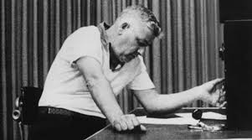
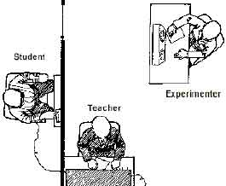

The key defining feature is that they come to you, rather than you selecting them. This is a simple way to get a large number of participants and since people want to take part, making it ethically sound.
However, people who come forward may not be representative of the population, for example, being more pro-social. The placement of the sign/advert asking for volunteers may lead to bias.
Systematic sampling involves picking people from fixed intervals from a list of the whole population. For example if you select every 20th person from the school register of 237 pupils, you would have a systematic sample of 11 participants in total. This eliminates researcher bias and is generally a representative sample, but the list may be incomplete and it has some of the same drawbacks as opportunity sampling.
Researcher bias - sometimes, unintentionally researchers distort results through their actions

In Stratified Sampling, the researcher identifies the different types of people that make up the target population and works out the proportions needed for the sample to be representative. In a study looking at how much money spent on books by undergraduates, then the main subject studied may be an important variable (e.g. English literature vs mathematics). The relative percentage of each group at a university e.g. Engineering 10%, Social Sciences 15%, English 20%, Sciences 25%, Languages 10%, Law 5%, Medicine 15% The sample must then contain all these groups in the same proportion as in the target population (university students). The disadvantage of stratified sampling is that gathering such a sample would be extremely time consuming and difficult to do. This method is rarely used in Psychology. However, the advantage is that the sample should be highly representative of the target population and therefore we can generalize from the results obtained.


A quota sample is similar to a stratified sample, but here, the researchers specify numbers of participants from the key groups/categories and then fill these "quotas". This helps to ensure representation of minority groups. Unlike, stratified sampling, the researchers do not try to keep the proportions of each group the same as those in the population. Quota sampling helps to ensure small minority groups are represented within a sample. It does not, however, always result in a representative sample as proportions of small groups are distorted. It must also be combined with another method, and therefore suffers the drawbacks of the other method.

Answer the following questions.

- What is meant by a sample in psychological research?

- Which is bigger – the target population or the sample?

- How large should a sample be?

- Why is it important for a sample to be representative?

- Which method of sampling is least likely to produce a biased sample?

- Is a random sample always representative of the target population?

- State three features of a good sample.

- Why is random sampling often considered the best sampling method?

- Why is quota sampling not a complete method of sampling?

- Which method of sampling is better at ensuring that the size of groups within the sample are proportionate to the size of the groups within the target population?

Summarise methods of sampling in psychology
(e.g. mind-map, Quizlet)
Ethics

LI: To become familiar with the ethical codes of conduct in research.
Success Criteria:
- Become familiar with the British Psychological Society's Code of Ethics and Conduct.
- Describe ethical considerations that must take place in psychological research including:
Consent Deception
Withdrawal Confidentiality
Protection Debriefing

Ethics refers to the correct rules of conduct necessary when carrying out research.
Psychologists carry out research on people so must follow a set of principles known as a code of ethics that states what is and is not acceptable in research. This is known as The British Psychological Society - Code of Ethics and Conduct

Answer the following questions:
- What four ethical principles is the code based on?
- Name something psychologists should consider when applying the values of respect.
- Name something psychologists should consider when applying the values of competence.
- Name something psychologists should consider when applying the values of responsibility.
- Name something psychologists should consider when applying the values of integrity.

Consent
At the start of the study, participants should agree to be part of the research. People should be in full knowledge of what they are agreeing to do and how long it will take. This is known as informed consent. Getting informed consent does not mean that participants need to be told the aims or hypothesis of the study, but they do need to be told what they will have to do.
Deception
Deception is where participants have been deliberately misled about the nature of a research task. Deception is unethical, and cases where it has been used are controversial. Sometimes it is not possible to get informed consent without revealing the aims and distorting the results. Researchers must therefore use an element of deception. BPS guidelines recognise this and state that it is acceptable only when there is no other alternative and participants must be given as much information as early as possible.
Withdrawal
Participants have the right to withdraw from any study at any time if they feel unhappy or uncomfortable or simply change their mind. They may also retrospectively withdraw consent when the study is over, in which case their data must be deleted/destroyed.
Protection
Arguably, the most important rule of research ethics is to avoid harm. Harm can happen accidentally (e.g. falling off a chair) but the risk of physical or psychological harm should be no greater than in everyday life. Closely related to the risk of harm is that participants should not be exposed to degrading or humiliating treatment.
Confidentiality
Maintaining confidentiality means data should be kept secure, and when results are published, no names or identifying information should be included. In some cases, initials are used (e.g. When Kennedy et al. were researching the effect of a damaged amygdala on personal space, they used the patient's initials "S.M").

Debriefing
After the study has taken place, all relevant aspects must be explained to the participants including the aims. Debriefing people afterwards does not excuse or justify unethical research. Participants are typically provided with the researcher's contact details should they wish to withdraw their consent later or to find out the conclusions of the study. The aim of the debriefing is not just to provide information, but to help the participant leave the situation in a similar frame of mind as when he/she entered it.

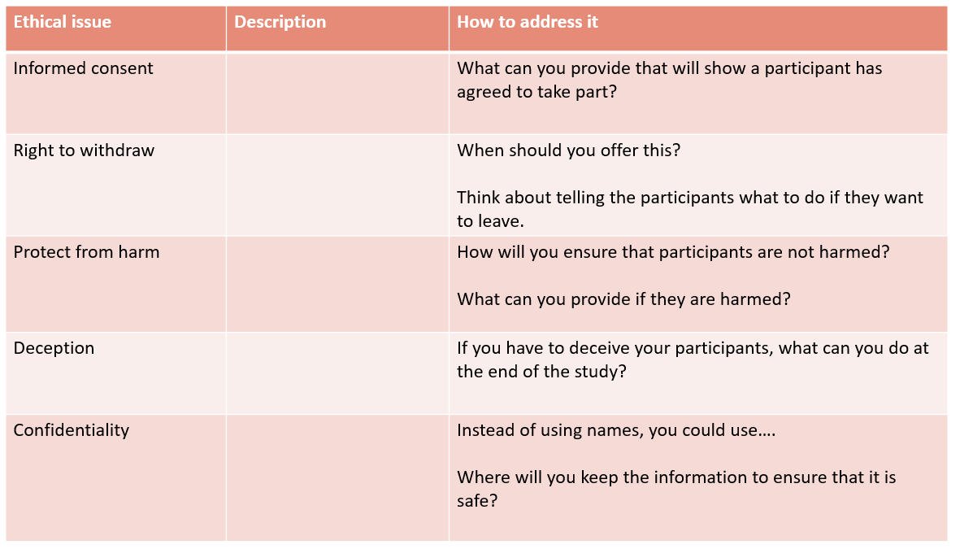

Unethical Studies
Read the following controversial studies and complete the table at the end.

Study 1 – The Monster Study (1939)
The Monster Study was a stuttering experiment on 22 orphan children in Davenport, USA, conducted by Wendell Johnson at the University of Iowa. Johnson chose one of his graduate students, Mary Tudor, to conduct the experiment and he supervised her research. After placing the children in control and experimental groups, Tudor gave positive speech therapy to half of the children, praising the fluency of their speech, and negative speech therapy to the other half, belittling the children for every speech imperfection and telling them they were stutterers. Many of the normal speaking orphan children who received negative therapy in the experiment suffered negative psychological effects and some retained speech problems during the course of their life. Dubbed “The Monster Study” by some of Johnson’s peers who were horrified that he would experiment on orphan children to prove a theory, the experiment was kept hidden for fear Johnson’s reputation would be tarnished in the wake of human experiments conducted by the Nazis during World War II. The University of Iowa publicly apologized for the Monster Study in 2001.
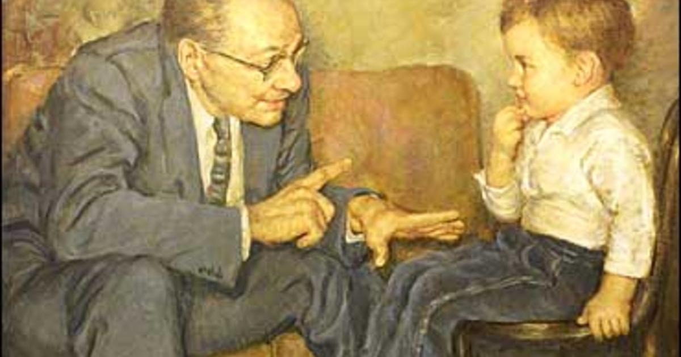
Study 2 - Monkey Drug Trials (1969)
While animal experimentation can be incredibly helpful in understanding man, and developing life-saving drugs, there have been experiments which go well beyond the realms of ethics. The monkey drug trials of 1969 were one such case. In this experiment, a large group of monkeys and rats were trained to inject themselves with an assortment of drugs, including morphine, alcohol, codeine, cocaine, and amphetamines. Once the animals were capable of self-injecting, they were left to their own devices with a large supply of each drug. The animals were so disturbed (as one would expect) that some tried so hard to escape that they broke their arms in the process. The monkeys taking cocaine suffered convulsions and, in some cases, tore off their own fingers (possible as a consequence of hallucinations), one monkey taking amphetamines tore all the fur from his arm and abdomen, and in the case of cocaine and morphine combined, death would occur within 2 weeks. The point of the experiment was simply to understand the effects of addiction and drug use; a point which, I think, most rational and ethical people would know did not require such horrendous treatment of animals.


Study 3 – The Stanford Prison Experiment (1971)

Famed psychologist Philip Zimbardo led this experiment to examine that behaviour of individuals when placed into roles of either prisoner or guard and the norms these individuals were expected to display. Prisoners were put into a situation purposely meant to cause disorientation, degradation, and depersonalization. Guards were not given any specific directions or training on how to carry out their roles. Though at first, the students were unsure of how to carry out their roles, eventually they had no problem. The second day of the experiment invited a rebellion by the prisoners, which brought a severe response from the guards. Things only went downhill from there. Guards implemented a privilege system meant to break solidarity between prisoners and create distrust between them. The guards became paranoid about the prisoners, believing they were out to get them. This caused the privilege system to be controlled in every aspect, even in the prisoners’ bodily functions. Prisoners began to experience emotional disturbances, depression, and learned helplessness. During this time, prisoners were visited by a prison chaplain. They identified themselves as numbers rather than their names, and when asked how they planned to leave the prison, prisoners were confused. They had completely assimilated into their roles. Dr Zimbardo ended the experiment after five days, when he realized just how real the prison had become to the subjects.
Though the experiment lasted only a short time, the results are very telling. How quickly someone can abuse their control when put into the right circumstances.
Study 4 - Little Albert (1920)
Albert John Watson was a psychologist who often used orphans in his experiments. Watson wanted to test the idea of whether fear was innate or a conditioned response. Little Albert, the nickname given to the nine-month-old infant that Watson chose from a hospital, was exposed to a white rabbit, a white rat, a monkey, masks with and without hair, cotton wool, burning newspaper, and a miscellanea of other things for two months without any sort of conditioning. Then experiment began by placing Albert on a mattress in the middle of a room. A white laboratory rat was placed near Albert and he was allowed to play with it. At this point, the child showed no fear of the rat. Then Watson would make a loud sound behind Albert’s back by striking a suspended steel bar with a hammer when the baby touched the rat. In these occasions, Little Albert cried and showed fear as he heard the noise. After this was done several times, Albert became very distressed when the rat was displayed. Albert had associated the white rat with the loud noise and was producing the fearful or emotional response of crying. Little Albert started to generalize his fear response to anything fluffy or white (or both). The most unfortunate part of this experiment is that Little Albert was not desensitized to his fear. He left the hospital before Watson could do so.
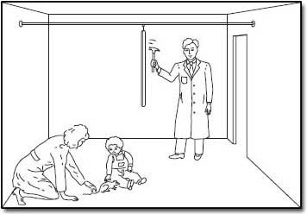
Study | Why it was unethical? | Should it have taken place? Why/why not?
The Monster Study
Monkey Drug Trials
The Stanford Prison Experiment
Little Albert

Exam Style Question
The Local Authority education department has recently commissioned you to find out if having mobile phones on in the classroom has an effect on pupils’ performance in problem-solving tasks. You decide to do this by carrying out a laboratory experiment with 100 participants who have been randomly selected from 6 local high schools.

Describe how you would implement ethical guidelines to ensure participants within this study are protected from harm (5 marks).

Essay

Write a short essay on what ethics mean to you. What ethical considerations are important in your life as a teenager/high school pupil? Have you ever seen someone acting unethically? How did it make you feel? How did you respond? What kind of things affect our own personal moral standards?

Statistics

Aim: To understand the importance of statistics in Psychology

Success Criteria:
- Develop knowledge and understanding of the use of descriptive statistics and demonstrate an ability to calculate mean, median and mode.
- Discuss merits and disadvantages of mean, median and mode.

Statistics…really?
Yes! Statistics courses are a major part of virtually all psychology programs, particularly those that involve experimental design or research methods.
To succeed in psychology, you not only need to be able to pass a statistics class. You need to be able to understand statistics, too.
Statistics allow us to make sense of and interpret a great deal of information.
In psychology, we are also confronted with enormous amounts of data. How do changes in one variable impact other variables? Is there a way we can measure that relationship? What is the overall strength of that relationship and what does that mean? Statistics allow us to answer these kinds of questions.

Statistics allow psychologists to:
- Organise data: Visual displays such as graphs, pie charts, frequency distributions and scatterplots allow researchers to get a better overview of data and look for patterns they might otherwise miss.
- Describe data: Descriptive statistics provide a way to summarize facts, such as how many men and women there are, how many children there are, or how many people are currently employed.
- Make inferences based on data: Psychologists use the data they have collected to test a hypothesis. Using statistical analysis, researchers can determine the likelihood that a hypothesis should be either accepted or rejected.

Research aims to produce good quality, valid data. Data analysis is a key part of the research process and a useful transferrable skill to learn. Data analysis builds on basic concepts that you will have come across in some of your other subjects.
Some types of studies, such as unstructured interviews, produce QUALITATIVE DATA. These are non-numerical data, especially verbal data such as descriptions. Images and videos made during an observation are also qualitative. Other studies (in particular, experiments) produce QUANTITATIVE DATA based on numbers. The data can be analysed or displayed in graphs.


Graphs are used to present results and to perform a basic visual analysis. Interpreting and constructing graphs are essential skills for your assignment.

Common graphs include:
- Bar graphs
- Histograms
- Pie Charts

A typical correlation study in psychology uses a non-experimental source such as a survey to obtain numerical data on two variables (e.g. IQ and extraversion). The researcher then uses a statistical technique to find if there is a relationship between the variables.

The relationship can be:
- Strong (closely connected) or weak
- Positive (rise and fall together) or negative (move in opposite directions).

The strength is shown between 1 and 0. The closer the number is to 1, the stronger the correlation. Negative correlations are shown between 0 and –1.

Percentages help to standardise scores, making them easier to compare. They can be calculated by dividing the score by the maximum and multiplying by 100. If participants had completed two tests, one out of 80 and one out of 65, it can be hard to compare the results. Is 49/80 better than 38/65? It is easier to compare 61.2% against 58.5% showing, the first score is superior.
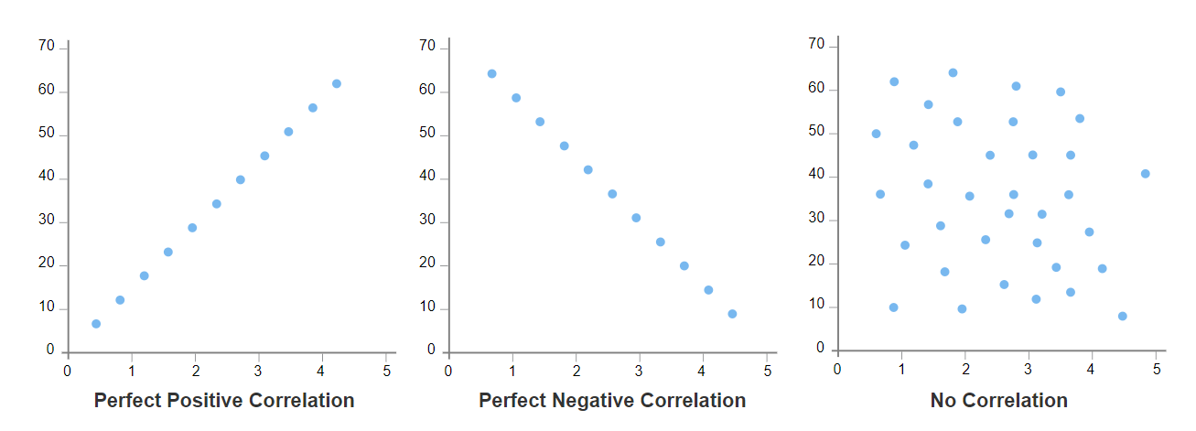
A scattergram is used to display correlations. For example, "the study suggests there is strongly positive relationship between the number of hours of sleep a student gets and their grade average".
Descriptive Statistics
These are ways of calculating numbers that describe the data in some way – that is, summarise a set of data in a single number. The most obvious example is to calculate an average.
People use the term average in everyday speech but there are three main ways of showing the average or most typical value of a set of data.
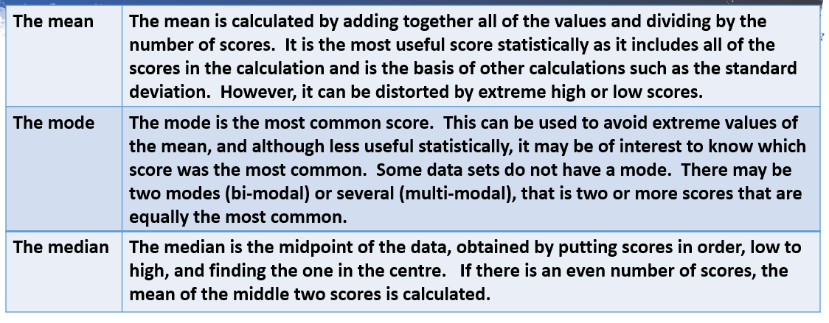
Dispersion

The mean, mode and median are useful statistics but having the average along gives us no indication of whether scores are generally too close or far away from this midpoint.

Dispersion means how widely data are spread out and it is calculated using a different set of descriptive statistics.

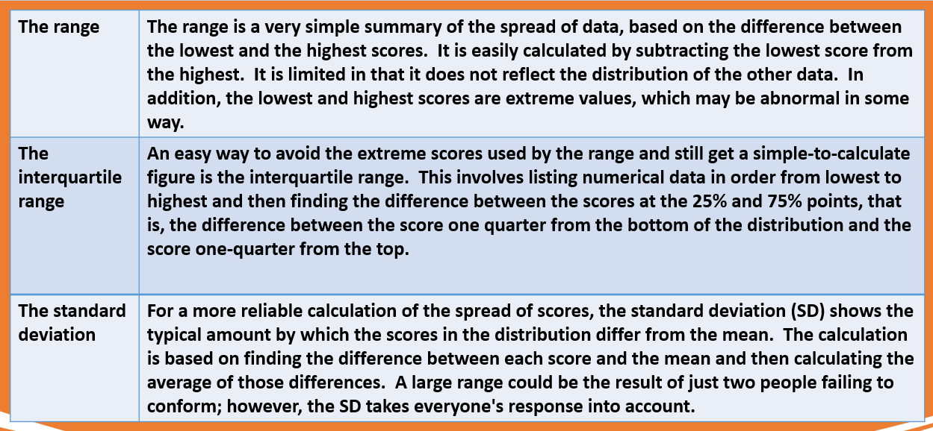

Now you are ready to embark on your Assignment!



