Sleep Disorders

“Laugh and the world laughs with you, snore and you sleep alone.”

List those products you know that help or hinder sleep.

Březinová (1974) investigated the effect of caffeine on whole night sleep using electrophysiological means in older men. After caffeine the mean total sleep time decreased on average by 2 hrs. The number of awakenings increased and the mean total intervening wakefulness was more than doubled after caffeine. In the first 3 hr cycle of sleep the men had less stages 3 and 4 and more stage 2 sleep patterns but no significant change in the amount of rapid eye movement sleep. These changes suggest caffeine stops deeper sleep so keeps you awake. Drake et al (2013) showed that drinking coffee three or six hours before sleep can reduce sleep time by an hour though participants did not always notice this loss.

What effect might drinking coffee have if it stops deep sleep?

While alcohol is well known to speed the onset of sleep, it disrupts sleep in the second half of the night as the body begins to metabolize the alcohol, causing arousal.

In both animals and humans a number of drugs reduce rapid eye movement (REM) sleep. Two classes of common antidepressants have been found to be particularly potent in reducing REM sleep. Baxter & Gluckman (1969) showed that Iprindole, from a different class of antidepressant drugs, did not block REM sleep.

Based on what you know of REM, why might the common anti-depressants be an issue for a patient, and Iprindole be a better prescription?
Insomnia
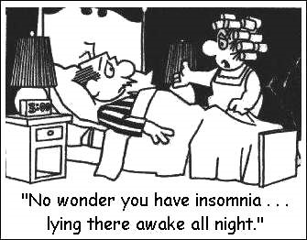
1 in 10 adults may have persistent insomnia affecting 3 or more nights in 7 for more than 3 months. Typical insomniacs remains active right up to bedtime involved with tasks of the day like work, dinner and email. They often have lights on in the room in which they sleep. Insomnia can also be due to natural and artificial influences such as the hot flushes of menopause, medication, caffeine and worry. Insomnia can lead to daytime fatigue and impaired performance.

How would stress affect sleep and sleep affect stress?

Shift work and jet lag - Circadian-phase misalignment
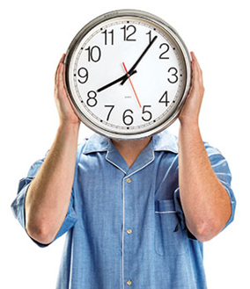
Those who perform shift-work or travel frequently are also subject to having their natural circadian rhythms disrupted. The SCN falls out of line with the zeitgebers and so your body activity cycle is out of phase with the environment. Phase delay moves with the clock or East to West when travelling and has limited effect. Phase advance goes back against the clock and leads to disorientation, stress, insomnia, reduced attention and co-ordination and may be a cause of accidents.

How would you treat: a) phase delay, and b) phase advance?

On arrival in or return from the USA, try sleeping for three hours (why 3 hrs?) and then get up and remain active until your normal bedtime. This will help re-entrain your SCN with the external zeitgebers. Melatonin tablets can be used to remedy jet lag showing that neurochemicals affect sleeping behaviour. Natural remedies like lavender might facilitate sleeping. Avoid caffeine and alcohol. Organisations should put their workers on shift with phase delay moving night to day to evening as this is easier for the body to adapt to than phase advance. Rest time after a set of night shifts should be at least 24 hours off.

Misalignment of the circadian phase and sleep deprivation are the principal factors contributing to the decrements in performance and increased accident rates associated with night-shift work. Circadian-phase misalignment, sleep deprivation or both may add to health problems such as digestive, cardiovascular and sleep disorders that are associated with night-time work. Light as a zeitgeber will affect sleep. The ability to induce adaptation to a bright-dark regimen could have important consequences for the health of night workers.

How can this be used to help support well-being?

Name: Czeisler et al (1990) Key Research!
Aim: to identify the conditions that ensure rapid entraining of the circadian pacemaker (SCN)
Method: a lab experiment in which eight young healthy males were subjected to night-shift work conditions. The control tests were under ordinary room light at night (150 lux) and daylight in transit to home where they slept. Those in the treatment were exposed to bright light at night (around 10,000 lux) and blacked-out dark conditions on return home to sleep during the day. Physiological and behavioural assessments were made across 7 days.
Results: men under the treatments were sleepier during the day and slept 7.7 hrs compared to controls of 5.7 hrs. Alertness and performance indices improved during the night shift for the bright-dark treatment.
Conclusion: The controls failed to adapt to an inversion of the daily routine even after a week. However the bright-dark regimen induced a complete adaptation to night work. So the circadian pacemaker (SCN) can be shifted using bright-dark conditions.
Meaning: The ability to adjust the circadian phase and improve the sleep of night-shift workers could have important implications for both industrial productivity and safety.

Critique:
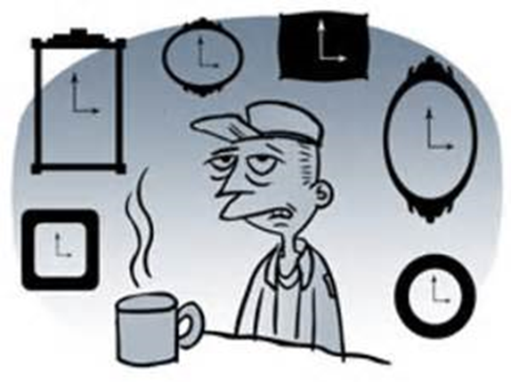
+ good control of conditions in a lab experiment when most prior research has been field experiment.
+ multiple physiological and behavioural assessments were used to provide robust findings that were in agreement
- a very small sample that does not generalise to the whole working population.

Sleep apnoea a = not pnoea = breathing

Sleep apnoea is the inability to breathe during sleep commonly caused by obesity, enlarged tonsils or throat and middle ear infections. Without breathing, carbon dioxide levels in the blood increase. This triggers the brain to wake up and breathe again, so the individual has regularly interrupted sleep. Obstructive Sleep Apnoea (OSA) is more common and related to snoring. Central Apnoea is an inherited CNS problem. Whilst treatable in adults, sleep apnoea is a possible cause of Sudden Infant Death Syndrome (Cot Death). Breathing and pulse functions are now included with EEG measurement in standard polysomnography.

Treatment includes beneficial lifestyle changes such as:
- losing weight, quitting smoking and limiting your alcohol consumption
- avoiding sedative medications and sleeping tablets
- sleeping on your side rather than on your back

Continuous positive airway pressure (CPAP)

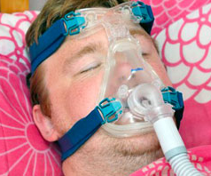
People with moderate to severe OSA will usually need to use a CPAP device, a small pump that delivers a continuous supply of compressed air to you through a mask. The compressed air prevents your throat closing. CPAP can feel peculiar to start with and you may be tempted to stop using it. But people usually get used to it and their symptoms improve significantly. It is the most effective therapy for treating severe cases of OSA.

Mandibular advancement device (MAD)
An MAD is a dental appliance, similar to a gum shield, sometimes used to treat mild OSA. It is designed to hold your jaw and tongue forward to increase the space at the back of your throat and reduce the narrowing of your airway that causes snoring.

Sleep Hygiene Improving your Well-Being
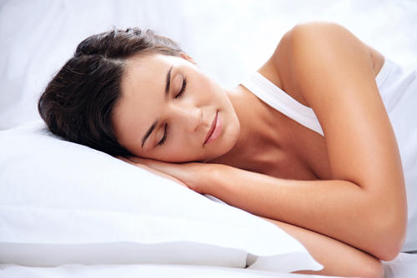
Ever had trouble sleeping? Keep on waking during the night? Feel tired during the day? These sleep disturbances are signs of poor sleep hygiene. Sleep hygiene is the control of all behavioural and environmental factors that precede sleep, and may interfere with sleep. Maintaining good sleep hygiene attempts to ensure more restful, effective sleep which can promote daytime alertness and help treat or avoid certain kinds of sleep disorders and maintain your sense of health and well-being.

The most important sleep hygiene measure is to maintain a regular sleep and wake pattern seven days a week to get enough sleep not too little, or too much. Consider this advice:
- Avoid napping during the day and lie-ins at the weekend
- Avoid large meals and stimulants too close to bedtime
- Moderate exercise can promote good sleep
- Ensure adequate exposure to natural day light
- Establish a regular relaxing bedtime routine to wind down
- Associate your bed with sleep not iPad, mobile, computer etc.
- Make sure that the sleep environment is pleasant and relaxing

What sleep hygiene advice might you recommend to your friend?
Which piece of sleep hygiene advice might be best for you?

http://www.bbc.co.uk/schoolreport/26537419

