Higher Morality and Relationships
Langholm Academy
Part One – Relationships
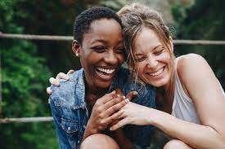
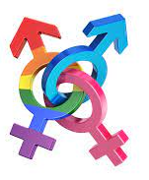
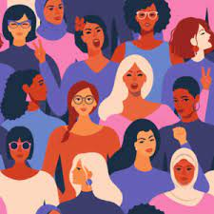
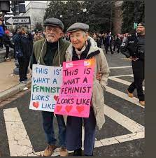
Introduction to Morality and Relationships Course
Throughout this unit, we will be looking at moral issues that arise from Morality and Relationships and how religious and non-religious people respond to them. For the majority of the course, we will focus on Christianity as the religious response and Humanism as the non-religious response, but there will be a few acceptations.
Religious Response - Christianity
At first, all Christians belonged to one organisation, one Christian Church. Two thousand years after the death of Jesus Christ, three main branches have developed and from these branches several thousand groups or denominations have sprouted. Each branch and denomination have slightly different beliefs and practices. All share the same root beliefs: the belief in the Holy Trinity; the belief that Jesus was the son of God; the belief in the resurrection. Their similarities are greater than their differences. Those three branches are: The Roman Catholic Church; The Orthodox Church and Protestantism.
It is important to have a basic understanding of how Christians make moral decisions. Firstly, not all Christians respond to moral issues in the same way: there are many different denominations of Christianity and even within those denominations, not everyone will agree on everything. For the most part, we will be focusing on the Roman Catholic Church and the Church of Scotland.
Christians make moral decisions several ways, including:
- Consulting the Bible – they will look to specific passaged in the Bible for guidance on an issue.
- Seeking advice from clergy – a minister, priest or pastor could give advice and guidance.
- Pray for an answer – some may use the power of prayer and look for a sign from God that will guide them.
- Church law/rules - these are the rules that are set out specifically by the Church and is a representation of how that Church interprets their Christian faith. For the Roman Catholic Church this law comes in the forms of the Catechism and letters or instructions from The Pope and the Vatican City. The Pope is believed by Catholics to be God’s representative on earth and therefore, his word on all matters morality should be final. For the Church of Scotland, the laws and rules set out are agreed and voted upon at the General Assembly where ministers represent their congregation. This form of governance has led the Church of Scotland to be more progressive than that Catholic Church in many areas as it reflects the general feeling in society towards issues such as equal rights for women and acceptance of same-sex relationships.
Non-Religious Response – Humanism
Humanism is a non-religious viewpoint. Humanists are people who form their views on moral issues through gathering evidence.
They use reason and think critically about what they find to make decisions. Humanists don’t have a central “authority” on right and wrong – there is no sacred text or leader of Humanists. Instead Humanism is a way of thinking rather than a religion. Because of this, Humanists will sometimes disagree with each other over the right answer to key problems.
Humanists, however, share an understanding that our world is best understood through science, observation and rational enquiry rather than accepting supernatural explanations that cannot be tested. Humanists also share an understanding that our decisions should not unfairly impact on others. Humanists think we are all ultimately responsible for our actions and future.
The following is the SQA Course Assessment Specification for Morality and Relationships Unit. It details the mandatory content that the SQA can ask about in the exam:

Morality and relationships
Relationships
- sexual relationships
- the purpose of sex
Marriage
- arranged marriage
- forced marriage
- same-sex marriage
- divorce
Gender inequality and exploitation
- in the media
- in society
- in religion

We will explore moral issues that arise from each of the above areas and look at the religious and non-religious responses to each.

Relationships: Sexual Relationships
A sexual relationships is a relationship that involves sexual intimacy, e.g. sexual intercourse.

Traditionally, heterosexual relationships are the most common and can be seen as having the least amount of moral issues arising from it as it is seen as the ‘normative’ type of relationship. This does not mean that being heterosexual is “normal” and all other kinds of sexuality are not normal, it just means that heterosexual relationships are the most recognisable and accepted by the majority of the population.

This type of relationship is viewed as the dominant sexual identity because of its link to reproduction: until very recently, it has only been possible to have babies when two people of the opposite sex engage in sexual activity.

A typical family set up is based upon a male and female relationship, however, society is rapidly changing and this idea of a heteronormative (heterosexuality being the norm) is becoming less prominent as it is accepted that families can come in many different formats: single mums; single dads; two mums; two dads etc.

In this section of the course, we are going to focus on the moral issues arising from the following types of relationships:
- Homosexual – attracted to the same sex​
- Sex before marriage
- Polyamory – a relationship between more than two people

Sexual Relationship Type 1 – Homosexual Relationships
Homosexual relationships are when two people of the same sex are in a relationships together. The reason it is considered a moral issue is because society has not been very accepting of homosexuality until very recently in the UK and there are still many countries around the world where homosexuality is illegal and often punishable by law.
A timeline of LGBT Rights in the UK
1967—homosexual acts decriminalised between two men over the age of 21 (England and Wales)
1980—Male homosexuality decriminalised in Scotland.
1988—Section 28, preventing the ‘promotion’ of homosexuality in schools, comes into force.
1994–Age of consent between men reduced to 18.
2001 – Age of consent reduced to 16.
2003– Repeal of Section 28.
2004 – Civil Partnerships introduced.
2013– Same-sex marriage made legal in England
2014– Same-sex marriage made legal in Scotland

​

Moral Issues arising from Homosexual Relationships:
As we can see from the timeline above, homosexuality has not been accepted by society until very recently and some people still do not accept it. Some people will claim that their religion prevents them from supporting homosexuality or that it is unnatural, however, there are counter-arguments to this (which we will explore) and it is generally accepted that to be actively against homosexual relationships is homophobic. Sexual Orientation is a protected characteristic in the Equality Act 2010 and, in Scotland, Homophobic acts can result in prosecution.
Religion – See the section on religious responses to Homosexuality.
Reproduction – Obviously it is not possible to reproduce naturally in a same-sex relationship and so IVF or a surrogate has to be used. Whilst IVF is more widely available on the NHS, it is only recently that it has been offered routinely to lesbian couples. If a gay, male couple wants to have a baby, they will need to find a surrogate mother to carry the child and this can be very difficult to find as women in the UK cannot be paid to be a surrogate and therefore have to do it for altruistic reasons. Some people may choose to go abroad for a surrogate where they can pay for it, however, this could raise issues of whether the woman is being exploited, especially if coning from a poor country.
​Unnatural – Some people use the argument that homosexual relationships are unnatural due to the fact that, biologically, the opposite sex are needed to reproduce and this is needed in order for species to continue and to evolve. However, same-sex behaviour, ranging from co-parenting to sexual intercourse, has been recorded in over 1,000 species of animal.
Illegal – In many countries around the world, Homosexuality is illegal, making it punishable by law and, in some countries, by death.
Task
Visit https://www.humandignitytrust.org/lgbt-the-law/map-of-criminalisation/
and answer these questions:
1a) How many countries criminalise LGBT people?
1b) Write down three of those countries along with the maximum punishment.
2a) How many countries have the possibility of the death penalty for LGBT people?
2b) name three of these countries.

Article from the Guardian Newspaper – August 2021

Spate of attacks across UK sparks fear among LGBTQ+ community
Hate crimes related to sexual orientation and gender identity have increased year on year since 2015

Birmingham’s gay village, scene of an attack on a couple earlier this month. Photograph: Jacob King/PA

Two weeks ago, Ranjith “Roy” Kankanamalage, 50, was discovered with a fatal head injury in Tower Hamlets Cemetery Park, east London. The brutal attack was, police believe, motivated by homophobia and a man has been arrested on suspicion of murder.
A day earlier, a couple called Rob and Patrick were attacked with broken bottles in Birmingham’s gay village, leaving one unconscious and the other with extensive cuts. Three men have been arrested on suspicion of robbery and wounding.
On 30 July, in Edinburgh, a married gay couple were punched, kicked and spat at as they walked down a busy city centre street. Three men have been charged in connection with alleged assaults and homophobic crimes.
And in Liverpool, during Pride month, hundreds of people joined a protest on 22 June after at least three street attacks on young men within the space of a few weeks.
Local activists and national campaigners have told the Guardian that this spate of attacks across the UK, while unconnected, underscores a climate of fear endured by the LGBTQ+ community on the streets.
Since 2015, hate crimes related to sexual orientation and gender identity have increased year on year, according to government data for England, Wales and Scotland. In the year to March 2020 in England and Wales, sexual orientation hate crimes rose by 19% to 15,835, and transgender identity hate crimes by 16% to 2,540 – averaging more than 50 reports each day.
Sasha Misra, the associate director of campaigns at the LGBTQ+ rights charity Stonewall, said: “The recent incidents in Edinburgh, Birmingham, Liverpool and London are a stark reminder that in 2021, lesbian, gay, bi, trans and queer people do not feel safe to be ourselves.” Misra also pointed to Stonewall data from 2017 indicating that four in five such incidents go unreported, with LGBTQ+ victims often reluctant to go to the police.
But local activists describe what they perceive as an escalation in public hostility. Lawrence Barton, the director of Birmingham Pride, who runs a number of venues in the gay district, said: “There has been an increase in this type of activity, locally and nationally. We had a homophobic attack on a drag queen only a few weeks ago.
“I’m out regularly in the gay district on a weekend, and it staggers me how many people come out with homophobic remarks, shout from their car windows and make comments as they’re walking past,” he added.
While preventing attacks was important, Barton said tackling the wider problem of homophobic views is his biggest concern. “Some people delude themselves into thinking that we live in a society that’s very progressive, and that we enjoy all these equalities and freedoms. But actually, when you cut underneath the surface, it’s clear there’s still a massive journey to true equality.”
LGBTQ+ hate crimes do not often make headlines, said Divina de Campo, a drag queen from Manchester, who said she was aware of a number of recent assaults in the city, including one of a transgender woman.
De Campo, who spearheaded fundraising efforts after LGBTQ+ murals in the city’s gay village were defaced at the end of June, said: “I’m very aware that the atmosphere and environment on the street is much more hostile. A lot of this is linked to how the press talk about transgender people and the government’s stance on conversion therapy, rolling back reform of the Gender Recognition Act and funding for schools education. It sends out a clear message to people who are bigoted and want to do LGBTQ+ people harm that it’s OK.”
Task
1) Summarise the article. You should include:
- The year the article was published.
- What is the article focused on?
- Some statistics quoted in the article
2) What are the consequences of what is being reported for:
- The LGBT+ Community
- Society in general

Religious Response to Homosexual Relationships
As with many moral issues, it depends on which branch of the Christian faith a person follows that determines how they respond to Homosexual Relationships. There are general arguments that some Christians will use for and against same-sex relationships and they are:

Arguments against Homosexuality | Arguments for Christianity
God made male and female according to the Book of Genesis to complete each other and to procreate.​  Homosexual practice is forbidden in the book of Leviticus.  Paul's letters included in the Bible, he condemns homosexuality as ‘unrighteous’.  Some fundamental (literal) Christians believe that homosexuality is a sin, even homosexual thoughts are considered a sin. | Many Christians adopt a more modern approach to society and appreciate that the Bible was written at a time when society was homophobic and it was unknown.  Jesus said “Love thy neighbour as yourself” which means treat others as you wish to be treated. If following this teaching, Christians should oppose homophobia.  Many Christian churches hold the position that you should 'Love the sinner, but hate the sin'. This is generally interpreted to mean that Christians should show love and compassion to homosexuals, but that homosexuals should not engage in sexual activity.​

Catholic Church View
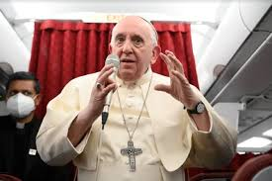
“Who am I to judge gay people?”

Some Roman Catholics believe that homosexuality is a sin and if someone is gay they have a duty to remain celibate as to not to live in sin.
Whilst Pope Francis has spoken up in defence of gay people and endorsed Same-Sex Civil Unions, he is still against same-sex marriage being blessed n the Catholic Church.

Church of Scotland View
The Church of Scotland is a progressive one, and, as society has changed and become more accepting, so too has to the Church: In 2015, the Church’s General Assembly voted to allow openly gay ministers; in 2017 an apology was issued to gay people who had previously been discriminated against by the Church; and church are moving closer to approving same-sex marriages being performed by those ministers who feel comfortable to do so; those who don’t will not be forced to.
Task
Imagine you are a gay Christian. Imagine how your church’s teachings would impact you if the church you attend is:
- Catholic
- Church of Scotland

Matthew Vines: God and the Gay Christian
Watch the YouTube clip of gay Christian Matthew Vines. Using the teranscript below, summarise the Biblical Passages he talks about and how he puts them into context.
https://www.youtube.com/watch?v=gmp6lLct-fQ

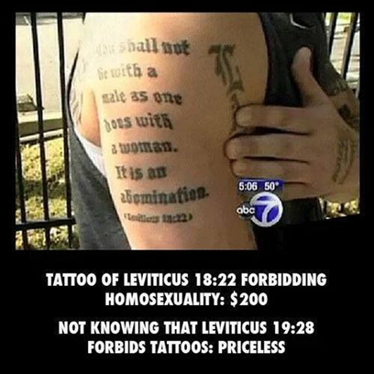
The Story of Sodom & Gomorrah (Genesis 19)
This story in Genesis 19 is probably the most popular passage used to condemn homosexuality. Here is how Vines explains it:
"God sends two angels disguised as men into the City of Sodom where the men of Sodom threatened to rape them. The angels blind the men, and God destroys the city. For centuries, this story was interpreted as God's judgment on same-sex relations, but the only form of same-sex behaviour described is a threatened gang rape."
So gang rape = not good (also not the same thing as homosexuality). But the recap of Sodom and Gomorrah found in Ezekial 16:49 highlights what Vines believes is the real point of the story:
"Now, this was the sin of your sister, Sodom. She and her daughters were arrogant, overfed, and unconcerned, they did not help the poor and needy."
In other words, everyone using this story as evidence of the sin of homosexuality, might be missing the point entirely.
When God calls homosexuality an abomination
(Leviticus 18:22) (Leviticus 20:13)
Yep. We've all heard that Leviticus is where the Bible straight-up says that homosexual behavior is an abomination. And yes, it does. It also says that homosexuals should receive the death penalty (!!!). It also says the same thing about eating pork or shellfish, charging interest on loans, and a whole bunch of other restrictions that were a part of the Old Testament Law Code. But for Christians, the Old Testament doesn't (dare I say "shouldn't?") settle any issue because Romans 10:4 says that Christ is the end of the law. Which is probably why most Christians today eat meat, use credit cards, wear makeup, and support equality for women. Because, as Hebrews 8:13 says, the old law is obsolete and aging.

When people turn away from God (Romans 1:26-27)
"Even their women exchanged natural sexual relations for unnatural ones; in the same way, men committed shameful acts with other men and received in themselves the due penalty for their error."
This is where Vines really digs in on the cultural context angle. In Biblical times, same-sex behaviour was primarily seen as happening between adult men and adolescent boys (masters and servants — yikes), via prostitution, and by men who were married to women. In all of those cases, we can see why it would have been viewed as sinful, excessive, lustful, and against God's law. But he makes no mention of love, commitment, faithfulness, or the type of same-sex relationships that are at question in the debate around marriage. (By the way, Paul also says that men having long hair is "unnatural" and that women shouldn't speak in church, so it's clear Paul himself may have had some issues of his own.)

Uses of the Greek works "Malakoi" and "Arsenokoitai"
(1 Corinthians 6:9-10) (1 Timothy 1:10)
These words are included in the New Testament's lists of people who will not inherit God's kingdom. And there has been much debate over their original meaning. (Translating ancient words is hard, guys.) Some believe them to mean homosexuality and sodomy, whereas others have said that the closest modern translation would be "dirty old men." Ha! Here's how Vines explains it:
Many modern translators have rendered these terms as sweeping statements about gay people, but the concept of sexual orientation didn't even exist in the ancient world. Yes, Paul did not take a positive view of same-sex relations (nor did he support women speaking in church...), but the context he was writing in is worlds apart from gay people in committed, monogamous relationships. The Bible never addresses the issues of sexual orientation or same-sex marriage, so there's no reason why faithful Christians can't support their gay brothers and sisters.

Non-religious response to homosexual relationships
Humanists believe that all individuals should be treated equally and fairly. Humanists believe that morality comes from individuals and their experiences and not from an outside source like a belief in God. When considering LGBT rights, Humanists think about how what we do impacts upon other people. They argue that restricting rights for LGBT people is unfair and unequal.
For Humanists there are no ‘rules’ on sexuality; they support the view that an individual has a right to do what they want in their life – so long as it does not harm others. Same-sex relationships are not viewed any differently from mixed-sex relationships by Humanists. At their core is a mutual wish for a relationship between two consenting individuals and that is all that matters.
Humanists believe in equal rights.​
Humanists have been vocal campaigners for equal rights for LGBT people. In Scotland, Humanist Society Scotland was one of the key actors in the successful campaign to legalise same-sex marriage.
In other parts of the world where homosexuality is still a criminal offence, Humanists are at the forefront of trying to change the law. As Humanists believe there is only one life, they believe it is important to stand up and campaign for human rights. Humanists strongly believe it is what we do in the present that is important.
For humanists the question is simply whether same-sex marriages cause anybody any harm. The answer is no. ​Humanists believe there is no reason to suspect that a same-sex couple would be worse parents than two parents of the opposite sex.​ The best way to deal with any problems children might face is not to deny same-sex parenting but to work to make society in general more open-minded and tolerant of difference.
Task
1. Would you agree that a person’s sexuality is nobody’s business but their own? Why?
2. How would a Humanist react to discrimination against LGBT people?
3. What are the main issues that LGBT people in Scotland face? Has anything changed in recent years?

Task
Read the profile on Humanist computer scientist Alan Turing. Can you find out more about his achievements? Why is he considered important?
2. Most people accept that being gay is not something that needs or has a cure:
a) Where is gay ‘cure’ therapy still promoted in the world?
b) Can find out what UK politicians have said about such methods?
c) How does this make you feel?
d) Do you think governments should intervene where this is promoted? Why?
Humanist Profiles
Name: Alan Turing
Occupation: Code breaker & mathematician
Alan Turing was a pioneer of computer science who developed the machines that led to the breaking of the ‘enigma codes’ used by Nazi Germany in World War II. Turing was prosecuted for being gay in 1952 – a time when this was a crime in Britain. As part of his criminal punishment he was injected with hormone ‘therapy’ to ‘cure’ or ‘limit’ his homosexuality. This and other pressures, such as losing his security clearance, led to his suicide two years later. In 2009 the then Prime Minister, Gordon Brown, made a public apology on behalf of the country for the way Alan Turing had been treated.

Sexual Relationships Type 2 –Sex before marriage
Sex before marriage – this happens all the time and is something that many people will not wait for. There was time when sex before marriage was frowned upon, however, as society has become less religious, this is not something that is important to people any more, most people will have sex before they get married, many will never get married at all.
Moral issues arising from sex before marriage:
Underage sex and consent The term 'age of consent' means the age at which a person is legally allowed to decide to have sex. If consent does not happen then the sexual activity is considered to be rape. In Scotland, the age of consent is 16. If one person is under 16, then the person over 16 is breaking the law. Having sex with a young person under the age of 16 is punishable by up to 10 years in prison, and life imprisonment where the young person is aged under 13.
Teenage Pregnancy – A risk if having underage sex is that teenage pregnancy can happen.
Promiscuity and use of Contraception Sometimes people will choose to have many sexual partners. This can be fine if everyone involved is happy to do so. However, it can also cause issues such as:
- Mental health issues – someone may be sleeping around due to low self-esteem
- Unwanted pregnancy
- Spread of Sexually Transmitted Infections (STI’s), if condoms are not used.
Task
What are the consequences or impacts of the moral issues in bold? Think about how the people involved in would be effected.

Religious Response to sex before marriage
Bible Quotes: Sex before marriage
“But because of the temptation to sexual immorality, each man should have his own wife and each woman her own husband.” Corinthians​
“Let marriage be held in honour among all, and let the marriage bed be undefiled, for God will judge the sexually immoral and adulterous.” Hebrews​
“Therefore a man shall leave his father and his mother and hold fast to his wife, and they shall become one flesh. And the man and his wife were both naked and were not ashamed.” Genesis
“You shall not commit adultery.” Exodus​

For many Christians, especially literal Christians and Catholic Christians, it is important sex does not happen before marriage. They use many passages in the Bible to justify this and generally look upon sex before marriage as a sin.
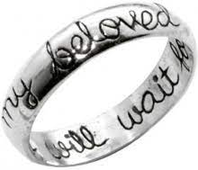
Chastity Some young Christians will take a pledge of Chastity which means that they will not have sex until they are married. This is common in some American Christian communities. They may wear a Chastity bracelet or a Purity Ring, on their wedding ring finger, to show that they will not have sex before marriage. Popstars the Jonas Brothers were famous for wearing the rings as their dad was a Pastor, however, they removed them as they got older.
Task
https://www.youtube.com/watch?v=6CCSeOwiHnI&t=236s
Watch the video on Purity Balls in America. Once it is finished, write down as many key words and phrases that stick in your mind. Share them with the class and then write half a page answering this question:
“It is important for young girls to pledge their chastity if they wish to be Christians” To what extent do you agree?
Catholic Church View:
In Catholicism, sex should only happen between a man and woman during marriage. This is because the main purpose of sex is to reproduce as God commanded humans to “be fruitful and multiply” (Genesis).
Church of Scotland View:
The Church of Scotland allows co-habitation (people living together) before marriage as it is important to make sure that two people are compatible before being married. Although, the Church states that the most stable basis for a sexual relationship is within a loving marriage.
Non-religious responses to sex before marriage
Humanism: Many Humanists support marriage however, they also do not believe that it is necessary and a couple can live as part of a loving relationships without the need of a marriage certificate to prove their commitment.
Sexual Relationships Type 3 –Polyamorous and Polygamous Relationships
Polyamory specifically refers to people who have multiple romantic relationships at the same time. It does not mean any type of open relationship that may include more casual sexual partners. In many polyamorous relationships, each partner is aware of the other ones. There are many different types of polyamorous relationship, one example is a Throuple: similar to a couple but with three people. Polyamory has become more popular in recent times as people feel that monogamy (having only one partner) does not work for them.
Statistic: In a 2020 YouGov Poll, One-third of Americans said that their ideal relationships would be non-monogamous.
Moral Issues arising from Polyamorous Relationships:
Time constraints - Having multiple relationships can be difficult because each relationship requires time. A “time squeeze” can be quite stressful.
Energy constraints - Similarly, each relationship requires energy — emotional, mental, and physical. This can be a challenge, especially if you have difficulties with energy in general.
Jealousy - Some polyamorous people don’t experience jealousy, while others do. Being jealous isn’t inherently bad, but you’ll want to learn to express and manage it in a healthy way.
Religious Views on Polyamorous Relationships
Most sections of Christianity would not agree with Polyamorous Relationships. The Bible is clear that marriage is between a man and a woman. Even Christians who are more liberal and accept same-sex marriage are not likely to accept polyamorous relationships or polygamy (marriage to more than one partner). However, the Bible does have some sections where it discusses Polygamy. For example, Exodus 21:10 sets out some guidelines for how to treat your wives if you have more than one. Deuteronomy 21:15–17 governs inheritance amongst children in polygamous marriages. If authors of these passages thought polygamy was wrong, their advice would have been “don’t do it!” not “here’s how you should do it.”
Task
Source: Three Wives, One Husband
Three Wives, One Husband is set in Rockland Ranch in Utah, where a community of Polygamous Mormons live. Watch the first episode and take notes on the following:
- What typically happens when a husband and wife decides to take a new wife?
- What are the religious reasons that the community uses to justify polygamy?
- What benefits do you see of living this way?
- What are the challenges of living this way?

The Catholic Church are definitely against polyamorous relationships as all sexual relationships should happen within a marriage and marriage can only happen between one man and one woman.
Non-religious view on polyamorous relationships
Humanists believe that how we treat each other in life is important and that everyone is respectful to one another, especially in the context of relationships. They do not have a standard view on polyamory, however, it is likely that they would be accepting of it if everyone in the relationship is consenting and aware of what is going on. They do not believe that humans are being judged by a God or have a commanded way of being in a relationship (Adam and Eve = man and woman) so they would support a polyamorous relationships if no harm is being done to anyone.
Relationships: The Purpose of Sex
There is a lot of misinformation about sex in modern society. Internet, TV, videos, films, music and magazines can make it difficult to sort out truth from fiction. Sex sells! It has become a commodity, easily commercialised and sold without regard for the damage it may do. The sexual act is a giving of oneself in a very deep way. Sexual relationships can create new life and enrich human relationships and self-discovery.
For this part of the course, we are looking at three main purposes of sex; the three P’s:
- Procreation
- Pleasure
- Sex for money (Prostitution or sex work)
Task
Copy and complete this table in your jotter:
Positive aspects of sex | Negative aspects of sex

1st Purpose of Sex: Procreation
Having sex for procreation means having sex to reproduce i.e. have children. As reproduction is required in order for species’ to continue, most – but not all – people are biologically hard-wired to reproduce. One of the main reasons that sex is pleasurable is so that humans continue to do it and therefore create offspring. There are other evolutionary factors involved in reproduction that encourages people to do it, for example, after childbirth, the hormone Oxytocin (often known as the ‘love hormone’) floods the mother’s body to help her create a bond with her baby and may even help her to forget the pain of childbirth so that she will do it again.
Moral Issues arising from Procreation:
Unable to have children - Some people or couples are unable to have children. If procreation is viewed as the main purpose of sex, are these people expected to not do it?
Do not want children – Many people do not want to have children or are having children at a later age. Again, should these people not have sex unless they are planning on reproducing?
Already have children – Many people will want to plan their family and so decide to stop trying after 2 or 3 or more children. If those people have decided to stop having children, should they stop having sex?

Religious response to Procreation
Catholic Church
Procreation is the main purpose of sex for the Catholic Church, however, the Church also places an emphasis on sex being a gift from God that should be used to strengthen a relationship. They take their teachings from the Bible and specifically in Genesis where God commands Adam and Eve to “be fruitful and multiply” meaning that they should have sex and populate the earth. Due to this, the Catholic Church has a ban on using contraception. There are many consequences to this ban:
- Large families – As contraception is not allowed, family planning is harder and so many Catholic families are quite large. This means that children may be brought up in a home where there is not a lot of spare money to go round and/or with many siblings and there is not enough attention from the parents.
- Overpopulation – This is especially a problem in some developing or poorer countries that have a Catholic majority population such as Brazil. As contraception is banned, people continue to have children when they may not be able to afford it or they live in densely populated area.
- The rapid spread of AIDS and HIV is not helped by the Catholic Church’s opposing to condoms in some African countries, where the Catholic Church is becoming increasingly popular.
- Many Catholic women ignore the ban which can bring them a sense of shame or guilt for going against the Church’s teachings.
- Infertile couples
Church of Scotland
The Church of Scotland believes that procreation is an important purpose of sex but also that sex is an expression of love between two committed people, preferably within the confines of marriage, however, they allow co-habitation if the relationships is stable. The Church of Scotland agree with the use of contraception a within marriage as it allows for family planning. This shows that there main focus is not on procreation.
Non-religious response to procreation
Humanists believe that the decision to have children should be not be taken lightly. Bringing children into the world is a big commitment so people should ask themselves if they can afford it and if they can give them enough love and attention. Humanists support the use of contraception.
2nd Purpose of sex: Pleasure
Human beings are biologically wired to find sex pleasurable in order for us to keep on doing it and reproduce. However, not every human being will get pleasure from sex and everyone has different things that they may find pleasurable. When a sexual relationships is successful, there are many positive benefits: It can strengthen a couple’s bond; intimacy is an important, human experience; it can increase everyone’s happiness; it can deepen love; makes babies; it is a natural part of life and is good for overall wellbeing.
Moral issues arising from sex for pleasure:
Pleasure is not the same for everyone​ The representation of sex in the media influences the way that society views sex. Sex has predominantly been shown on TV and film through the male gaze and sex scenes have often been written and directed by men and so, what we have seen on the screen does not reflect was is happening in the bedroom. As a result, we have been lead to believe that there are a few standard ‘moves’ which will result in orgasm for men and women at the same time (most onscreen sex is heteronormative sex). The reality is, what is pleasurable for one person, isn’t necessarily pleasurable for another. Couples have to work together to find what they like.

Promiscuity As we have seen before, enjoying sex too much can be a challenge if it leads to a person being promiscuous:
- Unwanted pregnancy can result in someone having a baby before they are ready or having an abortion. Having a baby before being ready is not always the end of the world, but it can present challenges if a person is not ready: Sometimes one parent is not on board with having a new child and so may become an absent parent; young parents have to make a lot of sacrifices such as in education and work; if parents are young they may not be mature enough to raise children (although this is not something that only young parents experience!)
- Having an abortion can have many negative effects on a person, no matter what age they are. When someone seeks an abortion it is not something that they do lightly or happily. It is something that carries a lot of stigma with it and, even when people are pro-choice it does not mean that experiencing abortion is a positive experience.
- Spread of STI’s if condoms are not used.
Religious response of sex for pleasure:
Catholic Church
The Catholic Church understand that people have sex for pleasure and that it is a physical expression of love and intimacy. It is an important part of a relationships but it can only happen between a married man and woman.
The Catholic Church does not allow the use of contraception, as the main purpose of sex should be reproduction. Therefore, the only acceptable method of controlling the size of a family is the ‘rhythm method’ where a couple has sex during the times of a woman’s menstrual cycle where she is not likely to be ovulating.
Church of Scotland

The Church of Scotland accepts that sexual intercourse serves to enrich relationships and believes that our sexuality can be expressed in a variety of loving relationships that offer mutual joy and pleasure.

The Church would prefer couples to be marries as the best and securest foundation for a long and happy relationship. However, they accept that co-habiting and long-term partners have sex.

Non-religious response to sex for pleasure

Humanism

Humanists believe that sex is a pleasure that can be enjoyed responsibly and it can be a positive ingredient of a happy life.​ Sex is not ‘sinful’, it can take place outside marriage, and it does not need to be performed only with the goal of reproduction.​

However, everyone is responsible for their own actions. People should be physically and mentally mature enough to make the decision. They should consider carefully the potential consequences and risks.​

3rd Purpose of sex: Sex for money (Prostitution/sex work)
Prostitution or Sex Work is often described as “The world’s oldest profession”. This is the practice of exchanging sex acts for money. Sex workers would also include porn actors and strippers.
Sex work must always be consensual for it to be sex work – human trafficking of adults and children and forced prostitution of children is not sex work as work is consensual.
Children cannot give consent to take part in sex work so if children are involved it is not it is not sex work but rape.

In Great Britain (England, Wales and Scotland), the act of engaging in sex as part of an exchange of sexual services for money is legal, but a number of related activities, including soliciting in a public place, kerb crawling, owning or managing a brothel, pimping and pandering, are crimes. Some people argue that we should have the Nordic Model where all sex for money is banned completely in order to free women of exploitation whilst others argue that sex work is legitimate work and should be completely decriminalised and legislated as any other job would.
Question – What would be the positive and negatives of making sex-work completely de-criminalised?


Source: Sex, Drugs and Murder. BBC iPlayer

Watch the BBC3 documentary and answer the following questions:
Episode One:
1) What are the details of the legal Red Light District that Leeds Council have set up in the Holbeck area?
2) What effect has it had on the local area?
3) Why do many of the women work selling sex?
4) What are the dangers of working in the Red Light District?

Episode Two:
1) What are some of the things that Sammie Jo’s clients have asked her to do?
2) Up to how much money can Sammie Jo spend on drugs in a day?
3) What has happened to the number of incidents reported to the police by sex workers since the Red Light District was introduced?

Source: Sex for Sale, Inside a British Brothel
Victoria Derbyshire visited a, technically illegal, brothel.
1) Make notes on how the brothel is run.
2) How much money does Louise make? How much does the Brothel keep?
Task
Write a short essay (at least half a page) detailing the differences between the legal Red Light District in Leeds and the illegal Brothel. Which do you think is a better system?

Moral Issues arising from Prostitution:

Exploitation – the people who sell sex for a living are sometimes being exploited and/or mistreated. Some women have pimps who will take the money that they earn and often abuse them. Many people who sell sex for a living are vulnerable and it is easy for them to be abused by their clients as they are often operating outside of the law and so it might be harder for them to seek protection for the poice or to report serious incident.
Morally wrong – many people view sex work as morally wrong and they believe that sex is something that should not be sold. However, some people would disagree and say that a person should be able to use their boy however they want to.
Adultery – Sometimes a client can be married or in a long-term relationship and therefore, by sleeping with someone else, they are committing adultery. In these circumstances, the relationship would be kept a secret but, if found out, it can ruin the lives of their partner or family.
Stigma – There is a lot of stigma associated with being a sex worker and people will often hide their identity when working so that those around them do not know what they do. It is generally frowned upon by society and people, especially women, would be judged badly if it is known that they are a sex worker.

Positive aspects of Sex for Money | Negative aspects of Sex for Money
Sex workers can make a lot of money | Can still be exploitative, men often make money from women
Sex workers often work for themselves and set their own limits/boundaries/terms/hours | It is looked down upon in society and can lead to the sex worker/prostitute being judged
Can provide a safe space for people to act out fantasies or fetishes | Can put a strain on existing relationships
 | People are forced into doing things that they don’t want to do (Hot Girls Wanted netflix doc.)
 | Can cause a lot of pain if the family of the client finds out - Adultery
 | Pornography can have a negative affect on how people view sex – especially young people
Religious Response to Sex for Money:
There are a number of passages in the Bible that refer to prostitution or that can be applied to our understanding of this type of relationship (e.g. sex for money as adultery):
- “Flee from sexual immorality. All other sins a person commits are outside the body, but whoever sins sexually, sins against their own body.” Corinthians​
- “But because of the temptation to sexual immorality, each man should have his own wife and each woman her own husband.” Corinthians​
- “Let marriage be held in honour among all, and let the marriage bed be undefiled, for God will judge the sexually immoral and adulterous.” Hebrews​
- ​“You shall not commit adultery.” Exodus
Goes against Christian teaching of love, respect, faithfulness, commitment. In 2015, faith leaders in Scotland (including the Catholic Church, Church of Scotland, Islam and Sikhism) wrote a letter to the Scottish Government calling for the Nordic Model to be enforced in Scotland.
Catholic Church View: Pope Francis asked forgiveness for all Christians who buy sex from women - 'This isn't making love. This is torturing a woman’​. He said that men who use prostitutes have a sick mentality and that they are exploiting women.
Non-religious response to sex for money:
Humanist View: Humanists accept that prostitution will never be eliminated and it is sometimes a free and successful choice. Therefore, a system of legalised brothels should be imposed in order for sex workers to protect themselves, it is important that the brothels are not run by criminals, pimps or any other person attempting to exploit the prostitutes. Prostitution is usually the result of poverty, drug addiction, homelessness, lack of alternative employment and the other factors and Humanists believe that it can be reduced by tackling these underlying problems.
Additional Sources exploring Sex for money:
Louis Theroux. Dark States: Trafficking Sex. BBC iPlayer
Louis Theroux spends time with American women working in Houston's illegal sex industry and explores the often complex dynamic between prostitute and pimp.
Hot Girls Wanted. Netflix
Several 18- to 25-year-old young women are interviewed about their experiences as pornography performers. Several women are recruited by a 23-year-old pro-amateur porn agent Riley Reynolds to live in his North Miami Beach home. Viewer discretion is advised – whilst there are no actual porno0graphic images in the film, there is a lot of filming ‘around’ pornographic scenes where the action happens off camera. There are some instances where women describe some of the acts they have to do and it can be quite distressing to hear. The film gives an interesting insight into one part of the porn industry and raises questions about exploitation.

Gender Inequality and Exploitation
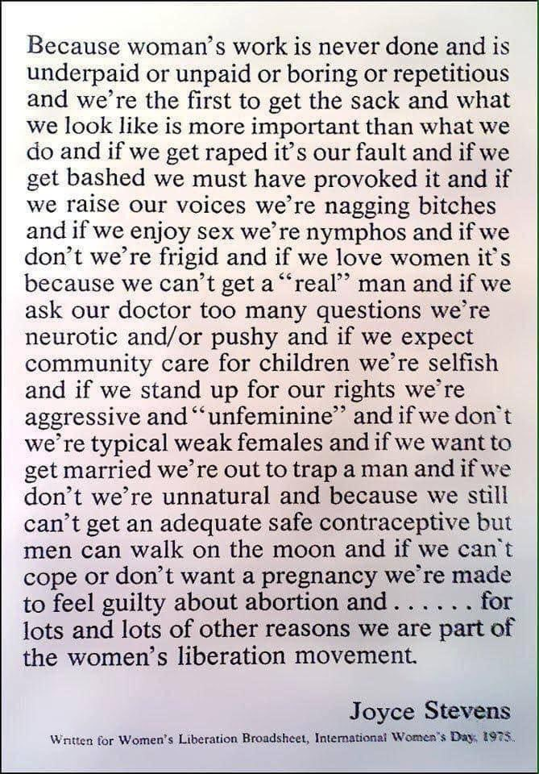

Gender Inequality and Exploitation in the media, society and religion are closely linked and often overlapping. There is a “chicken and egg” situation in that, what came first: inequality in society which in turn influenced the media and religion; inequality in the media which influences society and religion; or inequality in religion which influences society and, therefore, the media? Some people believe that the answer is that all of these structures have been set up by, and in support of, the patriarchy. Patriarchy is a system of society or government in which men hold the power and women are largely excluded from it. Almost all societies around the world are patriarchal and the effects of the patriarchy are harmful not only for women but for men too (as we will find out when watching The Mask You Live In).
Gender Exploitation in the media
Media can mean a number of different things – TV, film, radio, magazines, newspapers, social media, advertisements, music etc.

The problem with GIE in the media is that the media can often portray damaging stereotypes of men and women.
Gender Stereotypes
Gender Stereotypes are where certain characteristics are put onto males and females that directly relate to their gender. For example: men like the colour blue, are interested in sports and do hard labour jobs; women like the colour pink, are interested in make-up do domesticated jobs. Obviously these characteristics are true for some, if not many, men and women. However, when we begin to define men and women purely by these roles, we limit them, and the possibilities of what they can achieve. This is especially damaging to small children, where gender stereotyping happens early and can have a very negative effect on what girls and boys believe they can become as they grow older.
Task
Using an A3 sheet of paper, draw a stick man of a woman on one side and a man on the other. Write out all of the stereotypes that you think are associated with that gender. For example: names that gender can be called, including slang and/or swear words; phrases associated with the gender; jobs; personality traits; physical looks etc.
Discuss the results as a class, then answer the following questions:
- What are the common names women were called?
- What are the commons names men get called?
- What kind of job types to the men have?
- What kind of job types to the women have?
- What are the differences in how men and women are stereotyped?

The Mask you Live in
Watch the documentary up unit _______ .

What are the effects of gender stereotypes on boys and men?
What consequences does this have for society as a whole?
Mad Men, Episode 1
Watch the first episode of the TV show Made Men. It is set in a New York advertising agency in the late 1950’s. Note down as many examples of sexism that you can see.

Gender Inequality and Exploitation in Advertising
Advertising is responsible for how people view themselves and what they aspire to be. Advertising agencies employ psychologists to help them identify how to target their products at people which has resulted in many different methods being used to sell products. Traditionally, a lot of gender stereotypes were used in order to make products appeal to men and women. On the next page you will see some examples of these from the 1095’s – 1960s.
Task
For each of the adverts, answer the following:
- What is being advertised?
- Is the advert aimed at men or women?
- What gender stereotypes are being represented for
    - Men
    - women
The first advert is answered for you.

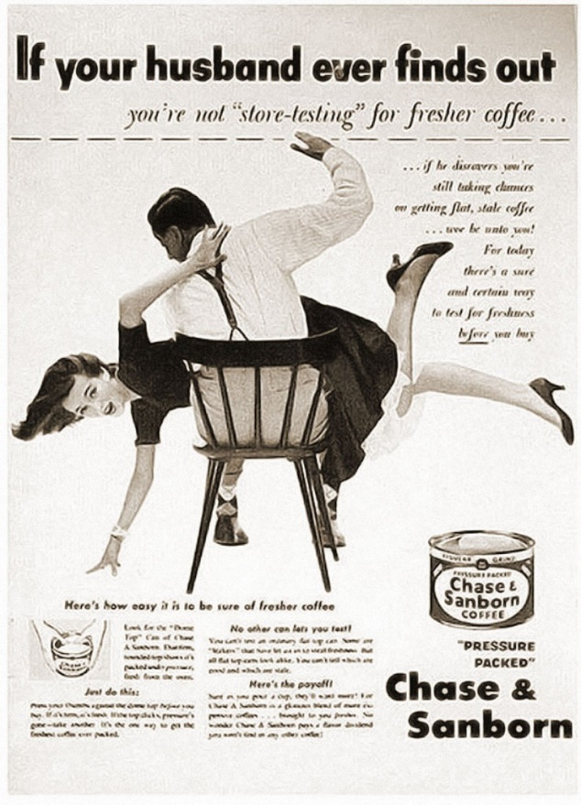
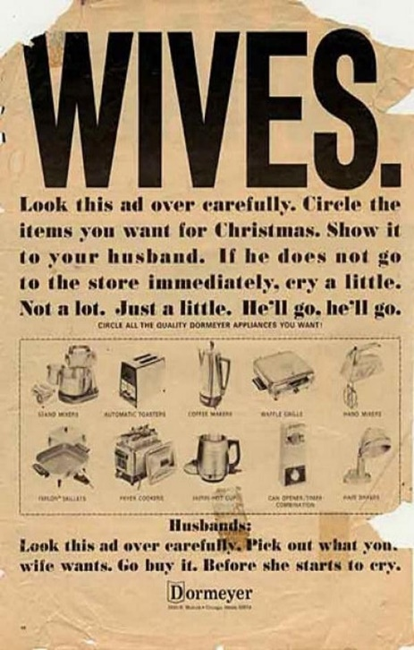
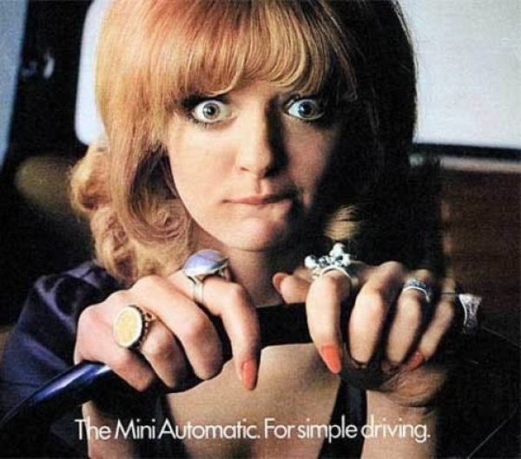
3

2

1

1) This is advertising kitchen appliances.
2) The advert is aimed at men and women.
3a) Men are in control of the money/breadwinners. Men are in charge of how the money is spent.
3b) Women are only interested in household chores. They are emotional and will use crying to manipulate men into getting what they want.
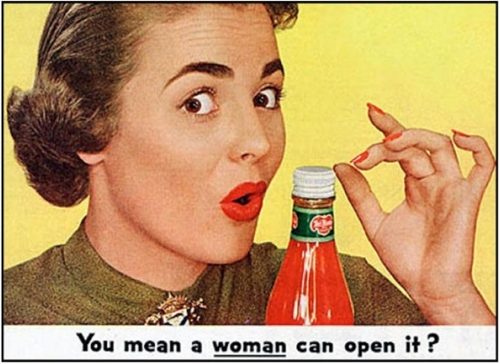
5

4

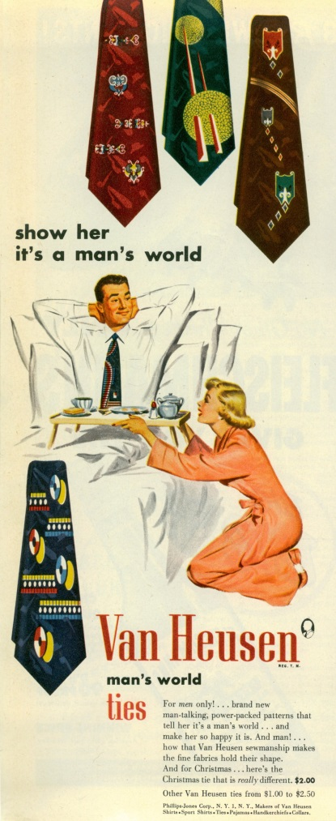

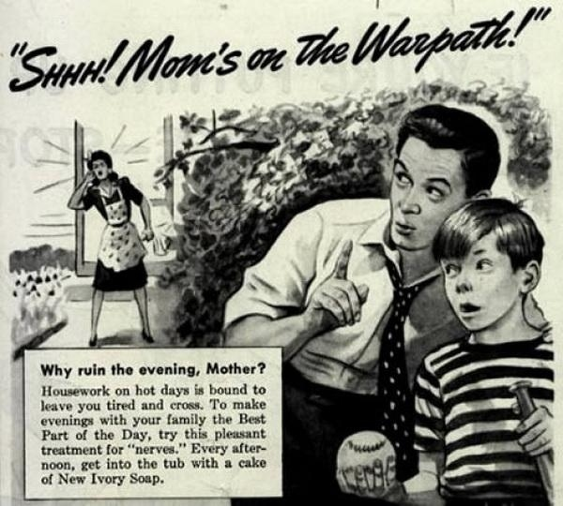
7

6

Modern Advertising
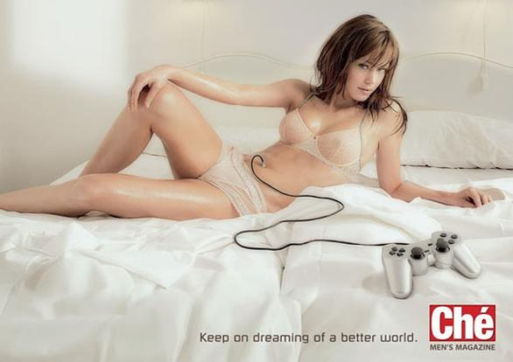

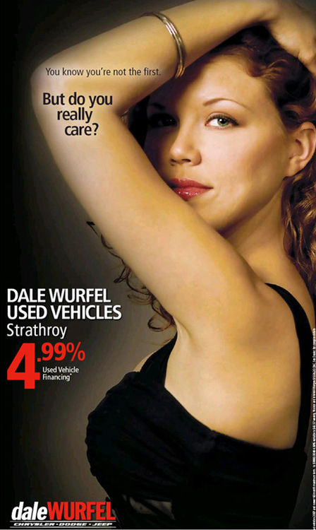

With the sexual revolution in the 1960’s and 70’s, advertisers realised that relying on such simplified gender stereotypes was no longer going to work: women no longer wanted to stay at home in the
1

1

1

1) This is advertising the clothing brand, Dolce & Gabbana.
2) It is not clear who this is aimed at.
3a) the men are strong, dominant, aggressive, in control.
3b) The woman is submissive, passive, dominated, victim of sexual assault.
Task
Answer the same questions as before, for modern adverts.
The first has been completed for you.

4

3

2



Miss Representation (media)
Advertising and Body Image
Watch Miss Representation to 15 mins then answer the questions below:
1) “I looked around me and I was really frightened for her” Why was Jennifer specifically afraid for he child because she was a girl?
2) “You never see a photograph of a woman considered to be beautiful without the image being digitally altered to make her absolutely, inhumanly perfect.” Write down this quote and state what the effect of photo shopping has on women and girls.
3) What does the film say about how advertising works?
4a) How does the media make women and girls feel about themselves?
b) What effect does this have?

Miss Representation (media)
Representation in TV and Film
22.52 – 40.35
“You can’t be what you can’t see” – What does this quote mean?
What stereotypes are being portrayed in most Hollywood films?
a) What are some examples of the hyper-sexualisation of women?
b) What are the consequences of women being portrayed as sexual objects?
What happened to many women news presenters in the USA?

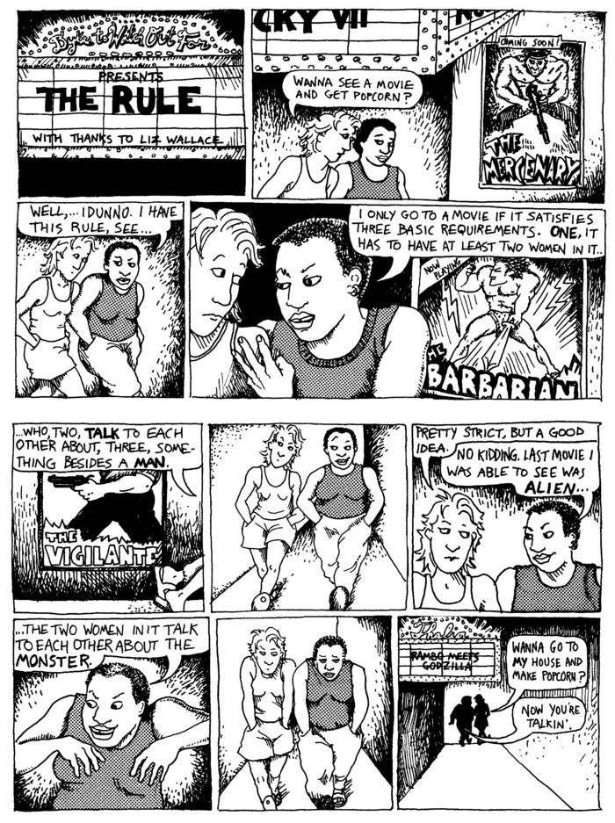
The Bechdel Test
Task
1) Write down the three rules of the Bechdel Test
2) What is the point of the Bechdel Test?
3) Can you identify three films that do not pass the Bechdel Test?
4) Can you think of three films that do pass the Bechdel Test?

The Male Gaze
The male gaze is when women are viewed from the perspective of men, for men, with the purpose of diminishing and sexualising women. Many sex scenes that we see on TV and in film has been written and directed by men and so will often be heavily biased towards the male perspective, not taking into account the true nature of sex and intimacy from a female point of view.
The Male Gaze in Teen Films (search in Youtube)
https://www.youtube.com/watch?v=5MpDbbvM3qo
Watch the clip and note down how the women are shown as subjects of the male gaze (how are they dressed? Where does the camera film them on their bodies? How do the other people in the scen react to them?)
Rape Culture in the media
Rape Culture is an environment in which rape is prevalent and in which sexual violence against women is normalized and excused in the media and popular culture. We will explore rape culture and misogyny in greater depth when we look at gender inequality and exploitation in society.
Rape culture on screen When rape and sexual assault is used as a plot device rather than to move the story on or to portray a message, the depictions become gratuitous and used for shock value to keep viewers watching.

Source: Game of Thrones
The hit HBO series Game of Thrones had many rape scenes, including: Daenerys Targaryen - the Mother of Dragons – who forced into marriage to Khal Drogo, raped on her wedding night then later falls in love with him; Briene being dragged away to be gang raped before being saved by Jamie Lanister; Jamie raping his sister, Cersi, next to their dead son and Sansa being raped by Ramsay Bolton after her forced marriage to him.
When asked to justify the use of sexual violence in the books, George RR Martin claimed that rape has always been used as a weapon of war and so the depiction is realistic. Male rape is also a common weapon of war but was not depicted in the books for show.

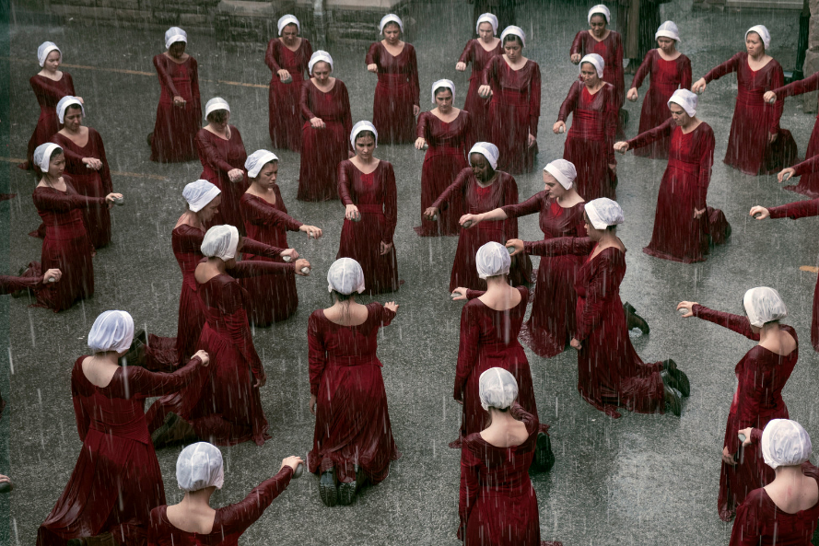
Source: The Handmaid’s Tale
The Handmaid’s Tale is another show, based on a book, which has many depictions of sexual violence and aggression against women. Whilst the premise of the show is to present a dystopian future where women are the property of men, the use of rape and sexual violence in the show has become prolific. Viewers have watched June be raped by Commander Waterford; have nonconsensual sex with Nick, followed by consensual sex when she later falls in love with him (there’s that trope again); be raped by Waterford while nine months pregnant; be raped by Commander Lawrence when Waterford orders it; and murder Commander Winslow after he attempts to rape her. We’ve also seen female characters suffer genital mutilation, have their eyes taken out, be beaten with straps, and have fingers removed. The current season presents a 14-year-old who’s already been raped by multiple men, the prolonged torture of June after she’s recaptured (yet again) by Gilead, and a different handmaid who develops romantic feelings for a man who’s assaulted her.
Rape culture in music
There are many songs where women are written about in a violent and sexually explicit way. Listen to the following in class and discuss the meaning of these song lyrics:


Blurred Lines, Robin Thicke “Good girl, I know you want it..... now he was close, tried to domesticate you, but you're an animal, baby its in your nature, just let it liberate you....”


What do you mean, Justin Bieber “When you nod your head yes but you wanna say no.”


Sex you back to sleep, Chris Brown “Just let me ffff you back to sleep girl, don't say a word no, girl don't you talk”

Little White Lies - One Direction – “You say you're a good girl, but I know you would girl”
Statistics
- Estimates published by WHO indicate that globally about 1 in 3 (30%) of women worldwide have been subjected to either physical and/or sexual intimate partner violence or non-partner sexual violence in their lifetime.
- Sexual assault accounted for 37% of Sexual crimes in Scotland in 2019-20.
- Reported Rapes & attempted rape in Scotland 2019-20 = 2343
  - Prosecuted = 300
  - Convicted = 130

Religious Response to gender inequality and exploitation in the media
Within Christianity, there are different views on gender inequality. Some believe that passages in the Bible justify an imbalance in the sexes; others believe that the Bible is the product of a patriarchal society, and some believe that the Bible has many passages that can have a feminist reading. All of these ways of reading the Bible can be applied to many parts of this course, especially gender inequality and exploitation in society and religion.
Gender Inequality in the Bible | Gender Equality in the Bible
The Ten Commandments seem to be directed at men. (Ex. 22.31) ‘Thou shalt not covet thy neighbour’s house, thou shalt not covet thy neighbour’s wife, nor his manservant...’  GENESIS 2  In this section we have another version of the creation myth. A myth is an explanation of why the world is as it is, not an explanation of how it came to be. Man is created as steward of the Garden of Eden. Man – Adam, is created to work. Woman - Eve, is created out of Man. Man is created as the very first living being. The world is created around him. God breathes life into man and then creates a garden in which he will live. God then determines that man should not live alone and so forms the animals from the soil just as he created man and they are named by man. The creation of woman is different from the others. Man is placed into a deep sleep by God and woman is created out of one of man’s ribs. ‘Woman is her name because she was taken out of man.’ It is only with the creation of woman that man can achieve wholeness as a social being but woman is created into man’s world and it is man who names her and everything else. Naming in the ancient world was an activity declaring power and authority over the named.  GENESIS 3  Here we have the story which is most often interpreted as depicting woman as the first sinner and as temptress to man. According to this reading of the story, women are portrayed as being deceitful and therefore have to be controlled. Woman is encouraged to disobey God by a snake and then man follows her example by eating the forbidden fruit. At the end of the story, as punishment, woman is reduced to her basic biological role.  ‘I will increase your trouble in pregnancy and your pain in giving birth. In spite of this you will still have desire for your husband, yet you will be subject to him.’  Implicit in this is the message that women cannot be trusted with responsibility and authority. They are under the authority of men. (This has obvious implications for the modern workplace debate.)  This passage has often been interpreted as justifying the domination of women in all circumstances and, since it is a religious principle, some Christians argue that it is not subject to modification or change.  As a result of her disobedience to God woman is punished with the pain of childbirth. If God can inflict pain on women for disobedience then what lesson does this give men?  1 CORINTHIANS 11: 2-13  In this passage Paul declares that a husband is in authority over his wife in church and in social matters. She must be modest in deference to her husband. Men are excused covering their heads in church by Paul (compared with Jewish custom) because they reflect the ‘image and glory of God.’ But a woman should cover her head as she ‘reflects the glory of man.’ He goes on - ‘for man was not created from a woman, but a woman from man.’  And in verse 11 Paul states that ‘she is under her husband’s authority.’  This is one of the passages most often used to support the exclusion of women from power within the Church and, to a certain extent, their subordinate role in society.  Paul was an extremely influential theologian in Christianity and so his opinion on such matters has been important right up to the present day.  Some have argued that Paul in this and the next passage was not intending to lay down the law for all time, but was merely responding to a specific problem at a certain time and in a certain place. However, it does serve to continue the patriarchal tradition of Judaism within early Christianity and together with Graeco-Roman attitudes to women, still has considerable influence today.  EPHESIANS 5:21-33  ‘Submit yourselves to one another because of your reverence for Christ. Wives, submit to your husbands as to the Lord. For a husband has authority over his wife just as Christ has authority over the church…’  In this passage we again have the view that women should play a subordinate role to their husbands and should obey them in all things and in return husbands are to care for their wives. This gives women a subordinate role and a role only in relation to their husbands. Power and control lie as usual with the male.  LUKE 8: 1-3  Jesus chose twelve men to be his disciples and seems to give some women the subordinate role of ‘followers’ - (Mary Magdalene and Joanna). Those who wish to maintain the superior place of men in the Church argue that Jesus, as the Son of God, would not have been conditioned by social conventions of the time and therefore could have made women disciples if he wanted them. He did not and therefore this example should be followed today and women should not be appointed to the ministry.  Feminists point out that Jesus did not appoint priests and that Jesus was a Jew of the 1st century. He quoted from and followed the Torah. He lived in a patriarchal society in which women were severely restricted by men. It is hardly surprising that he chose men to represent the twelve tribes of Israel. Remember the position of women witnesses in Judaism of the time. | In the Gospels from the exchanges between mothers-to-be Mary and Elizabeth to the Resurrection women appear to perceive the deep religious meaning of the events surrounding them. By contrast their male counterparts are portrayed as not understanding very much at all.  GENESIS 1: 24-31  In this section we have the creation of human beings in the image of God - ‘like us’ and both sexes are equally ‘blessed’ by God. Just what this means is subject to speculation but there does not seem to be any concept of inequality here. Men and women are both created in the ‘image of God’. This has usually been thought of as meaning that all humans are equally spiritual and ethical beings.  The implication seems to be that men and women are equally spiritual and good. This is important in the arguments for and against the ability and calling of women with respect to the ministry in particular and for the place of women in society in general. This statement on the equality between the sexes is different from the next two chapters, where women seem not to be placed on an equal footing with men. The point for Genesis 1 is that there is a complete absence of any gender discrimination.  In Genesis 1 sex is seen as being an integral part of the relationship between men and women. Since, according to Genesis 1, humankind is created in the image of God, then God must have some properties which are reflected in both men and women.  GENESIS 3  Phyllis Trible (1978) challenges both the traditional interpretation of this story and thus the view that it legitimises the subordination of women. She argues that the egalitarian and universalist theme of Genesis 1 - literally God creates an ‘earth creature’ out of the ‘earth’ - ‘…in his own image he created him, male and female he created them’, is also woven into chapters 2 and 3. In Genesis 2, Trible argues that the term ‘helper’ used in connection with the creation of woman as a ‘helper’ for man in its Hebrew meaning is associated elsewhere in the Bible with the image of ‘protector and saviour of Israel’ and is therefore not intended to indicate inferiority. In chapter 3, she says, the focus of the story is on the introduction of death - the punishment for disobedience to God is banishment from the Garden of Eden and the tree of life. Humans become mortal as an act of retribution. The theme of death is juxtaposed with the name Eve which means ‘life’. This is how the story should be read.  If we accept this interpretation then, according to Keith Whitelam, Trible has reclaimed ‘an important text that has been used to justify the subordination of women for centuries and provides an alternative perspective which challenges traditional readings and interpretations.’ (Esler, p.196)  Most commentators however would agree that in Genesis chapters 1-3 we seem to have two competing interpretations. The first is that women are inferior to men and that men have a religious duty to control women. The second view is that men and women are equal partners in a relationship which includes God and the world.  Given that these passages are products of patriarchal societies, the surprise is that there are any egalitarian elements at all. Patriarchy is a male creation not a creation of God and therefore is the cause of, not a justification for, the domination of women.  JOHN 20: 1-18  A woman, Mary Magdalene, is the first person to witness the Resurrection. Women were also present at the Crucifixion when the disciples are presumed to be in hiding. Does this suggest a higher degree of spiritual understanding and faith of the women or merely the accepted role of women of the time as those who would be most closely associated with funeral rites? Did God choose to reveal the Resurrection to women for a purpose? If so, the purpose remains unclear. Mary rushes to tell the men. It is through women that the gospel is first revealed and initially spread but then men take over.  JOHN 20: 1-18  A woman, Mary Magdalene, is the first person to witness the Resurrection. Women were also present at the Crucifixion when the disciples are presumed to be in hiding. Does this suggest a higher degree of spiritual understanding and faith of the women or merely the accepted role of women of the time as those who would be most closely associated with funeral rites? Did God choose to reveal the Resurrection to women for a purpose? If so, the purpose remains unclear. Mary rushes to tell the men. It is through women that the gospel is first revealed and initially spread but then men take over.  GALATIANS 3: 26-28  ‘So there is no difference between Jews and Gentiles, between slaves and free men, between men and women; you are all one in union with Jesus Christ.’  Here we have Paul’s famous declaration that all differences between people are rendered unimportant by Christ. All are totally equal. This seems to be, both from the content and the language used, a more definitive statement and one which feminists have claimed should carry more weight than the other utterances of St Paul which they say reflect more the social circumstances of the time than Paul’s true beliefs. He does seem to be making some sort of ‘mission statement’ in this passage.  An important element in examining apparent contradictions in the writings of St Paul is that we have here a man who was expecting the end of the world to come soon. Any ‘social squabble’ such as arguments on male/female roles and relationships within the Church would seem to be an unnecessary distraction. For Paul, the task in hand was making Christ known to the world and ushering in the Kingdom of God. The question remains - how are these passages to be interpreted by Christians today and what is their importance and relevance?

Non-religious response to Gender Inequality and Exploitation in the media
Task
For each of the following, find a religious response that supports male domination over women and one that supports equality of the sexes and explain why it supports it:
- Gender inequality and exploitation (GIE) in traditional advertising.
- GIE in modern advertising.
- Representation in TV and film
- Rap culture in the media

Traditionally society has defined that men and women have different roles. This has included views that men and women should dress differently and that there are jobs that only men or women should do. Certain behaviours or emotions have also been seen by some as “feminine” or “masculine” in nature.
Humanists don’t share the view that people have defined roles based on their gender. Humanists approach an individual’s role in society from a point of equality. Humanists think that people should be free to choose their own path in life. This means some people will choose to live a life that conforms to traditional gender roles but others will not.
For Humanists it is very important that individuals are not pressurised or expected to fill a particular role based on their gender. Traditional views on gender roles also ignore the existence of LGBT people. Defined gender roles only work in a world where everyone is heterosexual and their gender is fixed. LGBT people exist and Humanists think that this should be acknowledged, and that LGBT people should have the same rights and respect as other people.

Task
Humanist Profiles
Name: Anne Glover
Occupation: Biology Professor
When I was very young, it struck me as odd that teachers and others thought that it was unusual that I should be interested in science and that they should try and persuade me to consider something else. It is always unusual to me when others point out that I am the first woman to do something and that suggests to me we have quite a long way to go as the gender of someone in a role should not be worthy of comment. There is nothing that women cannot do and if they come across a barrier, just look for a way round it and always keep looking ahead. Never fear a rejection or a rebuff.

1. Why would a Humanist oppose men and women having defined roles?
2. Does this differ from religious groups you have studied?
3. Look at the profile of Anne Glover, a notable Scottish Humanist. How do her comments about working in science help you understand Humanist views on gender roles? Can you find any other information about Anne Glover?
4. Find a copy of the UN Universal Declaration on Human Rights. What does it say about gender? Do you think a Humanist would agree with this? What do you think of it – if you were to rewrite it what would you say?

Inequality/ Exploitation
Humanists stress the need to value every individual as an equal and that everyone should have equal opportunities. A Humanist would not change their mind about this regardless of a person’s gender, sexuality, race or any other characteristic.
A Humanist approach would be to look at the evidence, and the evidence shows that unequal treatment negatively affects people. For example, people who face stark inequality or discrimination often value their worth to society less than those who are privileged.
Other evidence shows that inequality reinforces itself. Take the example that women should be “home-makers” rather than workers earning an income. Because women in this situation do not have an independent income, they are reliant on someone else financially (traditionally a husband). This financial dependence further limits their ability to be autonomous and to do the things they wish to do in life without asking for permission.
A Humanist would say this shows that inequality and exploitation supports and leads to further inequality.

Humanists oppose people putting limitations or expectations on others and have actively campaigned against this. For example, they do not think that religious organisations should be able to ignore equality laws that protect against discrimination just because inequality is enshrined in their religious beliefs.
Humanist Profiles
Name: Sandi Toksvig
Occupation: Comedian/Presenter
I genuinely believe that society would be more at ease with itself – men and women – if we had equality. I am partly a feminist because of my son: I don’t want him to have to ‘man up’; to not cry; to feel as if he has to carry the burden of the world. I’d like him to share it. Even in the most egalitarian countries, there’s still a gender pay gap and it’s time that we said ‘enough’.

Task
1. Give two views a Humanist would have on gender inequality.
2. Can you think of ways gender inequality is present in education?
Read the profile of Sandi Toksvig.
3. Do a search online and see if you can find other information about her views on gender equality.
4. Do you think being a Humanist shapes her views on this? If so why?
5. Can you find any examples of organisations that challenge gender inequality? What do they do to challenge it?
Task
For each of the following, state what a Humanist would respond, explain your answer:
- Gender inequality and exploitation (GIE) in traditional advertising.
- GIE in modern advertising.
- Representation in TV and film
- Rap culture in the media

Gender Inequality and Exploitation in Society
In this section we will look GIE in UK society and around the world. Whilst we consider ourselves, in the UK and Scotland, to be progressive nations, we still have a far way to go before we can achieve gender equality. We often feel that we are doing well as we compare ourselves to areas around the world where many women and girls still do not have basic human rights, in relation to their male counter-parts, and in some areas are being actively harmed due to their gender.
Misogyny
In recent years, we have seen a rise in the public debate about misogyny in society. Put simply, misogyny is a hatred of or prejudice against women. We have already explored examples of misogyny in the media and we are now going to look deeper into the moral issues arising from misogyny in society.

Moral issue 1 Gender Pay Gap
Men and women were not paid equally for equal jobs in the UK until the Equal Pay Act of 1970. Before then women were often classed as “unskilled” workers in order to get around paying them for similar work. This was highlighted by the striking workers of the Dagenham Ford car manufacturing plant where the women employed to sew the interiors of the car were paid considerably less than the male factory workers.
In 2018, Glasgow council workers went on strike to gain equal pay for workers who were in roles traditionally done by women (carers/cleaners/canteen workers) as the more traditionally male jobs (refuse collectors/ engineers) would get better pay, including bonuses. Glasgow City Council were found to be at fault and had to pay out £500,ooo,ooo in order to rectify the inequality.

BBC The entertainment industry is one where equality laws do not apply in the same way as the rest of society. This has led to a number of high-profile cases involving, for instance, the BBC when they have published a list of their talent and what they get paid. The gap between men and women is often very big.
Hollywood - Jennifer Lawrence spoke out after learning that her male co-stars on American Hustle were paid more than her and her female co-star, Amy Adams. She wrote an open letter where she talked of being angry with herself for not negotiating harder for a higher fee as she was afraid of coming across as if she was a “spoiled” - something she acknowledges is not likely her male co-stars are afraid of. Lawrence highlighted the different ways men and women conduct themselves in such negotiations with women feeling more like they want to be liked and not come across as difficult whereas men in the same position are likely to be commended for being fierce negotiated.
Task
Male
Both
Female
1.copy this table and put the words below under each of the headings. 2. Have a class discussion about how you associate the words – what are you thinking of when you hear the word? 3. choose two of the female words and two of the male words and say why you think they have been gendered in this way.
actor assertive bossy aggressive dominant bitch actress nice strong kind
funny smart slut annoying doctor footballer athlete anger drama model
artist young army bachelor mistress spinster master cute team

Effects of gender pay gap
Some people argued that giving equal pay to men and women meant that companies could not afford to pay anyone a bigger wage and so everyone gets less money.
Another, greater effect, is to classify that the work that women as “unskilled” demeans such duties as care worker. We are currently in a crisis of care where we do not have enough people doing this job which has had a huge effect on the NHS (bed blocking). To treat these jobs as less important is having a hugely negative effect on society.
By paying women and men entertainers a different amount is reinforcing the sexist stereotype of valuing men above women. Women will not want to seek out these roles and the lack of female representation in the media has an effect on young people ( you cannot be what you cannot see etc)
Moral Issue 2 Male Violence against Women
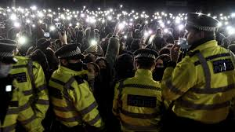
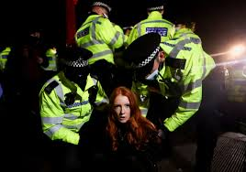
In March 2021, during a covid lockdown in London, 33 year old Sarah Everard went missing after leaving a friend’s house to walk home alone in the night. She had later found to have been murdered by police officer, Wayne Couzens. When Couzens was convicted and given a whole life sentence for the crime, attitudes towards women and their safety were highlighted. Following Sarah Everard’s death, women were prompted to speak up to say that they do not feel safe when they are outside on their own at night. Most women and girls are able to empathise with this sentiment, and can share experiences of being made to feel unsafe by men at some point in their lives. When women do walk home on their own at night they will often take measures such as: holding their keys in their hand to use as a weapon, if needed; stay on the phone to a friend or family member; text each other when they have arrived home; walk in the middle of the road; carry a rape alarm; spend a lot of money on taxis or simply avoid being alone outside altogether.
Vigil for Sarah Everard
Woman arrested at vigil for Sarah Everard
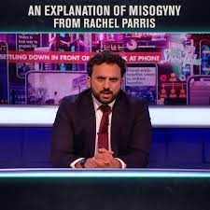
In response to concerns raised by Sarah Everard’s murder, many different public bodies came up with ideas of how to tackle the problem. The Conservative Government suggested that women should walk home at night using an app that tracked their location. A statement from the metropolitan police stated that women should “flag down a bus” if they feel unsafe when being approached by a police officer. These responses were criticised by many as being part of the problem where the emphasis is put on women and girls’ behaviour and how it should be altered in order to avoid being raped/assaulted/ murdered. Many feel that the responsibility should be shifted onto men to not commit the crimes in the first place.
Task
Watch this clip from the Mash Report and note down any statistics that are mentioned. https://www.youtube.com/watch?v=KlTu_SBS_4M (search for “women are knackered” on YouTube)
Police Scotland released a video called “Don’t be that guy” where male actors questioned their own behaviour and attitudes in relation to women. They were widely praised for being one of the first institutions to put the responsibility on men rather than women to tackle gender based violence.
Task
Visit the website that-guy.co.uk and choose one of the articles to read. Take notes about it then feedback to the class. You can work in groups, make sure that everyone in class picks a different article.

Religious Response
Matthew 5:29 ‘But I tell you that anyone who looks at a woman to lust after her has already committed adultery with her in his heart. If your right eye causes you to sin, gouge it out and throw it away. It is better for you to lose one part of your body than for your whole body to be thrown into hell.’ This passage is Jesus telling men that if they look lustfully at a woman then they might as well be committing adultery. This could be interpreted as making men responsible for their own behaviour, rather than women for dressing or looking a certain way that might invite attention.

Domestic Abuse
Statistics
Between 2016 and 2018:
- 74% of victims of domestic homicide were women
- of 270 female victims of homicide, 260 of the suspects were male
There was a study carried out by the police where they found that men were significantly more likely to be repeat offenders and to be violent.
In 2019, 92% of domestic abuse prosecutions were against men.

“If I’m not in Friday, I might be dead”
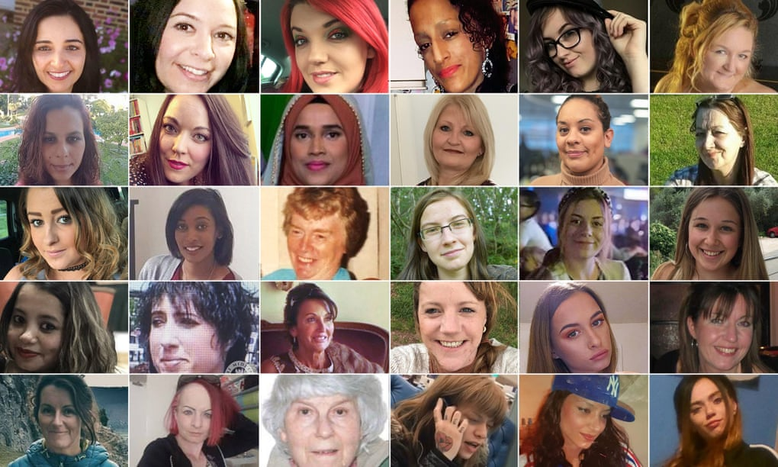
The Femicide Census has today [25.11.20] produced its fifth, and most comprehensive, report to date of women killed by men in the UK.

The disturbing, UK-wide, ten-year report [2009-2018], which includes expert contributions from families whose loved ones have been taken violently from them and from professionals working on violence against women and girls, examines 1,425 cases of women killed by 1,419 men in all forms of violence against women. The Femicide Census is unique in the UK in that it covers all women killed by men and not only domestic homicide. Worryingly, it finds the number of women killed every year by men has stayed distressingly consistent at between 124 and 168 women killed each year raising serious questions about the State’s response to men’s violence against women in the last decade. “By any measure, we had hoped to see the number of killings gradually decreasing given the State has had our data for a number of years, as well as its own initiatives to tackle men’s violent crime against women. We show that there are so many patterns to the killings which would enable the State to target certain factors which could lead to a reduction in the number of women killed. The fact that a similar number of women are still being killed over a decade is a serious failing and indicates a lack of will to tackle root causes.”

In 46% of all cases (658) the perpetrator had a history of violence, whether against this victim or against other people. Indeed, in 29 cases the perpetrator had killed before; in 20 cases, women and in nine cases, men and, in one case, the perpetrator was a serial killer. In at least 59% of femicides committed by intimate partners or male relatives, there was a history of prior abuse by the perpetrator against the victim. In 67% of cases of intimate partner violence, the victim had told someone about the abuse she was experiencing and in 55% of cases, the violence and brutality used in the killing amounted to “overkilling”.

The most common method of killing was with a sharp instrument (47%) followed by strangulation/asphyxiation(27%) and then by blunt instrument(16%) and then by use of hitting, kicking or stamping (15%).

In 62% of cases, the primary context of the violence was intimate partner abuse that is to say abuse committed by a current or ex-spouse/intimate partner and in 43% of those cases the victim had separated or taken steps to separate from the perpetrator and in 89% of such cases, she was killed within one year of separating/taking steps to separate. In a further 10% of cases, it was violence committed by another male relative, including 111 cases of sons, step-sons and grandsons killing mother figures. In 13% of cases where the victim was aged over 66 years, the killer was a robber or burglar.

The subheading of the Femicide Census is, “If I’m Not In On Friday, I Might Be Dead”. These are the words of Judith Nibbs, mother of five, who was beheaded by her husband of 30 years, Dempsey Nibbs. The report is dedicated to her memory and to every victim of femicide over the decade, each name listed. “People say, ‘It’s only a few women a week that die’,” Gemma Aitchison says. “But it’s been a few women a week ever since I was born, and I’m 34. It’s a huge systemic problem. The census says these women matter. ”

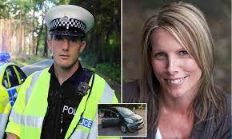
In 2020 a Dorset Police Officer, Timothy Brehmer, killed his lover, Claire Parry, in a car when she exposed their affair. She died from a brain injury after sever neck compression. He was convicted of manslaughter rather than murder because he had “lost control”. He was sentenced to 10 years in prison.

Rough Sex Defence

Grace Millane was a British backpacker whose was murdered in New Zealand in 2018. Her body was found in suitcase that had been dumped in the mountains. The man accused of her killing claimed she died during “rough sex”
In 2018 Natalie Connolly’s boyfriend was convicted of manslaughter and given 3 years and 8 months in prison. Natalie had over 40 injuries to her body including serious internal trauma, fractured eye socket and facial injuries. Her boyfriend claimed it was “sex-games gone wrong.”
The rough sex defence has been used as a defence over 60 times in the UK. It is not an official defence in law but juries are sympathetic to it because of the popularity of 50 Shades of Grey and accessibility to pornography. The campaign Group “We can’t consent to this” has been formed to raise awareness of the issue and to end the use of rough sex defence.
Task
1. What do the figures on domestic abuse tell us about violence against women?
2. What do you think the effect of domestic violence is on:
a) the woman?
b) her family?
c) any children in the home?
3.Boris Johnson said that he would not make misogyny a hate crime because of the increase in police work that it would create, what do you think of this?
4) Using the Rough Sex Defence is seen as acceptable by some and has, sometimes, been successful in reducing a sentence from murder to manslaughter, what does this tell us about society’s attitude to women?

Moral Issue 3 Politics
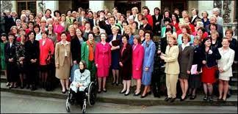
Statistics
In 2022 there were 225 women MP’s in UK Parliament - at 35% this is an all time high. The proportion of women MP’s has slowly grown until it jumped in the 1990’s with the election of Tony ‘Blair’s Babes’ (pictured).
45% of MSPs in the Scottish Parliament are women.

Women politicians are subject to greater scrutiny about many things such as their: appearance; role as a wife and mother and sexual attractiveness.

Nicola Sturgeon has the nickname of “Nippy Sweetie” The word Nippy tends to only be used to describe women who are annoying/nagging/whining/doesn’t shut up – The word nippy would not normally be used to describe a man.

When Theresa May was running for the Conservative Party Leadership, Andrea Leadsome question whether she would be a good leader as she is not a mother.

Labour MP, Yvette Cooper, is married to Ed Balls (former shadow chancellor). When they were both in shadow cabinet Cooper was asked who was doing the school run whilst Balls did not get any of those questions.

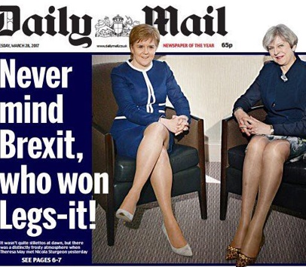
Jo Swinson, former Liberal Democrats Leader was asked about how she would manage work and homelife.

Nicola Sturgeon and Theresa May met in 2017 to discuss Brexit, however, the Daily Mail chose to run with a front page photo with the caption “Never mind Brexit, who won Legs-it!” with a story inside the paper evaluating the legs of each of the political leaders. It was widely condemned as being sexist.

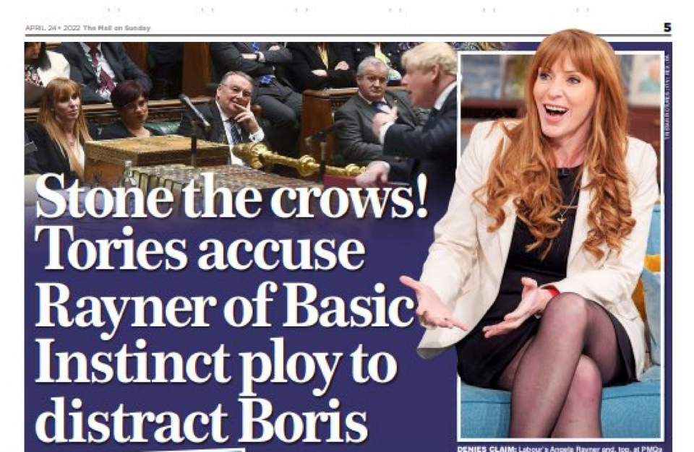
In 2022, the Mail on Sunday newspaper was criticised for running a story in which an anonymous Conservative politician complained that the Deputy Leader of the Labour Party, Angela Rayner, deliberately crossed and uncrossed her legs in order to distract the Prime Minister, Boris Johnson, during Prime Minister's question time. Reynor reported feeling down about the article and concered about how her sons would react to it and that she now felt like she was being judged for what she wore.

USA = Democrat Congresswoman Alexandria Occasion-Cortez (AOC) was called “crazy” and a “f*****g b***h!” by a republican polititian – shows a complete lack of respect and using sexist language (crazy/b***h)
Hilary Clinton and Nancy Pelosi are often judged on their appearance with a lot of time taken up in the media about speculation of Nancy Pelosi’s cosmetic surgery. In 2008, Hilary Clinton’s campaign for president was interrupted by two men shouting “iron my shirt!” at her.

Miss Representation (Politics)
15 mins – 23.24

Miss Representation (Politics)
40.35 – 50.59
Task
1. How are women in politics discussed by the media?
2. What do many of the men say about Hilary Clinton?
3. What are the effects of how women in politics are treated?

Moral Issue 4 Female Genital Mutilation (FGM)
Female Genital Mutilation (FGM)
Female Genital Mutilation comprises all procedures that involve partial or total removal of the external female genitalia, or other injury to the female genital organs for non-medical reasons. It is also sometimes referred to as female genital cutting or female circumcision. There are no health benefits to FGM and it is recognised internationally as a human rights violation.
Female genital mutilation is classified into four major types:
- Type 1 – Clitoridectomy: partial or total removal of the clitoris (a small, sensitive and erectile part of the female genitals) and, in very rare cases, only the prepuce (the fold of skin surrounding the clitoris).
- Type 2 – Excision: partial or total removal of the clitoris and the labia minora, with or without excision of the labia majora (the labia are “the lips” that surround the vagina).
- Type 3 – Infibulation: narrowing of the vaginal opening through the creation of a covering seal. The seal is formed by cutting and repositioning the inner, or outer, labia, with or without removal of the clitoris.
- Type 4 – Other: all other harmful procedures to the female genitalia for non-medical purposes, e.g. pricking, piercing, incising, scraping and cauterizing the genital area.
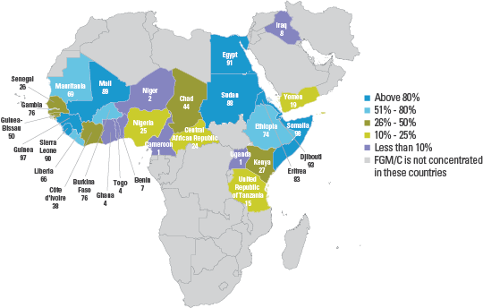

60,000 girls under 15 are at risk of FGM in the UK
137,000 girls and women are living with the consequences of FGM in the UK
At least 200 million girls and women worldwide have undergone FGM
FGM is practiced in more than 29 countries across Africa, parts of the Middle East, South East Asia and countries where migrants from FGM affected communities live.
The Health Risks of FGM
FGM puts the health of women and girls at great risk. It can result in excessive bleeding during the procedure and can be fatal. FGM is carried out by untrained women with no medical knowledge in unsanitised and unclean conditions. Those who undergo FGM will often suffer severe pain and shock, bleeding, infection, urine retention and injury to adjacent tissue. In the long-term women and girls who have undergone FGM can have problems during menstruation, complications in pregnancy and cysts and scarring. FGM has been shown to cause problems with childbirth and can cause the death of the baby. FGM can be emotionally very damaging. Some girls and women will go on to suffer emotional distress, sexual problems and post-traumatic stress.
“It is not helpful to define degrees within the practice of Female Genital Mutilation (FGM). Nothing is acceptable, not even a symbolic scratch, since that would be the start of a slippery slope.”
Mrs Unaiza Malik Assistant Treasurer, Muslim Council of Britain & President Muslim Women’s Association.

FGM and the Law
FGM is illegal in the UK and carries a prison sentence of up to 14 years The Female Genital Mutilation Act 2003 makes it illegal for FGM to be performed in the UK or anywhere in the world on UK citizens or permanent residents of any age. If a person carries out or helps to carry out FGM or if they arrange for someone to undergo FGM, they face up to 14-years in prison. This means that parents or family members who help arrange FGM in any way are committing a crime. It is also illegal to take a British national or a permanent resident abroad for FGM or to help anyone trying to do this. There is now a powerful movement against the practice of FGM and anyone who helps to carry out FGM or arranges for someone to undergo FGM or helps to take a British national or British resident abroad to undergo FGM, runs an increasingly high risk of being prosecuted by the police. FGM is not
only illegal in the UK but it is illegal in a growing number of countries where this cultural practice has been prevalent, such as: Central African Republic, Chad, Cote d’Ivoire, Djibouti, Egypt, Eretrea, Ethiopia, Ghana, Guinea, Kenya, Niger, Nigeria, Senegal, Tanzania, Togo and Uganda.
“FGM is prohibited by many international and regional human rights conventions that protect women and children from cruelty and violence as well as protecting them from harmful traditional practices.”
Dr Yunes Teinaz Fellow, Royal Society for Public Health and FORWARD Trustee

Why is FGM performed?
In every society in which it is practiced, female genital mutilation is a manifestation of deeply entrenched gender inequality. Where it is widely practiced, FGM is supported by both men and women, usually without question, and anyone that does not follow the norm may face condemnation, harassment and ostracism. It may be difficult for families to abandon the practice without support from the wider community. In fact, it is often practiced even when it is known to inflict harm upon girls because the social benefits of the practice are believed to be more important than its disadvantages.
The reasons given for practicing FGM fall generally into five categories:
Psychosexual reasons: FGM is carried out as a way to control women’s sexuality, which is sometimes said to be insatiable if parts of the genitalia, especially the clitoris, are not removed. It is thought to ensure virginity before marriage and fidelity (faithfulness) afterward, and to increase male sexual pleasure.
Sociological and cultural reasons: FGM is seen as part of a girl’s initiation into womanhood and as an intrinsic part of a community’s cultural heritage. Sometimes myths about female genitalia (e.g., that an uncut clitoris will grow to the size of a penis, or that FGM will enhance fertility or promote child survival) perpetuate the practice.
Hygiene and aesthetic reasons: In some communities, the external female genitalia are considered dirty and ugly and are removed, ostensibly to promote hygiene and aesthetic appeal.
Religious reasons: Although FGM is not endorsed by either Islam or by Christianity, supposed religious doctrine is often used to justify the practice.
Socio-economic factors: In many communities, FGM is a prerequisite for marriage. Where women are largely dependent on men, economic necessity can be a major driver of the procedure. FGM sometimes is a prerequisite for the right to inherit. It may also be a major income source for practitioners.
FGM and Religion
No religion promotes or condones FGM. Still, more than half of girls and women in four out of 14 countries where data is available saw FGM as a religious requirement. And although FGM is often perceived as being connected to Islam, perhaps because it is practiced among many Muslim groups, not all Islamic groups practice FGM, and many non-Islamic groups do, including some Christians, Ethiopian Jews, and followers of certain traditional African religions.
FGM is thus a cultural rather than a religious practice. In fact, many religious leaders have denounced it.
Islam
FGM is Non-Islamic, against the teachings of Islam and is not an Islamic requirement. The Islamic Shari’a Council, the Muslim College and the Muslim Council of Britain (MCB) have condemned the practice of FGM within the Muslim community. There is nothing in the Qu’ran that states girls must be circumcised. One of the basic principles of Islam comes from Muhammad when he said: “Do not harm yourself or others.” Most Muslims and Muslim countries around the world do not practice FGM and the practice was around before Islam was established.
“In Islam it is forbidden to mutilate the body, in this sense Female Genital Mutilation is condemnable as it irreversibly harms the woman. It is also prohibited to compel an individual to undertake this operation.”
Imam Abu Sayeed Chairman of the Islamic Shari’a Council

Christianity

The Bible does not mention FGM. Christian authorities agree that the practice has no foundation in Christianity's religious texts, and Christian missionaries in Africa were at the forefront of efforts to stop it. Despite the absence of scriptural support, women and girls within Christian communities, including i Christians in Ethiopia, and Protestants and Catholics in Sudan and Kenya. A 2013 UNICEF report identified 17 African countries in which at least 10 percent of Christian women and girls aged 15–49 had undergone it. In Niger, for example, 55 percent of Christian women and girls had experienced it, against two percent of Muslim women n Egypt, Kenya, Nigeria and Tanzania, do undergo FGM. It has been found among Coptic Christians in Egypt, Orthodox and girls.
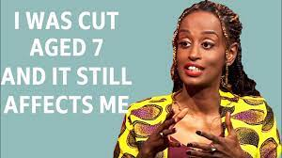
FGM Survivor’s experience (search FGM trauma in YouTube) https://www.youtube.com/watch?v=hwnzCKMB2eo
Task
1. Watch Leyla Hussein talk about the FGM that she experienced.
2. What happened when she was pregnant?
3. What reasons does she give for women continuing FGM?
4. What does she say about men and FGM?
5. Write down what the effects of FGM were on her.
6. How has FGM affected her?
The girl who said no to FGM (YouTube)
https://www.youtube.com/watch?v=MAQldouaOLE

Breast Ironing
Breast ironing affects 3.8 million women around the world and is particularly prevalent in Cameroon. It is a process where the breasts are pummelled, ironed or flattened down over a period of time (sometimes years) in order for the development of the breasts to slow down or disappear entirely.
Breast ironing is typically performed with large stones or spatulas which are heated and then used to pound and compress the breast tissue. After this process, restrictive bonds are placed around the chest to prevent growth in between poundings. The practice is typically carried out by women, 58% of the time it is the girl’s mother who does the ironing.
Why is Breast Ironing Carried Out?
In many cases, the abuser thinks they are doing something good for the child by delaying the effects of puberty and the practice is designed to:
- make teenage girls look less “womanly”
- prevent pregnancy and rape
- enable the girl to continue her education
- prevent dishonour being brought upon the family if the girl begins sexual relations outside of marriage
- deter unwanted attention
What the health consequences of breast flattening or breast ironing?
Due to the type of instruments that may be used, the type of force and the lack of aftercare, significant health and developmental issue may occur, such as:
- Abscesses
- Cysts
- Itching
- Tissue damage
- Infection
- Discharge of milk
- Dissymmetry of the breasts
- Severe fever
- Even the complete disappearance of one or both breasts.
There may also be an impact on the child’s social and psychological well-being such as causing PTSD, depression and body dysmorphia.

Religious Response to Gender Inequality and Exploitation in Society

In the previous section we explored many different passages that support or go against gender inequality. Use the information on pages to complete the task.

1.How might a Christian use the Bible to support the gender pay gap?
2. How might a Christian use the Bible to argue against the gender pay gap?

Gender Inequality and Exploitation in Religion
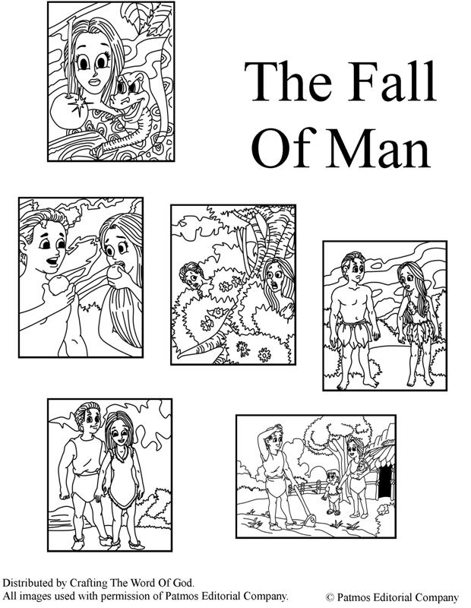
Genesis Chapter 3
Now the serpent was more deceitful than any other animal that God had made; and it said to the woman, "Has God really said, 'You shall not eat from any tree of the garden'?" The woman answered, "We may eat of the fruit of all the trees of the garden except the fruit of the tree which is in the middle of the garden, for God has said, 'You shall not eat from it, nor shall you touch it; for if you do, you shall die.'"

Then the serpent said to the woman, "You shall not surely die; for God knows that as soon as you eat of it your eyes will be opened, and you will know what is good and what is evil."

When the woman saw that the tree was good for food, beautiful to look at and that it would make her wise, she took some of its fruit and ate it. Then she gave some to her husband who was with her, and he ate.
Then the eyes of both of them were opened, so that they knew that they were naked; and they sewed fig-leaves together and made girdles for themselves. When they heard the sound of the footsteps of God, as he was walking in the garden in the cool of the day, the man and his wife hid from him among the trees of the garden.

And God called to the man and said to him, "Where are you?" and he answered, "I heard the sound of thy footsteps in the garden and I was afraid, because I was naked; so I hid myself." God said, "Who told you that you were naked? Have you eaten from the tree from which I forbade you to eat?" The man answered, "The woman whom thou didst give to me—she gave me fruit from the tree and I ate." God said to the woman, "What is this that you have done?" The woman replied, "The serpent deceived me, and I ate."

Then God said to the serpent, "Because you have done this, you shall be hated more than all beasts. You shall crawl on your belly and eat dust all your life, and men and serpents shall always be enemies. They shall bruise your head, and you shall wound them on the heel."

To the woman he said, "I will greatly increase your trouble and your pain, and you shall be subject to your husband, and he shall rule over you."
But to the man he said, "Because you have listened to your wife and have eaten of the tree from which I forbade you to eat, as long as you live you shall earn a living only by hard work. By hard work shall you raise food to eat. And you shall die and your body go back to the ground, for from dust you were made, and to dust you shall return!"

Genesis 3: Here we have the story which is most often interpreted as depicting woman as the first sinner and as temptress to man. According to this reading of the story, women are portrayed as being deceitful and therefore have to be controlled. Woman is encouraged to disobey God by a snake and then man follows her example by eating the forbidden fruit. At the end of the story, as punishment, woman is reduced to her basic biological role.

Implicit in this is the message that women cannot be trusted with responsibility and authority. They are under the authority of men.

This passage has often been interpreted as justifying the domination of women in all circumstances and, since it is a religious principle, some Christians argue that it is not subject to modification or change.

1st Issue arsing from GIE in Religion: Different roles for men and women
Jesus and early Christians lived in a male-dominated society and the Bible reflects this. The belief that men and women should have different roles is still common in some Christian communities today. This is because they believe that God made men and women differently.
Wives, submit to your husbands as to the Lord. For the husband is the head of the wife as Christ is the head of the church, his body, of which he is the Saviour. Now as the church submits to Christ, so also wives should submit to their husbands in everything.
St Paul's letter to the Ephesians 5:21-22

Other Christians believe that men and women were both made in the image of God and should be treated equally – they should share responsibilities and privileges.
There is neither Jew nor Gentile, neither slave nor free, nor is there male and female, for you are all one in Christ Jesus.
St Paul's letter to the Galatians 3:28

Many Catholics believe husbands and wives should respect each other's roles within a marriage and value both equally. These roles include those of care within the home, and that of earning money to provide for the family.
Men should truly esteem and love women with total respect for their personal dignity, and society should create and develop conditions favouring work in the home.
Pope John Paul II

The book of Genesis gives accounts of the order of creation of men and women which have been interpreted differently.
Then God said, “Let us make humankind in our image, according to our likeness;
Genesis 1:26

The Lord God said, ‘It is not good for the man to be alone. I will make a helper suitable for him.’
Genesis 2:18

2nd Issue arising from GIE in Religion: Interpreting teachings on gender
The different attitudes to the roles of men and women come from the way the believer interprets certain texts in the Bible.
Literal view
Denominations who take a more literal view of the Bible tend to stick to the original teachings from the Bible, believing they should not be changed.
Liberal view
Denominations who take a more liberal approach often believe that the teachings in the Bible need updating in today’s society, so they are willing to make some changes.
Some Christians, including conservative Catholics and literalists or fundamentalists, may get their views on the roles of men and women from passages such as this:
A woman should learn in quietness and full submission. I do not permit a woman to teach or to assume authority over a man; she must be quiet.
Timothy 2:11-12

But other, more liberal Christians, including liberal Catholics and other denominations, may take other teachings into account about the roles of men and women.
For all of you who were baptised into Christ have clothed yourself with Christ. There is neither Jew nor Gentile, neither slave nor free, nor is there male or female, for you are all one in Christ Jesus. If you belong to Christ, then you are Abraham's seed, and heirs according to the promise.
Galatians 3:27-29

There are also many examples of equality in the New Testament, such as the Golden Rule and the way that Jesus respected women and had many women followers. An example of one of these women is Mary Magdalene, who played a role in one of the most important scenes in the Gospels. When Jesus was crucified by the Romans, Mary Magdalene was there supporting him in his final moments mourning his death. It was Mary Magdalene who discovered Jesus' empty tomb, and she was the first person to witness Jesus' resurrection.
In the early Christian Church all of the original disciples were men. However, there are examples of women disciples, such as in Luke's gospel, which tells of a group of women who were also Jesus' followers:
Soon afterwards he went on through cities and villages, proclaiming and bringing the good news of the kingdom of God. The twelve were with him, as well as some women who had been cured of evil spirits and infirmities: Mary, called Magdalene, from whom seven demons had gone out, and Joanna, the wife of Herod's steward Chuza, and Susanna, and many others, who provided for them out of their resources.
Luke 8:1-3

3rd Moral Issue Arising from GIE in Religion: Women priests and bishops

Nowadays, most Protestant churches allow women to become ministers or priests. In 2014 the Church of England finally voted, after years of debate, to allow women to become bishops and the first women bishops were ordained in 2015.
Church of Scotland’s stance
The Church of Scotand’s General Assembly voted to allow women ministers in 1968, decades before The Church of England would allow the same (1994). In 2014, 204 women were serving ministers in the Church of Scotland within Scotland, representing 25.1% of the active Ministers in the country. There were also 61 women serving as Ministries Development Staff. Women have also played an increasingly prominent role in the Church's administration.
Catholic Church's stance
In the Catholic Church only men can become priests and bishops. They have to remain celibate because their position means they are married to the Church and need to be free of family responsibilities to be able to perform their duties fully. Women cannot be ordained as priests in the Catholic Church. Women have different roles in the Roman Catholic Church.
Catholics believe that men and women are equal but have different roles to play in religion.
Unordained members, called laymen and laywomen, are equally allowed to help in giving out the bread and wine at Mass, to read and to perform social roles such as visiting the sick.
In many denominations of Christianity, men and women can devote their lives to God by becoming a monk or nun.

