Writing Chemical formula questions 1

1.

2019

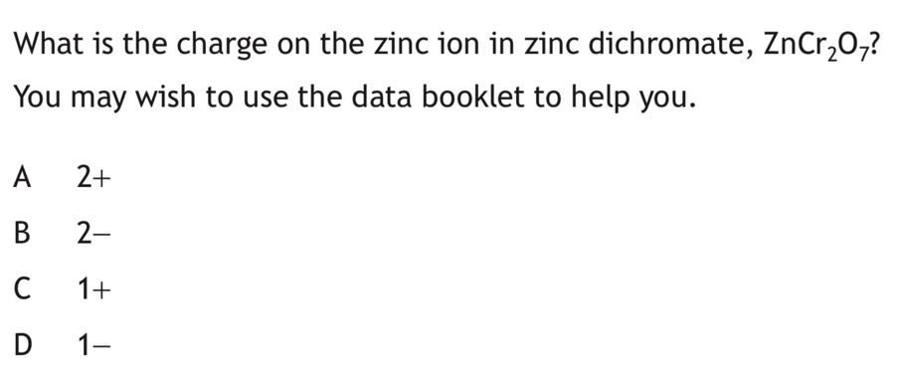
2.

2017

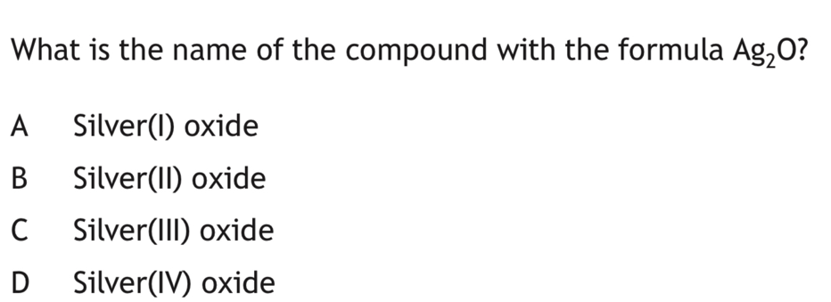
3.

2016

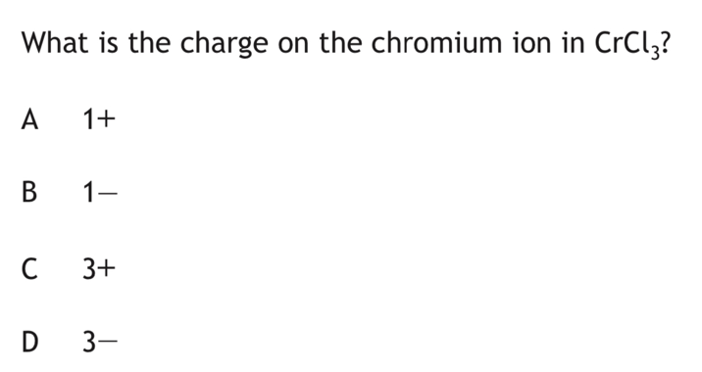
4.

2015
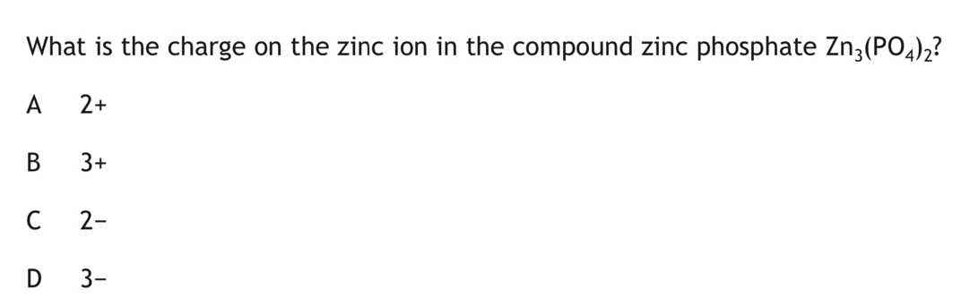
5.

2014

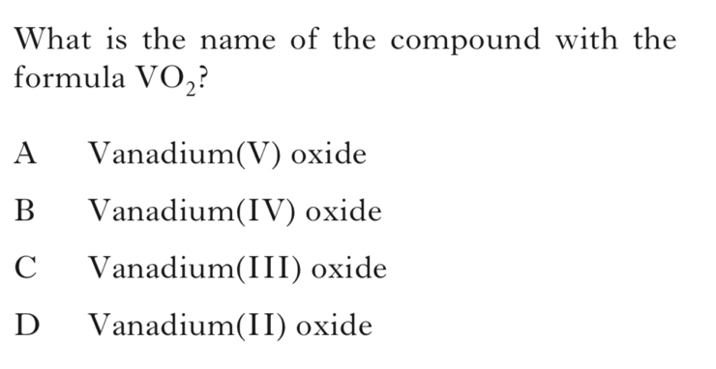
6.

INT 2 2013

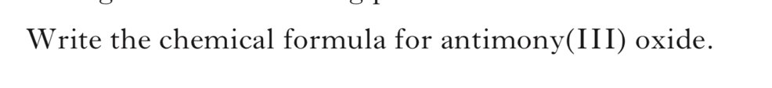
7.

INT 2 2012

8.
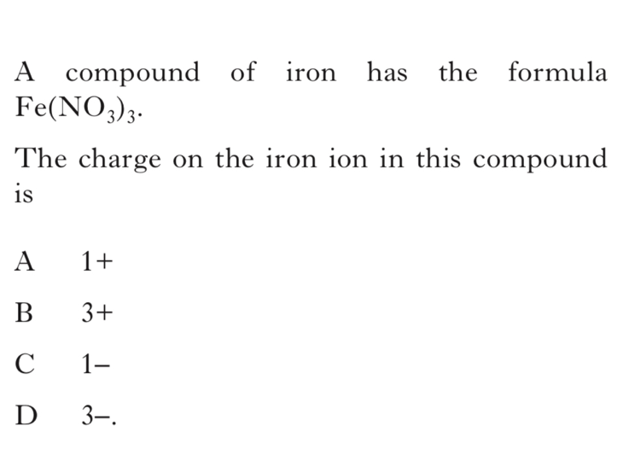

INT 2 2015

9.
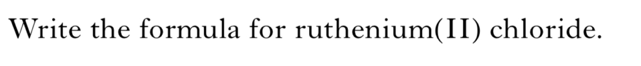
INT 2 2011

10.
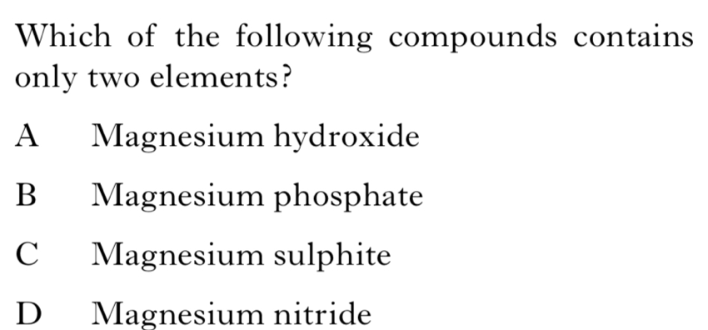

INT 2

