Calculations involving a balanced chemical equation questions 1

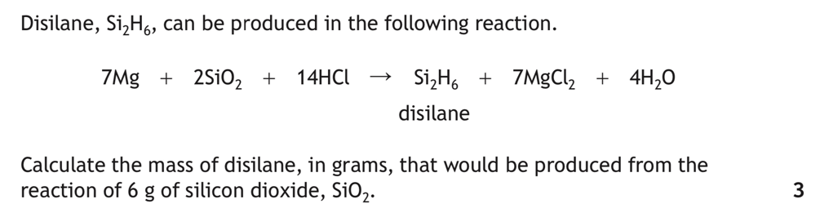
1.

2023

2.
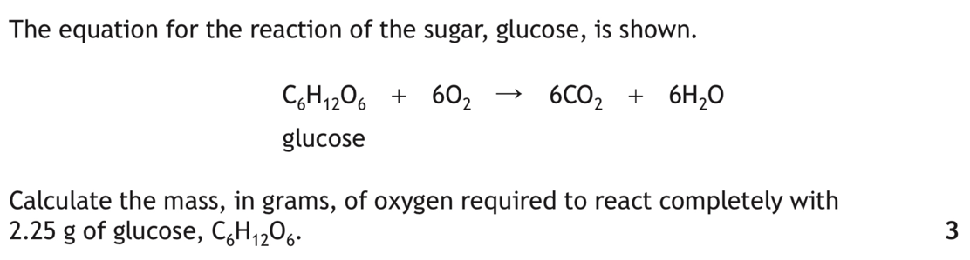

2022

3.

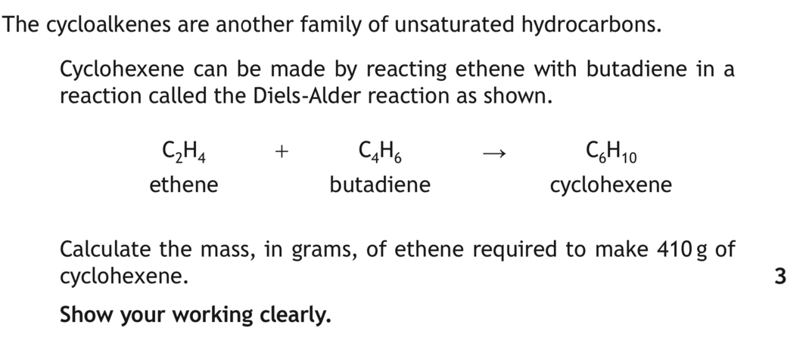

2019

4.
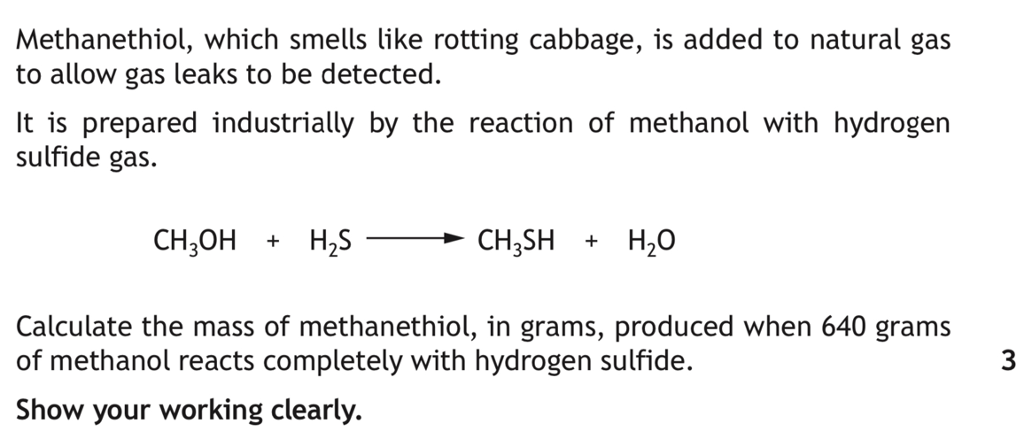
2018

5.
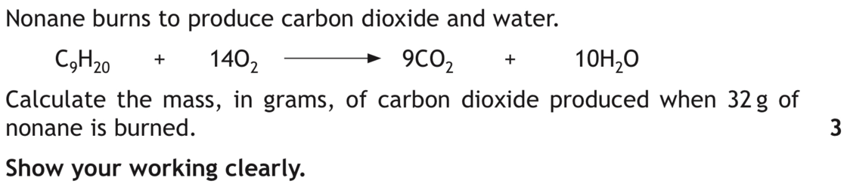

2014

6.
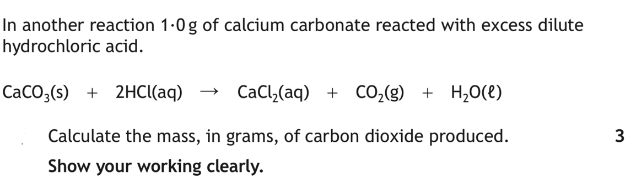
Specimen paper

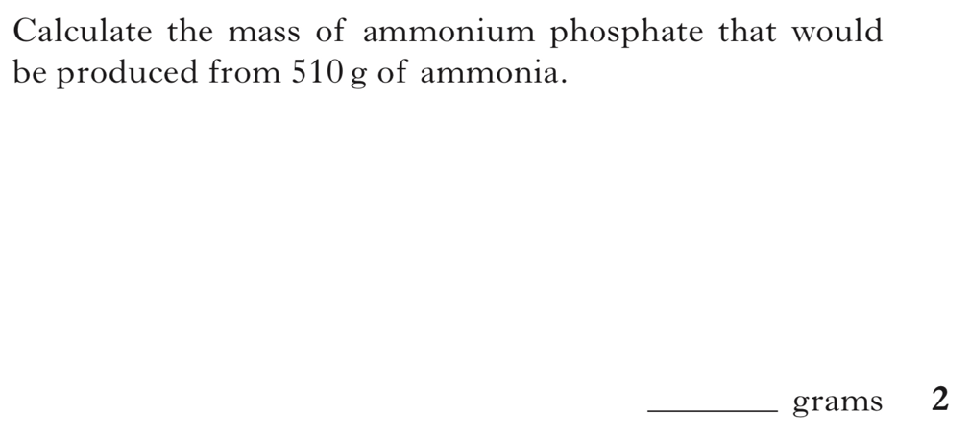
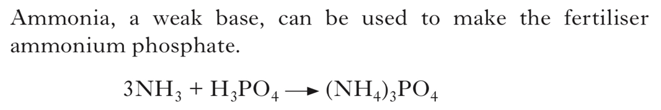
7.
INT 2014

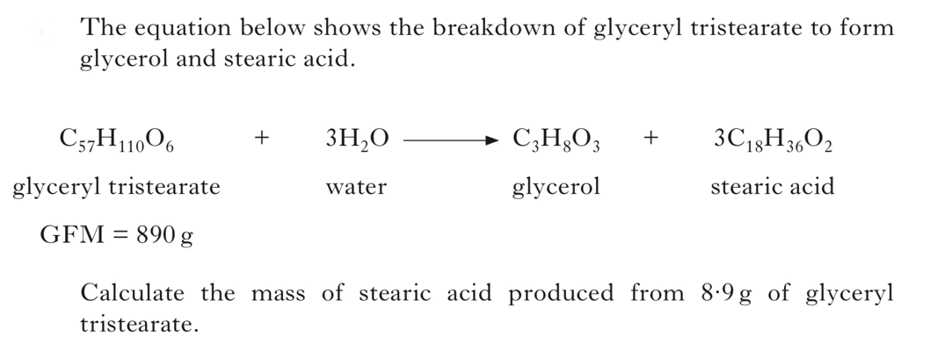
8.

INT 2 2013

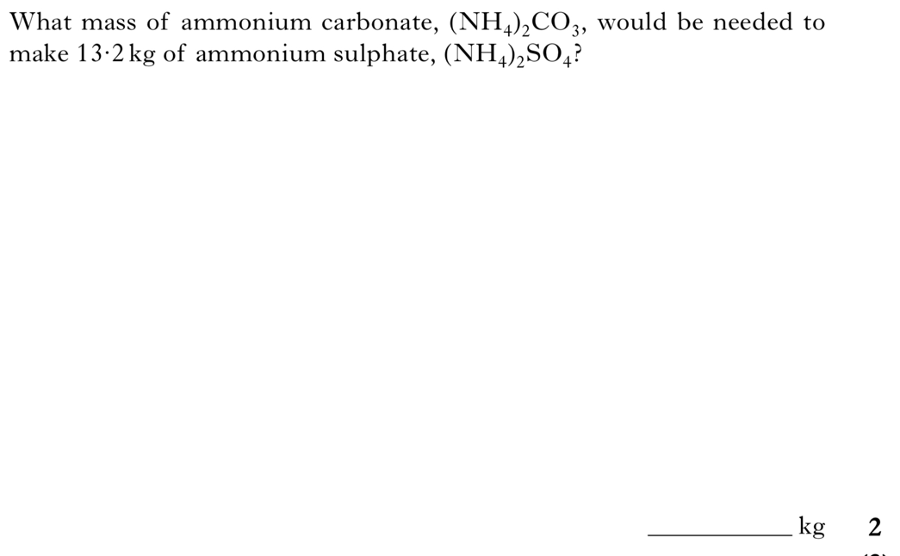
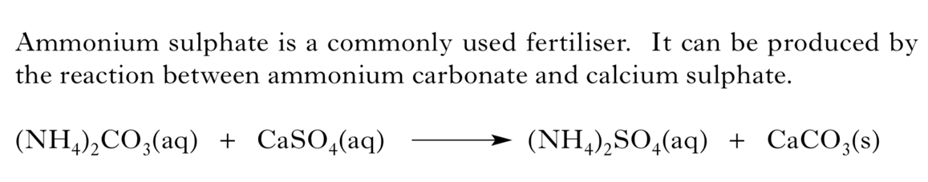
9.
INT 2 2011

10.
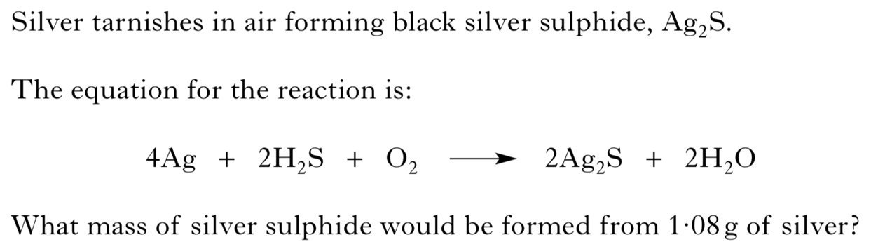

INT 2 2010

