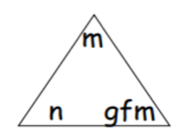
Calculations involving the solids triangle questions 1

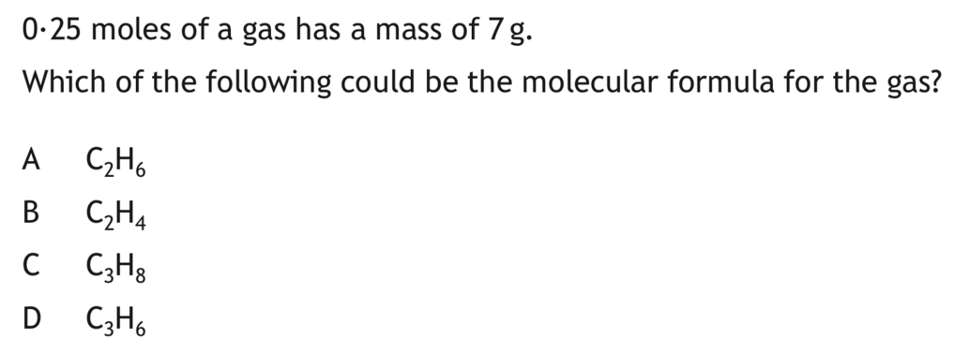
1.

2017

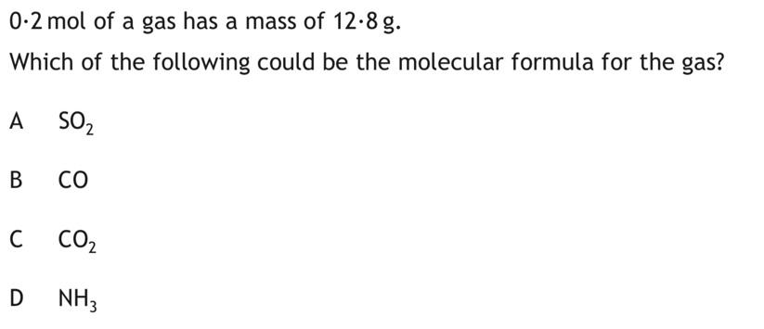
2.

2015

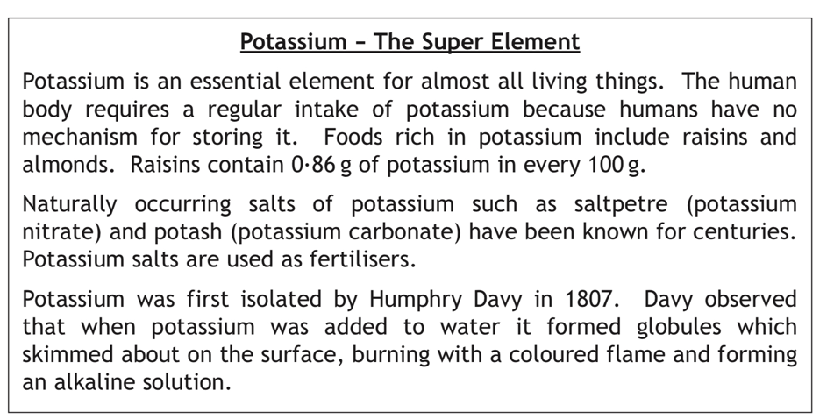
3.
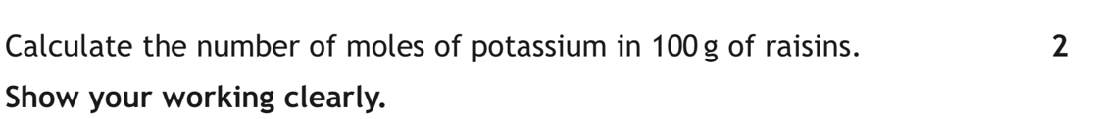
Calculate the number of moles of potassium in 100g of raisins
Show your working clearly

Answer 0.022

2014

4.

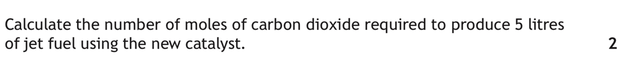
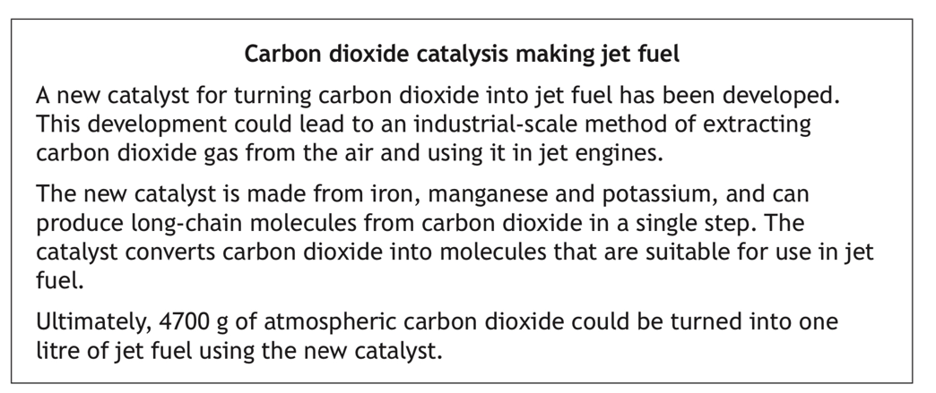
Answer
534.1

2023 Q4

5.
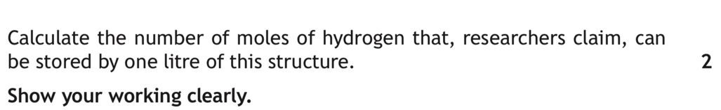
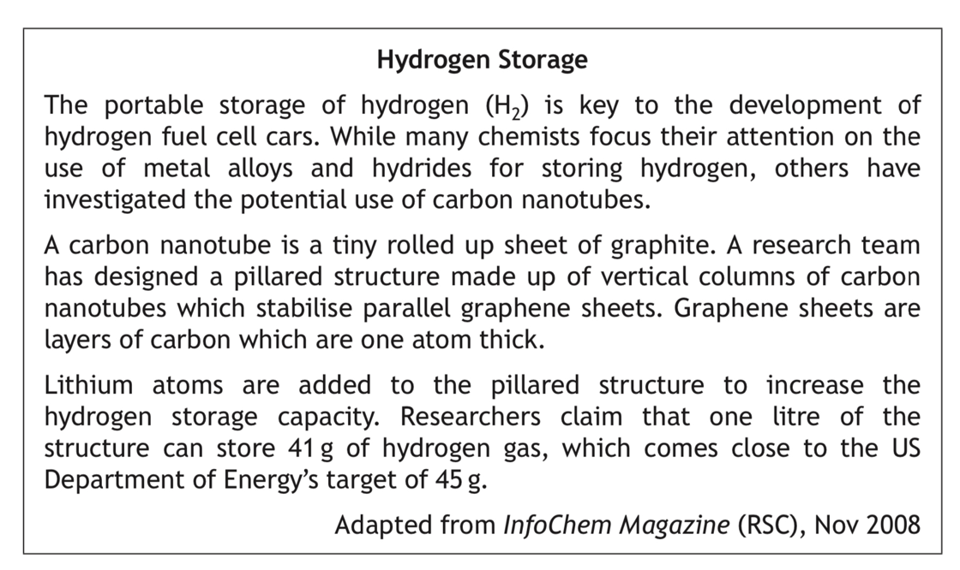

ANSWER
20.5

2017

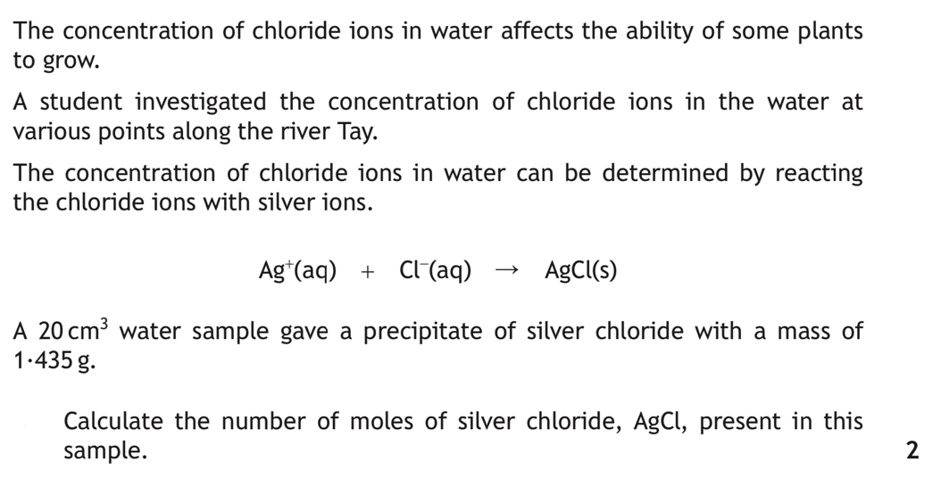
6.

Specimen paper Q15

ANSWER 0.01

7.
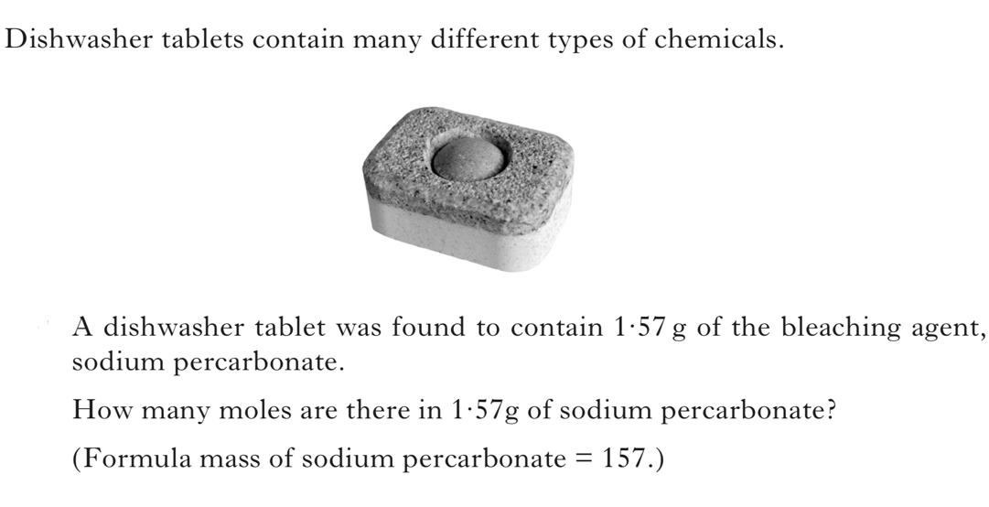

Int 2 2013

ANSWER 0.01

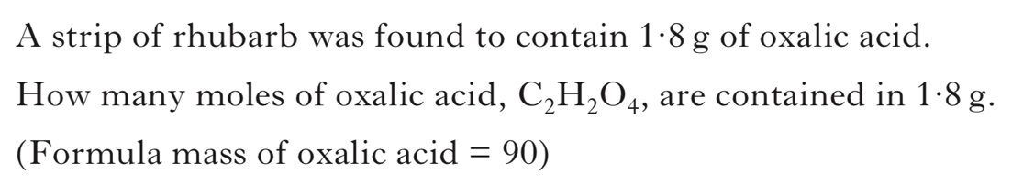
8.

INT 2 2012

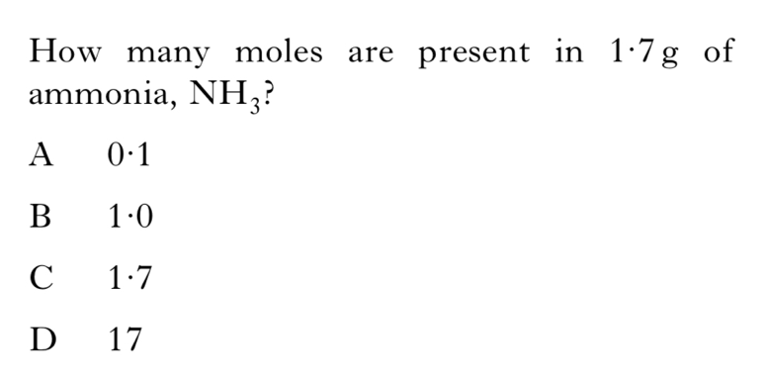
9.

INT 2 2008

10.
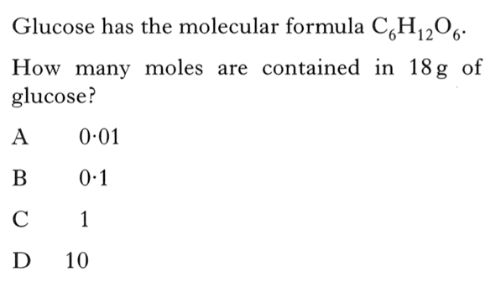

INT 2 2006

