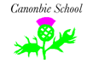
Canonbie Primary Termly Overview
Primary 5/6/7
This is an overview of the areas of learning which will be covered during term 1.
Writing/Listening and Talking  In spelling with Mrs Tilley, we will be continuing our fluid spelling programme, concentrating on various phonemes, common words and stage appropriate words.  In writing we will be covering a variety of areas through our Natural Disasters Topic; imaginative narrative stories, newspaper article, shape poems, writing in role and diary entry through our class novel. We will also be writing persuasive letters for classroom jobs and committee/house captain roles.  In grammar with Mrs Wilson, we are working on simple, compound and complex sentences.  In listening and talking, we will be taking part in group discussions, presenting our PowerPoint presentations to the class, taking notes during our topic and class novel work. | Maths  In numeracy, we will be focusing on place value, addition, subtraction, addition and multiplication.  In maths this term, we will be exploring shape and measurement including length, perimeter, area and volume.   | HWB  We will be learning about feelings and emotions with Mrs Tilley. We will focus on friendships and relationships, how to communicate our feelings and emotions in a healthy way and understand the importance of discussing any worries and accessing help.   | Expressive Arts/RME  Our artwork will be linked to our natural disasters topic. We will be creating our own interpretations of Hokusai’s The Great Wave and tornado inspired art. This will focus on developing and applying a range of skills for example: using lines and shading to create a 3D effect and utilize painting techniques to create value, 3D space and contrast.  Music: P7 will be having fortnightly music sessions with Miss Baxter.  In RME we will be exploring beliefs and values across different world religions including their places of worship and how we create our own belief and values.  
Science/Technologies  Our topic this term is the natural disasters. We will be researching a chosen disaster and creating a PowerPoint based on research and our learning which we will then present to the class. We will also be making volcanoes and experimenting with ingredients to make it ‘explode’ and participating in STEM challenges such as building a freestanding bridge that can withstand ‘a tsunami.’  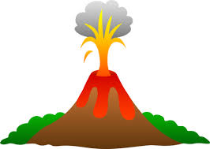 | Social Studies  Through our natural disaster topic, we will be learning about major natural disasters such as the Boxing Day Tsunami 2004, mapping tsunamis, early warning aids, the aftermath as well as volcanoes around the world and the different types.   | Reading  This term we will be reading a class novel linked to our topic: Escaping the Giant Wave by Peg Kehret. We will be engaging in a range of tasks to show our understanding of the text.  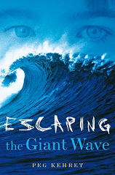  Pupils will also have the opportunity to read for enjoyment and challenge through Accelerated Reading and research through our topic. | PE  On a Monday with Mrs Tilley, we are working on netball/basketball.  On a Wednesday or Thursday with Mrs Humes, we are working on skills for invasion games such as dribbling, passing, defending and attacking.  